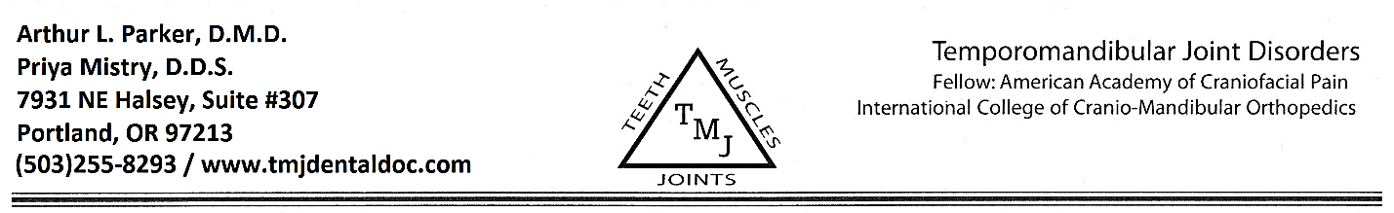
Consent Form

- A proper diagnosis regarding head and neck pain is very important because serious problems such as vascular disorders, brain tumors, cervical disc disorders, etc., can produce similar symptoms to TMJ disorders. It is important to inform our office of any changes in your health history form that previously provided.

- In order to achieve a successful outcome of your treatment, it is crucial that you make a commitment to keep all scheduled appointment and to remain in treatment until you are medically stationary. It had been our experience that most patients will achieve medical stability in 4-6 months from the time treatment begins.

- Length of treatment may vary according to the complexity of your condition. Treatment times, therefore, may vary from estimation. Although most conditions respond well to treatment, general health, stress, degree of tissue injury, posture, age, work habits, bite relationships, etc., do affect the outcome, and total resolution is not always possible.

- The treatment methods we will use are based on our experience and knowledge to be the most proven, appropriate, cost-effective and conservative. However, you should be aware there is much debate in the medical- dental community regarding the best way to treat various TMJ disorders.

- If an appliance is used in your treatment, it is theoretically possible for the appliance to be swallowed or inhaled. It must be said that a swallowed appliance may have to be surgically removed, and inhaled appliances may lead to respiratory arrest and death.

- As with any medical or dental treatment, unusual occurrences can and do happen. These possibilities could include minor tooth movement, broken or loosen teeth of dental restorations, sore mouth, changes in bite or occlusion, periodontal problems, muscle spasms, ear pain, neck pain, etc. Any of the mentioned complications are rare, but theoretically may occur. Additional medical and dental risk that have been mentioned may occur.

- You must always bring your splint with you for each appointment. Your splint will be re-evaluated in approximately six weeks form the time you receive it and may require a change in the treatment position at that time.

- Any balance after insurance payments are patient responsibility. Please communicate with the office staff and remit payment when services are rendered. If no payment is received within 60 days, you will be sent to collections and charged a $200 processing fee.

I have read or had read to me the information in this information consent, realized the risk and limitations involved, and consent to treatment. I understand that any of my photographs, models, and x-rays may be used in scientific papers or demonstrations.

I also understand that Dr. Arthur l. Parker and Dr. Priya Mistry are not contractual providers with any insurance company.

________________________________________________ ________________________
Signature of Patient and/or Legal Guardian Date
________________________________________________
Printed Name of Patient

