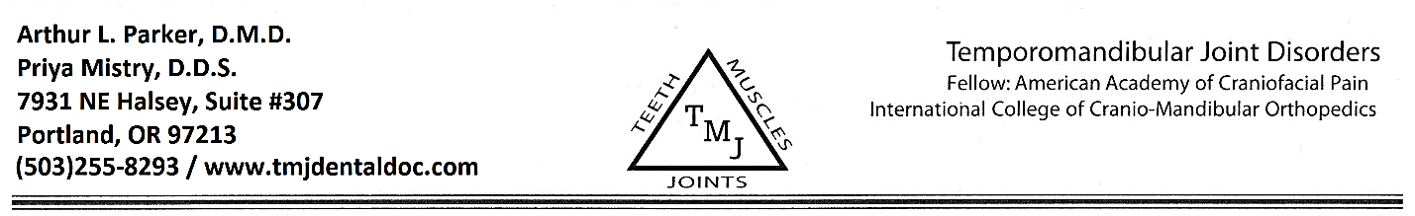
HIPAA Consent Form
I understand that, under the Health Insurance Portability & Accountability Act of 1996 (HIPAA), I have certain rights to privacy regarding my protected health information. I understand that this information can and will be used to:

- Conduct, plan, and direct my treatment and follow-up among the multiple healthcare providers who may be involved in that treatment directly and indirectly.
- Obtain payment from third-party payers.
- Conduct normal healthcare operations such as quality assessments and physician certifications.

I have been informed by you of your Notice of Privacy Practices containing a more complete description of the uses and disclosures of my health information. I have been given the right to review such Notice of Privacy Practices prior to signing this consent. I understand that this organizations has the right to change its Notice of Privacy Practices form time to time and that I may contact organization at any time at the address below to obtain a current copy of the Notice of Privacy Practices.
Arthur L. Parker, DMD
Priya Mistry, DDS
7931 NE Halsey, Ste. #307
Portland, OR 97213

I understand that I may request in writing that you restrict how my private information is used or disclosed to carry out treatment, payment and/or health care operations. I also understand you are not required to agree to my requested restrictions, but if you do agree then you are bound to abide by such restrictions.

I understand that I may revoke this consent in writing at any time, except to the extent that you have taken action relying on this content.

________________________________________________ ________________________
Signature of Patient and/or Legal Guardian Date

________________________________________________
Printed Name of Patient

