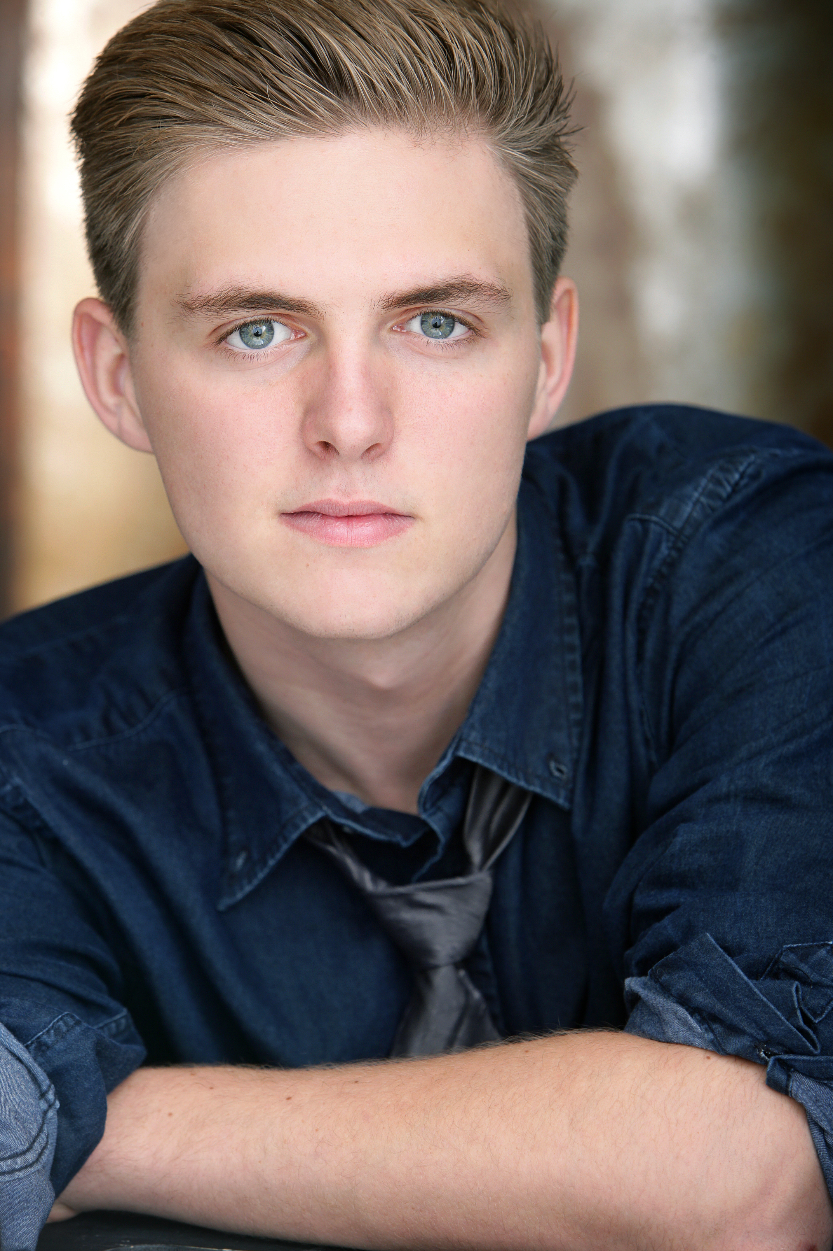

Broadway/Touring Company
Les Miserables Gavroche Broadway National Tour/Marius Company

REGIONAL THEATRE / OTHER
Ragtime Younger Brother Texas State University/Kaitlin Hopkins Dir.
A Chorus Line Paul Texas State University/Cassie Abate DIr.
Legally Blonde Carlos Texas State University/Cassie Abate Dir.
Great Expectations – World Premire Musical Young Pip Utah Shakespere Festival/Oddyssey
Theater. Jules Arron Dir.
A Christmas Carol Peter Cratchit Kodak Theater/Kevin Von Feldt Dir.
Into the Woods Jack LHSOC/Danielle Frazier Dir.
Peter Pan John 3D Theatricals/TJ Dawson Dir.
Tarzan Tarzan LHSOC/Chelsie Everheart Dir.
Oliver Oliver FCLO/Jan Duncan Dir.
Footloose Ren LHSOC/Terry Sohn Dir.

FILM/TELEVISION
The New Partridge Family Lead/Chris Partridge Sony and MTV network (VH-1)
Gilmore Girls Featured/Second Son Warner Brothers Network
Jack and the Beanstock Lead/Hansel Avalon Entertainment/Gary Tunnicliffe
Mad TV Featured/ Timmy Comedy Central

The Gaurdian Young Nick CBS Productions

VOICEOVER
Land Before Time XIII Little Foot Universal Animation/Charles Grosvenor
Bridge to Terabithia A.D.R. Choir BTT Productions/Tim Coddington
Family Guy Lead Singer FOX Broadcasting Company/Seth
McFarlane
Willie Wonka Broadway Jr Demo Charlie Umbrella Media for Hal Leonard

WORKSHOPS / READINGS
Two Orphans Texas State University Theresa Rebeck/Kim Grigsby
Swingset Moon Texas State University Alexander Gemignani

AWARDS
National High School Musical Theater Awards 2015 Best Actor (Van Kaplan, The Broadway League)

TRAINING
Texas State University BFA Musical Theatre-under the direction of Kaitlin Hopkins
Second City (Improv Intensive)
Dance: Tap (6 Years), Jazz (5 Years), Ballet (4Years).
Masterclasses: Rachel Hoffman, Joy Dewing, Michael Cassara, Sheri Sanders, Andrew Lippa, Kim Grigsby, Theresa Rebeck, Julia Murney, Dan Knechtges
On Camera: Bob Krakower, Aaron Speiser, Margie Haber

SPECIAL SKILLS
Dialects (Irish, British, fFench, German), Gymnastics (4 years), Whisteling, Special Effects Makeup.

