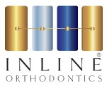
ADVICE FOR PATIENTS WEARING ELASTICS

- Please wear your elastics as shown:
- 24 hours a day.
- Night-time only.
- Please change your elastics once per day (i.e. every 24 hours).
- Whilst eating you can remove the elastics. Please replace them immediately after eating.
- Remove the elastics to clean your teeth. Please replace them immediately after cleaning your teeth.
- Do not wear the elastics for any longer than the time period advised by the clinician.
- Wearing the elastics will improve the way your teeth bite together and will help your orthodontic treatment to be completed sooner.
Please see the below diagram to help you on where to place your elastics.

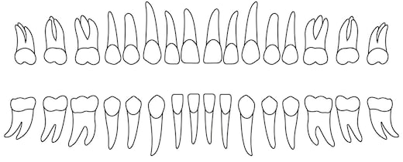

If the elastics are not in for the required amount of time per day then the movement will not happen, and you will delay your brace coming off. When the elastics are out of the mouth, what has been achieved whilst you wore them reverses; for instance, if you wore them all night but not in the daytime then during the day the night-time movement relapse’s so you achieve 0%.
If you lose your elastics or require more, please give us a call on 01438 765390. Elastics cost £1.00 per packet to replace.
When requesting more please quote the size you need:
1/8
3/16

