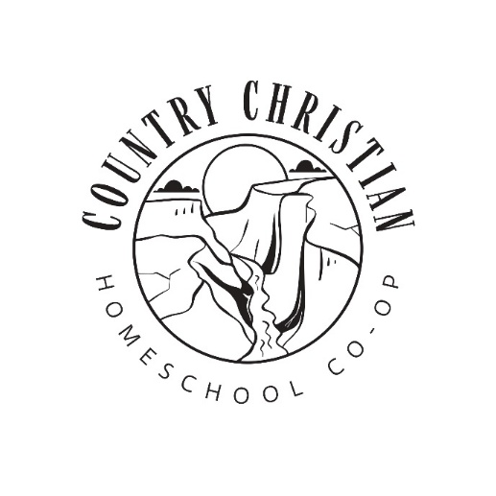
About our Co-op

This is a co-op that has been built by Homeschool Mom’s to come alongside families as they teach their children.
We are here to provide community, support and enrichment classes in an environment that glorifies God.

When we meet: Every Tuesday from September to May, with additional Field Trips
We will also be having informal summer activities as well.
Time: 10:00 am-2:30 pm
Place: Harvest Fellowship Church in Filer
Cost: Our cost is an annual fee for the school year of $75 per Family and a monthly fee of:
- $15 per student for Kindergarten -12th grade ($135/year)
- $10 per student for Preschool (or ½ day students)- ($90/year)
(for a family with 2 children the cost would be $345 for the year)
Grades: We have classes for:
Preschool in the mornings for 2-4 year olds from 10-12
Lower Elementary – Kindergarten to 2nd Grade
Upper Elementary – 3rd -6th Grade
High School – 8th-12th Grade (Middle school goes to either Upper elementary or High school depending on parents’ preference on learning level)
Classes may include Computers, Science, Art, Home Ec., Bible, Music, Wood Shop, Writing, Cooking, Life Skills, Devotions, and Many other Possibilities!
Our Co-op is run by volunteers, we are a 501-C-3 and governed by a board. Every family is asked to participate in some way. God has gifted each of us with gifts and talents, and it is through everyone’s participation that our group thrives.
Danae Wassenaar (President) Melissa Brower (Vice-President)
(208)944-5752 (208)731-3080
Visti our Website for more information: www.countrychristianhomeschool.com

