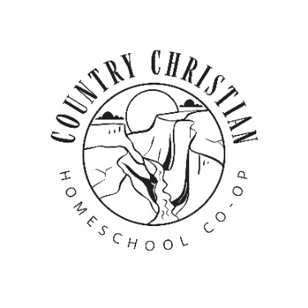
2025-2026 Schedule

10:00-10:15 – Opening time for all Grades
Preschool and Kindergarten | 1st to 8th Grade | 6th to 12th Grade
10:15-11:45 – Am Learning time | 10:15-10:45 – Bible/Presentations | 10:15-11:00 – Art
(Bible, Art, Language) | 10:45-11:15 – P.E. | 11:15-12:00 – ASL
11:45-12:15 – Lunch | 11:15-11:45 – Music Class | 12:00-12:30 – Lunch
12:15-12:45 Recess | 11:45-12:45 – Lunch and Recess | 12:45-1:30 – Bible, The Truth Project
12:45-2:30 PM Learning Time | 12:45-1:30 – Science Class | 1:30-1:45 – Health Class
(Science, Cooking, PE) | 1:30-2:30 – Home Ec | 1:45-2:30 – Life Skills

