Background Information:
Please tell us a little bit about your homeschooling journey. How long have you been homeschooling? Why did you decide to homeschool? What are your Goals?
_______________________________________________________________________________________________________________________________________________________________________________________________________________________________________________________________________________________________________________________________________________________________________________________________________________________________

What are some of your gifts, talents, and education? Are any of these topics or talents something you would be comfortable teaching?
_______________________________________________________________________________________________________________________________________________________________________________________________________________________________________________________________________________________________________________________________________________________________________________________________________________________________

We understand that we all come from different church backgrounds and have differing homeschool philosophies. We enjoy the diversity this brings to our group, but the one thing that unites our group is each individual’s commitment to a personal relationship with Christ. Briefly share about your relationship with Christ and how this affects your homeschooling journey.
___________________________________________________________________________________________________________________________________________________________________________________________________________________________________________________________________________________________________________________________________________________________________________________________________________________________________________________________________________________________________________________________________________________________________________________________________________________________________________________________________________________________________________________________________________________________________________________________________________________________________
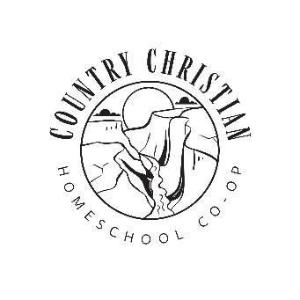
Country Christian Co-op’s
Statement of Faith
I believe in God the Father Almighty, Maker of heaven and earth, and in Jesus Christ His only Son our Lord, who was conceived by the Holy Spirit, born of the virgin Mary, suffered under Pontius Pilate, was crucified, dead, and buried. He descended into hell; The third day He rose again from the dead; He ascended into heaven and sits on the right hand of God the Father Almighty; who will come again to judge the living and the dead. We believe in the Holy Spirit, the holy church, the communion of saints; the forgiveness of sins; the resurrection of the body, and the life everlasting.
Misson Statement
We Believe in partnering with families
We believe education, spiritual, and character development begins in the home and that God designed community to come alongside and work together with parents. We believe that education begins with a solid foundation of God, His Son Jesus and the Holy Spirit. We at Country Christian Co-op are committed to having everything we teach start with a Foundation that is grounded in the Bible. Through our elective classes it is our goal that families are taught and encouraged in a Biblical worldview, integrating Christ into all areas and exemplifying that God’s ultimate truth is relevant to our lives today.
We believe in Equipping students and families with the skills needed to cultivate a successful understanding of who God has called them to be in school, society, and relationships. Facilitators act as “living curriculum” as they lead from a personal relationship with Jesus. We believe God has called us to be disciples that are adaptable, lead with curiosity, and embrace change with confidence. That each family demonstrate Christ-like character through worship, servant leadership, and personal growth.
The ________________________ family, hereby agree that our conduct, conversation and teaching as a member of Country Christian Co-op will demonstrate respect and support of the Co-op’s foundational beliefs.
Signatures
________________________________ _______________________________________
________________________________ _______________________________________
_______________________________ _______________________________________
________________________________ Date________________________

