
Attendance Policy
Monitoring attendance and expecting full attendance assists us in ensuring children are happy, safe and secure. Children build relationships with their peers and their key person by having regular sessions. Children feel comfortable and secure having routine, and understanding what is happening, when, where how and why.
We encourage all children to attend the days they are registered for.
If your child is unable to attend, we ask parents to call before their session, or as soon as possible, providing a reason and the expected return date.
Children are permitted to take holidays at any time throughout the year, we simply ask for prior notification so not to presume them missing or at risk of harm. Fees are still applicable during holiday days. We advise that should you have an appointment for your child, you make it at the beginning of the day so that they only come to nursery after, or at the end of the day, so they only come before. Sending children to nursery then taking them out for a period only to bring them back can cause upset and disrupt the routine which makes them feel happy and secure.
Should extra sessions be required these can be requested at any point however may not be guaranteed. Additional fees will need to be paid before care is given.
If your child has numerous days off in a row and becomes unsettled, we may ask for them to do shorter hours to allow the child to become settled again and ensure the child is as happy and feeling secure as possible whilst in our care.
Absent without informing
Should children not arrive to their session and contact has not been made by parents a member of the management team will call home to check the child and family are ok and do not need assistance. If your child attends on a morning or a full day, we will aim to contact you at 10am, if your child does an afternoon session, we will aim to contact you at 2pm. We call at these times to allow all children to come in, even if they are running a little bit late.
If contact is not achieved with parent 1 then parent 2 will be called. In the event neither parent/carer is available the emergency contact will be called. If that emergency contact is unavailable the second emergency contact will be called.
In the event all four contacts are unavailable they shall all be contacted again, in order as above.
If second attempt to contact all four numbers fails an email and text will be sent.
If The Willow tree is at all unsure about the safety and wellbeing of the child, Wakefield safeguarding children partnership (WSCP) or social services will be called. They may make a home visit.
Promoting Good Attendance
We ensure good attendance by:
- Making sure children attend for the expected hours.
- Requiring parents to contact school if their child is going to be late or absent.
- Requiring parents to report sickness / absence.
- Communicating with parents and following up on non -notification of absences as part of promoting good attendance and punctuality.
- Monitoring children 1
- Consistently following up poor attendance and punctuality.
Supporting Families
We recognise that sometimes families may need extra support with attendance and punctuality, therefore good communication is essential between families and key members of our staff. We will work with families to support children’s good attendance and punctuality. Where children’s attendance is poor and not improving, we may talk to families about the support available from local services (Family Hubs / Health Visitors), for example, implementing bedtime routines and parenting classes.
Who may be informed of my child’s absence?
All absences will be recorded, and information stored for 3 years in line with data protection law.
As mentioned above WSCP will be informed if a child is absent without contact, absent for long periods of time or The Willow tree has concerns about their welfare.
Wakefield Safeguarding Children Partnership: 01924 307712
Absences will be logged on the child’s overall record with details of the reason for absences. The log appears as below. Should there appear to be a pattern of concern, or The Willow tree is at all unsure about the safety and wellbeing of the child, social services will be contacted. Social services: 0345 850 3503.
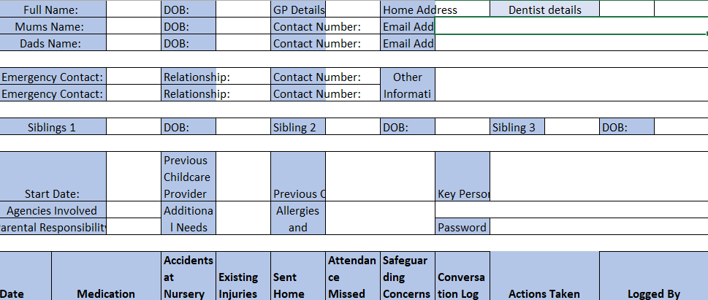
Where children obtaining 2-year-old funding are frequently absent or have an attendance percentage below 90%, the local authority funding department will be notified. This could affect a child’s suitability for funding. Families first funding: 0800 587 8042

Staff Absence
Staff attendance is very important as the children and families are relying on us. We are also legally bound by ratios, 1:3 for under 2’s, 1:5 for 2-year-olds, 1:8 for 3- and 4-year-olds. We also have to adhere to the qualification ratios which requires at least 1 level 3 and 50% level 2.
We must have enthusiastic, dedicated staff who can provide consistency for children to feel safe and secure whilst with us. Attendance and punctuality is expected of all staff. Every staff member is a vital part of the machine; without one element it does not run smoothly.
The Willow Tree do not use supply staff, as a rule, but may choose to do so in emergency situations. The Willow Tree should be able to cover staff absence in house, however, should there be a time we cannot cater for all children to attend therefore we reserve the right to cancel a child’s session with limited notice to protect and safeguard children. This will be monitored and approached fairly.
Staff absence is monitored, and poor attendance is approached through supervision meetings, mindfulness conversations and tasks. Poor attendance will result in action being taken, development plans, sickness plans and disciplinary action. Absences and lateness are recorded on the staff central log, 3 or more periods of absence within 3 months will result in disciplinary procedures.

Eligible staff will be paid statutory sick pay after 3 days of illness when in receipt of a doctor’s sick note. SSP is paid at £116.75 per week.
SSP before maternity pay – If you are claiming SSP this will stop when reaching 4 weeks prior to due date and maternity pay will commence.

Appointments
All appointments should be made so that you can attend without disruption to your work, this means that wherever possible you should book doctors, dentist or other appointment outside of working hours. If needing an emergency appointment, you should aim to make these appointments early in the day, during your lunch break or at the end of the day. Staff must inform the manager of all appointments with as much notice as possible.

If the reason for an appointment could affect your work or results in medication being prescribed, the manager must be informed of such details. All medication, conditions, illnesses etc will be logged on the central log. The employee must keep the manager up to date with any side effects, increase or changes to medication.

On the day absence or lateness
Staff procedure to notify of absence or lateness:
- Each day you are not attending or running late, you must call the setting as soon as you know you will be either absent or late.
- Leave a message with the manager or if not available on the answering machine, stating why you are absent or late, and when we should expect to see you.
- If you are scheduled to open or start a shift before 8am, you must contact the manager on duty (manager or deputy) directly via phone, leaving a voice message if unanswered.
- Should it feel appropriate, a message could be sent via the staff WhatsApp group to provide notice to the entire group and request cover.
You must not:
- Take leave with notifying the manager as stated above. We would expect your next of kin to contact the setting if you are unable. If the setting has not been notified of your absence or lateness, we will call you and your emergency contacts until we can confirm your whereabouts. If without good reason, no shows will result in disciplinary action and may be deemed as gross mis conduct.
- Tell a colleague in replacement of the correct procedure stated above.
- Send an email in replacement of the correct procedure above.
- Get someone else to call in for you, unless you are physically unable.
- Take unnecessary sick leave.
- Book more than 14 consecutive days off.
- Book tickets prior to gaining confirmation of a holiday request.

Pregnancy related absence
Pregnant employees have 4 main legal rights:
- Paid time off for antenatal care
- Maternity leave
- Maternity pay or maternity allowance
- Protection against unfair treatment, discrimination or dismissal
‘Antenatal care’ is not just medical appointments - it can also include antenatal or parenting classes if they’ve been recommended by a doctor or midwife.
Employers cannot change a pregnant employee’s contract terms and conditions without agreement - if they do they are in breach of contract.
Employers must give pregnant employees time off for antenatal care and pay their normal rate for this time off. Proof of appointment will be needed in order to process the payment of such appointments. The manager must be notified of all appointments when they are issued to provide maximum notice for cover.
The father or pregnant woman’s partner has the right to unpaid time off work to go to 2 antenatal appointments.
Employees cannot take time off for antenatal appointments until they’ve told the employer about the pregnancy.

Pregnancy-related illnesses: Maternity leave and Statutory Maternity Pay will start automatically if the employee is off work for a pregnancy-related illness in the 4 weeks before the baby is due - it does not matter what has been previously agreed.

Compulsory maternity leave: If the employee is not taking Statutory Maternity Leave, they must take 2 weeks off after the baby is born - or 4 weeks if they work in a factory.

Telling the employer about the pregnancy: Employees must tell their employer about the pregnancy at least 15 weeks before the beginning of the week the baby is due. If this is not possible (for example because they did not know they were pregnant) the employer must be told as soon as possible. Employees must also tell the employer when they want to start their Statutory Maternity Leave and Statutory Maternity Pay.
Statutory Maternity Pay
To be eligible for SMP employees must:
- Be on your payroll in the ‘qualifying week’ - the 15th week before the expected week of childbirth
- Give the correct notice
- Give proof of pregnancy This is usually a doctor’s letter or a maternity certificate (known as an MATB1 certificate). Midwives and doctors usually issue these 20 weeks before the due date.
- Have been continuously employed by you for at least 26 weeks up to any day in the qualifying week
- Earn at least £123 a week (gross) in an 8-week ‘relevant period’

Review date to ensure compliant with EYFS update 2025: 01.09.25 Reviewed by: Shannon Mills

