Health and Hygiene
Food and Drink
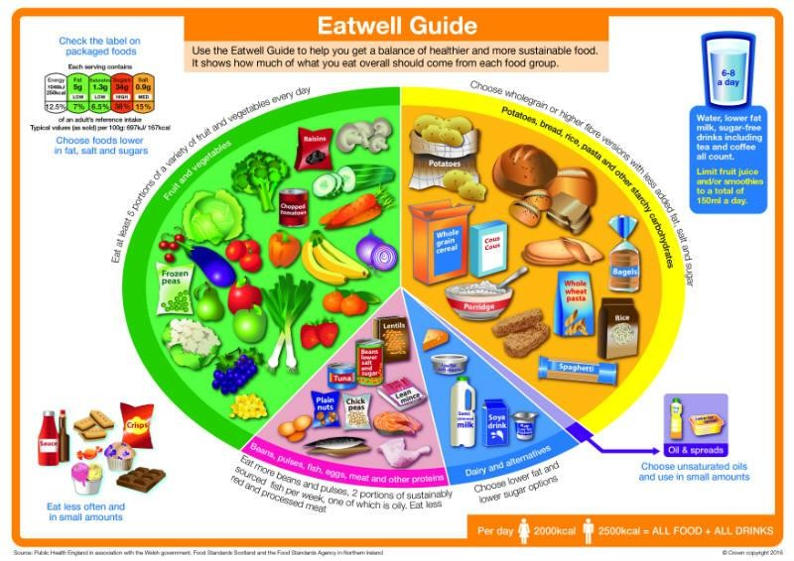
At The Willow Tree, we adhere to the Early Years Foundation Stage nutrition guidance. We pride ourselves on encouraging children to have a healthy, balanced diet whilst at nursery. Children are always encouraged but not forced to eat the food provided by our chef. We discourage parents from sending packed lunches into the setting as this creates an unfair environment which can not be directly controlled by the setting.
Current legislation holds the nursery accountable for what the children eat whilst at nursery. It states children must have fruit or vegetables as one of the options at every mealtime, with this in mind this will be our new eating routine:

7:30 – 8:30am: Low sugar cereal and/or fruit with water or full fat milk.
10am – Fruit (not dried fruit) with water or full fat milk.
11:30/12pm: Hot meal including at least two types of vegetable with water.
2pm – Fruit (not dried fruit) with water or full fat milk.
4pm – Small meal including 1 vegetable with water.

We will no longer be providing a dessert of any type.

Any packed lunches that are brought in must also follow the legislation Early Years Foundation Stage nutrition guidance, providing fruit at each meal time and avoiding the below:

We must avoid:
- Added salt and sugar in tinned vegetables and pulses and choose no added salt and sugar options or those tinned water.
- Cereals labelled as ‘high’ in sugar such as sugar-coated or chocolate-flavoured cereals.
- Flavoured dried rice, pasta, noodle products.
- Sweetened yogurts and fromage frais.
- Foods high in saturated fat, salt, and/or sugars like cakes, sweet and savoury pastries, biscuits, crisps, chocolate and other confectionary.
- Artificial sweeteners as they may encourage children to prefer very sweet foods.
- Skimmed and 1% milk.
- Sugary drinks, including fruit juices, squash and smoothies.
- Nuts in any form or variety.

We expect all families to work with us to ensure children get nutritional benefits from the food they eat enabling them to grow and develop.

Children are provided with a wide variety of foods for snacks and meals at The Willow Tree. Children are never forced to eat; however, they are always encouraged to give food a go. The meal offered is of an appropriate size for the ‘average’ child of their age and will consider any food allergies, intolerances, religious preferences, vegetarianism, veganism or eating a plant-based diet. New legislation does not allow alternative meals for children with additional support needs, only alternative modifications, preparation, serving or eating (having a cloth available to wipe hands) and environment (limited noise and distractions).

At The Willow Tree there is always more than one element to a meal for example, sausage, mash and peas, we encourage all children to try each element and aim for them to eat the majority of their meal. Alternatives will not be provided on individual parent/child request as this does not lend itself to children being prepared to give food a go and try new things.

Children have food available every 2 hours and water available all day. Children should enjoy the social element of mealtimes, sitting amongst their peers to share a meal, independently selecting the different elements, and placing them on their plate. We demonstrate, encourage and support children in being independent, using tools such as tongs, scoops, jugs, knife, fork and spoon.

Children need plenty of water to stay hydrated and healthy. Water makes up more than half of a child's weight, and a steady supply is necessary to keep the body working properly. Water is available throughout the day; we use water self service stations with a water dispenser and cups or individually labelled bottles. We have drink breaks so adults can support our children in getting their own cups of water and demonstrate drinking water. We do not allow children to have juice or other sugary, fizzy or unhealthy fluids at nursery.
The NHS suggests:
- Introducing an open top cup from around 6 months as it is better for tooth formation.
- From 1 year old feeding from a bottle is discouraged.
- It is not recommended to put anything in a bottle or cup other than breast milk, formula milk or water.
- Comfort sucking from a bottle with sweetened drinks causes tooth decay as the flow is slower and means the substance is in contact with the teeth for longer.
- Children under 6 months must have cooled boiled water.
- Formula milk, follow on milk and night milk are not needed after 12 months, no evidence to show it has any further benefits.
- Children under 12 months should not drink cow’s milk.
- Children should be encouraged to drink water. Drinking juices and cordials encourages having a sweet a tooth, can fill them up so they don’t want to eat food which is needed for their bodies and good energy and can lead to tooth decay and obesity.
What can parents do?
- Provide your child with water at home so that they are used to it and will drink water at nursery.
- Practice using an open top cup from 6 months old.
- Practice using knife, forks and spoons (suitable for their age).
- Provide a variety of meals which contain all elements of the food chart.
- Encourage children to sit at a table to eat in a position where they are at a suitable height to access their meal.
- Do not provide them with alternative meals if they refuse to eat what has been created.
- Only allow puddings as a treat, and not always of a refined sugar state.
- Demonstrate healthy eating, positive attitude towards food, good mealtimes and drinking water with siblings, parents, and peers whenever possible.
- Eliminate bottles of milk once your child is eating regular meals.
- Provide blended, smooth, lumpy, and cut up food in line with NHS recommendations so that the child is ready
Dummies
The Willow Tree advise children only use dummies, when necessary, e.g., sleep time or when they are becoming very upset. All children will need a dummy box for their dummies. We ask that children do not arrive with their dummy in their mouth but instead within their labelled dummy box and placed within their bag for hygiene.

Dummies can be useful when a child is born; it can develop the sucking ability, can help with reflux and can comfort babies to sleep. However, there can be many cons to using a dummy: it can slow the speech process considerably, it can prevent the correct formulation of sounds, it can disrupt the formation of teeth, it can cause sleep disruptions, it can create higher incidence of respiratory, ear and gastrointestinal infections, accidents and dental malocclusion and it can be a very stressful time for child and parent when trying to wean them off it. Language development- dummies | NHS Fife

Formula Bottles
Step-by-step guide to preparing a formula feed.
- Step 1: Fill the kettle with at least 1 litre of fresh tap water (Do not use water that has been boiled before).
- Step 2: Boil the water. Then leave the water to cool for no more than 30 minutes, so that it remains at a temperature of at least 70c.
- Step 3: Clean and disinfect the surface you are going to use.
- Step 4: Pour in the required amount of water to the bottle.
- Step 5: Match the number of oz of water with the number of scoops of formula.
- Step 6: Shake to mix.
- Step 7: Test the milk on the wrist, if you can feel it warm/hot is needs to be left to cool.

Nappies & Toileting
Parents are required to bring nappies, wipes and creams for their child. All nappies should be of the correct size where the tabs comfortably sit either side of the image on the front. Children should not be sent in or with pull ups unless circumstances require and has been agreed with the key worker. Parents should only send in enough nappies for a week to prevent lose or damage in over storing. Nappies will be checked roughly every 2 hours 9:30am, 11:30am, 1:30pm, 3:30pm, 5:30pm, as a minimum requirement. If the child is dry no change will take place, if wet or soiled they will be changed. If a child looks overly wet or has soiled at other times of the day they will also be changed. Staff will verbally announce a check and a change so that both the child and other staff are aware.

When starting the toilet training process, we recommend going to the toilet with your child, so they understand the use of the toilet, change nappies in the bathroom to familiarise them to the bathroom and being clean. We always recommend taking nappies off completely so the child can understand the sensation. Parent must begin the process over a long weekend, trying them on the toilet every 10 minutes to ensure they stay dry and find the training process a positive one. Parents should use positive language when the child tries and is successful. Once parents have dedicated a weekend to taking their child to the toilet every 10 minutes the child should have built up an understanding of the toilet and a positive relationship with it. At this stage the child is ready to continue these new skills and understanding at the nursery.

Clothing
Having the right clothing at the right time is very important. Please refer to our weather policy for further details. Should any parent struggle to gain access to the right clothing, ie jumpers, hats and coats in winter please do let us know as we always have spares which you are welcome to.

Independence is one of our key aims, children are assisted where needed and encouraged to put on and off their shoes, slippers coats, jumpers etc. Showing them at home and allowing them to practice would be very useful in their transition to nursery and throughout.

What should my child have?
- All children no matter their age should be provided with suitable indoor and outdoor footwear. Pre walkers will need these to keep their feet warm, safe and to assist in their movements. Wellies in winter are required for all walkers.
- Jumpers and trousers should be worn and packed in back packs in cold weather.
- Sun hats, sun creams, shorts and t-shirts in warmer weather.
- All in one wetsuit for all in wet weather.
- Spares in backpack is always useful as children participate in a variety of experiences, some of a messy nature. They are also trying to be independent with serving, eating, and drinking by themselves so please ensure we have a spare of everything in their bag.

Teeth
We teach children the importance of keeping clean healthy teeth as part of our curriculum. On top of drinking only water and eating well, we demonstrate brushing our teeth at The Willow Tree. This is done to support good techniques and understanding, but it is the parents’ responsibility to ensure their child brushes their teeth twice a day, every day.

What can parents do?
- Assist children in brushing their teeth in the morning and before bedtime.
- Use age-appropriate toothpaste.
- Encourage drinking of water.
- Limit the amount of sugar.
- Promote healthy eating and a positive attitude towards food.
- Reduce dummy use.
- Reduce use of bottles.

Hygiene
We ensure our routines and practices lend to the most hygienic environment possible, here are some examples:
- We wash our hands regularly throughout the day and especially before eating, using hand wash from a pump dispenser and disposable paper towels.
- We clean resources and environment regularly.
- We have individual face clothes, clothing, wipes, bedding, bibs and drinking vessels.
- We teach children how to self-serve hygienically using shared equipment.
- We tend to snotty noses in a timely manner.
- We change nappies regularly and in a timely manner when soiled.
- We have external cleaning out of hours to ensure a clean environment.
- We have suitable bins for use with lids and foot pedals.
- We assist in toilet training promoting independence.
- We have suitable protective equipment including gloves and aprons.
- We have a strict health exclusion policy preventing child attendance in ill health.
- We carry out risk assessments which are living documents which respond to need and requirements.

What do we ask of parents?
- We ask that parents keep us in the loop to how their child is, any concerns or conditions to be aware of.
- We ask that parents do not send their child to nursery if they suspect they are ill or contagious.
- We ask that parents encourage independent self-care at home with hand washing, changing clothes, using the toilet etc.

Risks and Safety
Allowing children to take age-appropriate risks is part of our curriculum. We demonstrate and discuss correct use of tools, equipment, resources, and spaces, independently and together. During circle time, focus time and other adult led experiences we talk about turn talking, sharing, understanding, respect and teamwork, installing a collective understanding of ourselves and others and how to be together happily, safely, securely and without prejudice. We set challenges for children to explore concepts and take small risks. Through risk assessments of the environment, resources, and new experiences we ensure risks are appropriate and that their safety is monitored.

We teach children about respecting their bodies, keeping them safe and healthy, caring for ourselves and others. With this knowledge we aim for children to have an understanding of how to protect themselves and keeping themselves safe.

We teach children about road safety, stranger danger, calling 999, who can help us, how to ride a bike, how to feed themselves and express their needs and requirements etc. All of which are lifelong skills which help to protect them and keep them safe from harm.

What do we ask of parents?
Allow children to take age-appropriate risks at home, in the garden and when out and about. For example:
- Using an age-appropriate knife to cut their own food and help prepare meals.
- Climb an age-appropriate climbing frame.
- Walk up and down steps independently.
- Drink from open top cups.
- Walk along the side of the road holding your hand, pausing to cross the road, looking and listening (not on reins).
- Speak about their safety, who to speak to, appropriate use of devices, protecting their bodies (underpants rule)

Screen Time
Allowing children iPad, TV time, laptops, mobile phones or tables to access YouTube Kids, Netflix, games and other programmes is increasing. Children often find this time very enjoyable but unfortunately it has its negatives:
- Sleep problems due to over brain activity and stimulation.
- Children can become addicted and obsessed.
- Children can struggle to navigate from the technological world to the real word, resulting in behaviours that challenge, anxiety and depression.
- Weakened emotional judgement.
- Impaired social skills.
- Delayed learning and loss of cognitive ability.
- Too much screen time can lead to obesity, heart disease and other health problems.

The recommended maximum screen time per day is:
Under 2 – No screen time
2-5 years old – 1 hour per day
Above 5 years – 2 hours a day

What do we recommend from parents?
- Set an amount of time for your child to have screen time based on the recommendations above.
- Avoid use within the last hour before bedtime.
- Set parental controls to avoid inappropriate content.
- Monitor their use closely, explaining safe use and protecting them from being the subject of abuse.
- Hold conversations about their use, language and online behaviours to ensure they are not becoming an abuser.
- Watch out for signs of anxiety or depression.
- Do not allow your child on normal YouTube.
- Do not allow your child to have a social media page.
- Set screen time breaks to ensure they can transition from the technological world to the real world.
Screen Time and Your Developing Child

Reviewed by: Shannon Mills Date: 04.09/2025

