

Medical Policy and Procedure
Each child, parent and staff members health and safety is very important to us at The Willow Tree, therefore we have this policy in place to help protect everyone involved.
Ill Health
- If a child or member of staff is not seen to be well enough to attend by the managers, then The Willow Tree reserves the right to request that they stay at home or be collected.
- The passing of infections or diseases must be controlled and therefore your child may not be allowed to attend the nursery should they show any signs or symptoms of any disease, infection, or other health issue (time scales are taken under advisement from government infectious controls however can be extended by the managers should they deem necessary).
- Children should not attend nursery if they have any contagious illness, including but not limited to; hand foot and mouth, head lice, chicken pox, etc.
- Parents should be open and honest with the nursery about their child’s health and keep them at home if they are not well enough to attend.
- Parents must keep their child at home for the first 48 hour after starting new antibiotics to ensure they do not have any adverse reactions and to provide time for the antibiotics to take effect.
- Parents must keep their child off nursery for 48 hours if they have sickness or diarrhoea.
- Parents are requested to call the nursery the morning their child is due in to report any absences, if we do not hear anything before 10am, we will contact the parents to find out the reasoning of why the child is not attending. Tapestry can also be used to update nursery on any absences, illnesses or accidents from home. A written record of this will be held at nursery.
- Parent should comply with living with covid rules and regulations, such as frequent hand washing, covering mouth when coughing and keeping up to date with signs and symptoms of ongoing variants.
- The Willow Tree will not be responsible or reliable for monies lost due to parents having to take time off work to care for their child.
- The Willow Tree will not refund fees on days a child is sick, absent or requested not to come due to ill health.
- Parents should make every effort to collect their child or arrange for someone else to collect their child in a timely manner should they be advised to do so.
- A risk assessment may be required to ensure children are not excluded from nursery for long periods of time. Only when the nursery manager deems it safe enough would children be able to attend.
- Children can have what is called a “Fabricated Illness” this is when a parent or carer exaggerates or deliberately causes symptoms of illness in the child.
- The health protection poster/exclusion periods is displayed in the corridor and is shared with parents.
storing Medication
- We shall store medication as advised on the packaging.
- We shall only store medication that has been prescribed for that child (with the exception of Calpol/Ibuprofen and Antihistamines for severe allergies – see section on Calpol/Ibuprofen and Antihistamines)
- Medication is kept in the medication cabinet or fridge within the office.
- Medication needed for that day will be stored in a medication box and sent home if/when needed.
- Medication must be in the original packaging/bottle or container.
- Medication must show the correct medical label from a registered pharmacy or doctors.
- Medication must state the child’s name for whom we are storing it for.
- Medication must be in date.
Administering Medication/ Basic First aid
- For minor accidents, a cold compress or wet paper towel will be applied, wounds with dirt may need to be washed to prevent infection.
- Plasters will be administered if parent permission is gained.
- Other basic first aid will be applied by the first aider responding (All staff are Paediatric first aid trained within 3 months of starting at The Willow Tree so can apply basic first aid to children. The managers are first aid in the workplace trained so can apply basic first aid to staff.
- First aid required that is beyond basic first aid will be sort from the correct medical professional. Parents will be informed if this is necessary and wherever possible should be the ones to take their child to gain such medical assistance.
- Staff may contact parent before or after any medication to seek clarification or to update parents of medical situation.
- Parents will be informed via a phone call if their child has received a bump to the head.
- Parents must give signed consent via completing the medication form before we will administer any medication.
- Medication must be prescribed for that child and display their name and correct medical label.
- We will only administer medication which is in date.
- The dosage on the medication must match the requests of the parent, we shall only give as prescribed.
- We shall only administer at times indicated by doctor and agreed by parents unless asleep in which case it may be discussed with parents that it is given later.
- Medication shall be administered in the office by manager and counter signed by responding adult.
- The dose shall be checked by a second member of staff before administering and shall be counter signed as proof.
- Staff shall wear appropriate clothing (gloves) where necessary.
- Staff should be made aware by parents of symptoms and reactions to the medication and the medical issue in writing.
- Staff will follow the protocol for emergencies.
- Should a child have an allergy an allergy notification form should be completed by parents with detailed instructions to follow should the child have the allergic reaction.
- This will be displayed in the appropriate room for which the child attends, the kitchen and the office.
- If the child should have a health care plan parents should provide the nursery with a copy.
Calpol/Ibuprofen and Antihistamines
- Calpol and Ibuprofen can be administered to children when signed parental consent has been given on a medication form without it being prescribed by a doctor.
- All medication is stored in the locked cabinet in the office and only management with administer medication to children.
- Staff need to monitor the frequency of how often a child is having medication at nursery or how often a child comes to nursery having had medication at home. Staff to inform DSL if they have any concerns.
- We get parents to fill our medication form on drop off to explain why, what time and how much medication has been given to the child at home. The parents will also sign the form when they pick their child up.
- A child will not be given Calpol over the 3-day mark and will be requested to go see their GP.
- If a child is unwell, please do not send your child into nursery, with or without Calpol.
- Antihistamines can be administered at nursery without it being prescribed if the child has a known severe allergy which is declared to the nursery. Children with hay fever should have their medication at home before coming to nursery.
- Antihistamines will not be stored at nursery unless the child has a known severe allergy.
- All medication must be labelled with the child’s name and cannot be shared with others.
- The name label must not cover the medications directions or the expiry date.
- These liquid suspensions will be monitored and cannot be given for longer periods of time than two consecutive weeks.
- As with any medication The Willow Tree can only administer as to the instructions on the box.
- Parents are required to inform the nursery manager whether they would like to be informed before any Calpol is given or whether the medication can be given at the intervals suggested on the bottle on that given day.
- These medications will be recorded just like any other medication.
- These medications will be stored just like any other medication.
- These medications will be administered just like any other medication.
Record Keeping
- All medication must be signed for and permission provided in writing before any medication can be administered.
- Parents must inform the nursery of any medication administered at home on arrival at nursery. This includes any medication not being requested to be administered that day at nursery.
- Parents will be informed via Tapestry or phone call of any accident requiring first aid or of any medication provided.
- A record of all medication administered dosage, time and date are kept and stored safely and confidential.
- Medication should be checked, and counter signed by another member of staff.
- Parents are to sign each dose of medication given at the end of each day.
- All records of accidents are kept on the accident forms on Tapestry – dated and signed by the manager and parents.
- We inform parents of any incidents, accidents, injuries, diseases, reactions or symptoms of their child or other children where needed on the same day.
- Allergy information are displayed within the office, kitchen and the child’s room for all staff to see. All staff are aware of this information)
- We record why a child is absent, including when sent home on a log in the back of the register.
- Records of absence and/or illness may be shared with other agencies if required. Parent consent may not always be required to pass on this information however wherever appropriate this would be gained.
- We report any of the above to the Health and Safety Executive and any other agencies where/if necessary.
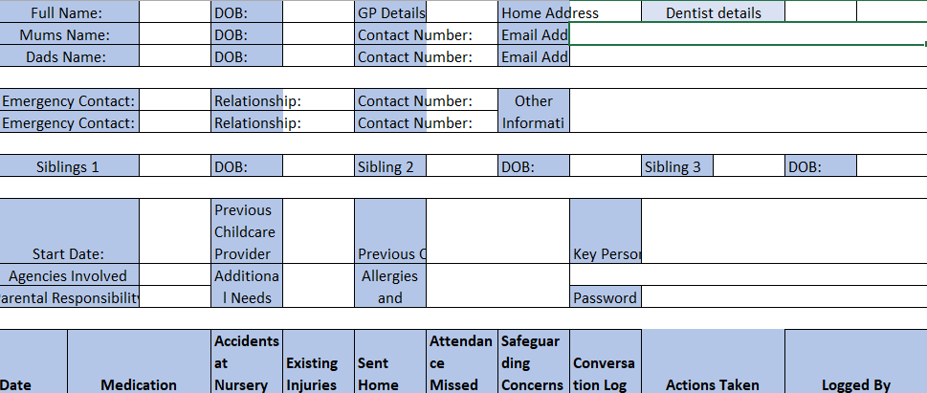
- An overall children’s log is kept tallying a log of any accident’s children have had whilst at nursery and any other information to keep them safe. Each child has their own sheet see below:

If a Child is ‘Not Themselves’
There are many different reasons as to why a child may appear ‘not themselves’. One might presume they are unwell however this is not always the case. If a child appears to be ‘not themselves’, we will follow the following steps:
- Check their nappy.
- Check they are not thirsty.
- Check they are not hungry.
- Check they are not too warm/cold (place two warm fingers 1inch down the top front of the child’s vest – does the chest feel overly warm or cold? Remove a layer or add one if needed).
- Check they do not need a little cuddle/1:1 time.
If the child has still not calmed after this point, staff will inform the room leader and continue with the following steps:
- Take the child’s temperature – high temperature is above 38C/100.4F (This will be recorded on child’s overview log)
- Check the child’s body (We will ensure this is done in a warm environment, only taking off items of clothing needed to see if the child has a rash or any other signs of illness).
If after all these steps the child still appears unwell / ’not themselves’ the manager will call parents to inform them, possibly asking them to collect their child.
Sending Children Home
A child will be sent home if they:
- Have 3 or more loose nappies / stools within the day. (Child must stay home for 48 hours unless in receipt of a doctor’s note to say they are well to attend and have not had diarrhoea).
- Vomit (Child must stay home for 48 hours after their last episode of sickness).
- When a known illness is spreading around the nursery parents will be notified of such illness, and children showing symptoms will be sent home at first sighting.
- Have a temperature – 38C or above
- Have any signs or symptoms of any contagious infections or diseases (Child must stay home until they are no longer contagious).
- Have head lice. (Child is to stay home until the lice and eggs are fully removed and a registered headlice treatment has been used).
- Appear unwell and unable to participate in normal nursery routines.
The Willow Tree reserves the right to extend isolation periods should they deem it necessary for the safety and wellbeing of all individuals connected to The Willow Tree.

Table of Exclusion

Some of our exclusion period will not follow the NHS exclusion period as we feel it is most important to keep the spreading of illnesses/ diseases to a minimum.

These are only a few illnesses, please contact the nursery manger directly to confirm the isolation period of any other illness, infection or disease.

Updated: 14.07.25 Updated by: Christina Smith

