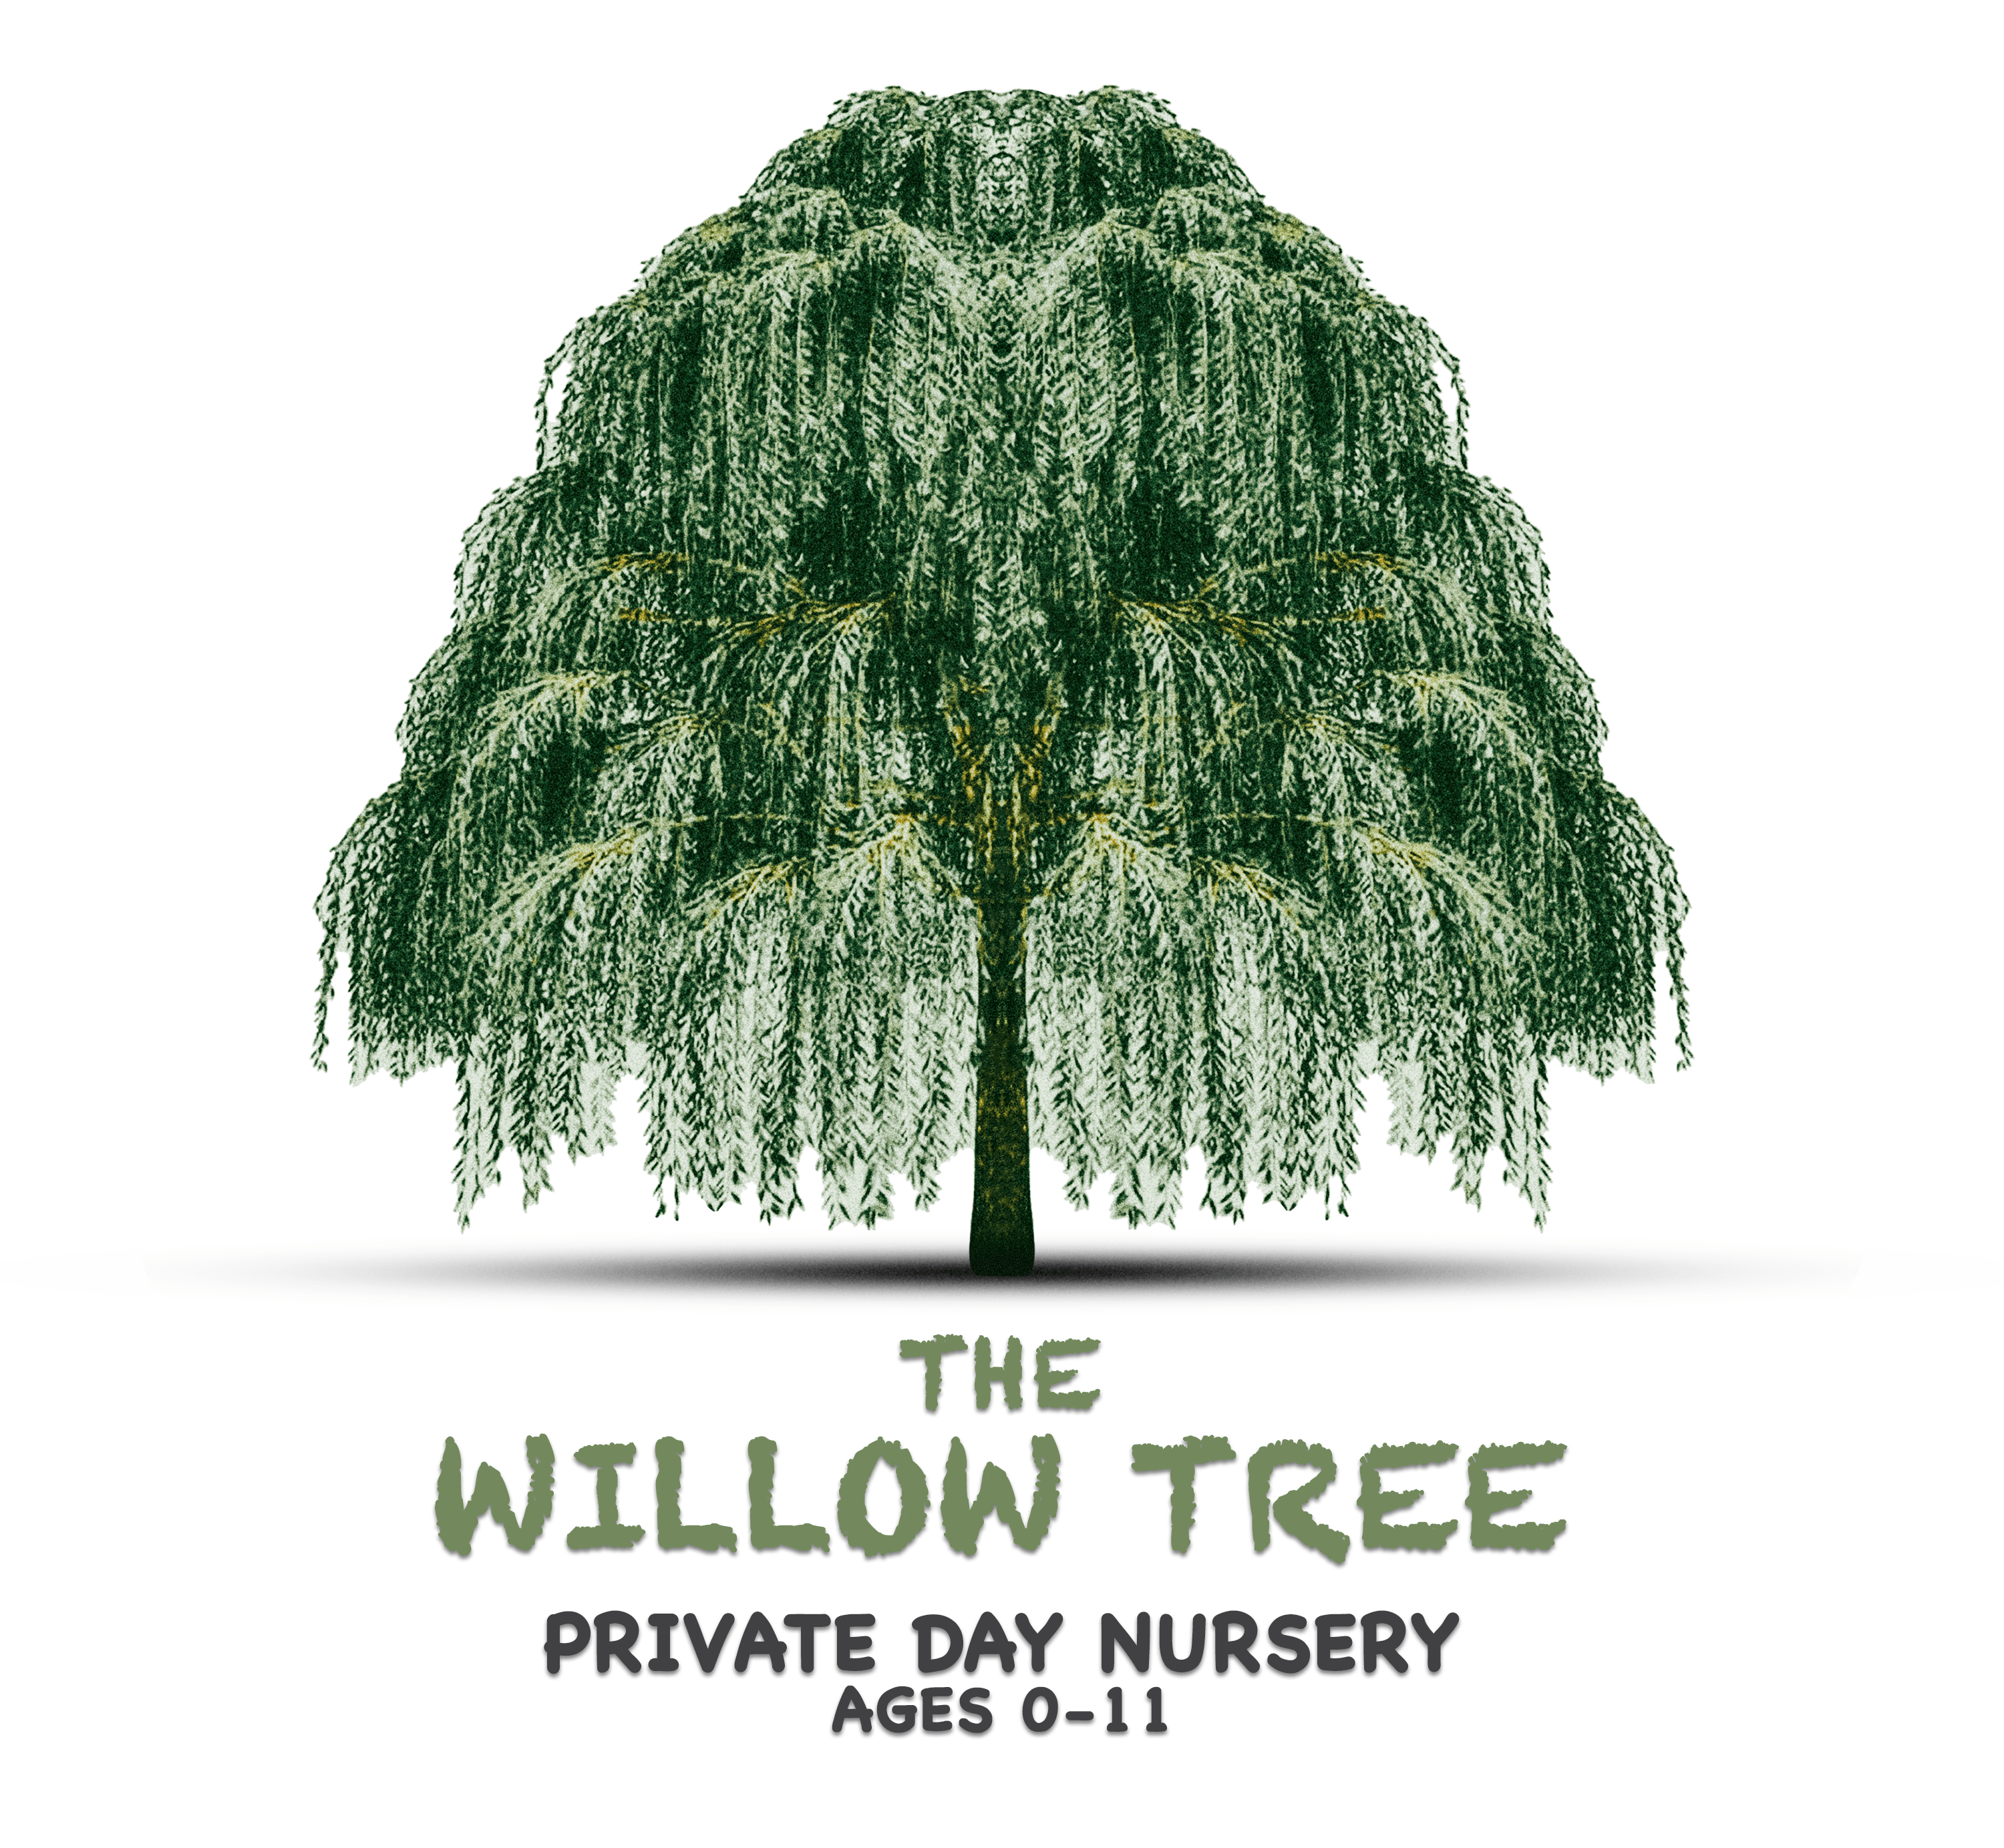
Inclusion and Equality for children
Inclusion and equalities apply to all children and families. These characteristics of identity apply to all people, not just those in minoritised groups, so equality means considering practices in relation to all individuals and groups. Each child and family bring their own identity, values and their unique funds of knowledge that are built over time by taking part in the practices of their community.
No matter how well-meaning, human beings are subject to bias. We are all influenced by ideas from the society we live in which affect our attitudes, beliefs and the way we see others and how they may live their lives. By becoming aware of and challenging any bias or misconceptions, practitioners can work with families in an equal partnership that requires actively listening to the realities, experiences and perspectives of each individual. Creating an ethos of equality involves being aware of how all the practices and environments in an early years setting appear through the lens of each unique child. Managers should ensure that time is given for individuals and staff teams to engage in reflective practice, thinking through issues of inclusion and equalities including their own views and prejudices, and to think through future concerns as they arise including possible conflicts with views that children may encounter at home.
Practitioners should share their willingness to challenge stereotypes and misunderstandings as they arise in play, conversation, books or other contexts – whether about communities, families, languages, gender, special educational needs, disabilities, race, ethnicity, faith or cultures. Settings can value the diversity they hold. Practitioners themselves carry a wealth of knowledge from their own diverse backgrounds that should be celebrated by everyone.

As well as legally protected characteristics, diversity in the setting may include children living in temporary accommodation, refugees and asylum seekers, or children and families that have very different lives or family structures. When families engage with services, it is important to bear in mind that in some families’ protected characteristics or identity markers may overlap. Such combinations are known as intersectionality and may make some children and families more prone to discrimination or privilege than others.
Equity and inclusion require more than treating everyone the same. There is an important difference between equity and equality. Equality aims to provide fairness through treating everyone the same regardless of need, while equity achieves this through treating people differently dependent on need. While it is vital for all children and their families to be included and for difference to be celebrated, it is also important that early years practitioners are aware of the significant physical, emotional and cognitive barriers many children encounter in accessing early education. Low socio-economic status, mistrust of the establishment, lack of access to play experiences, overcrowded living conditions, parental illiteracy, etc. all take a toll. Practitioners should acknowledge the unique situations that families find themselves in, and plan to lessen the effects of these barriers by offering additional opportunities, for example increased time on balance bikes for those children living with no access to outside space.
Practitioners should also be aware that within any organisation there are often “taken for granted” norms which are unspoken and implicit, for example: we wear coats when we go outside, we go outside even if it’s cold or raining, boys and girls play together, it’s great to get messy, food play is good, we eat with our knives and forks. Practitioners need to understand that these are not universal values, and their assumptions may need to change. Sometimes children and their families may require extra support, such as provision of wellies, and sensitive conversations to develop trust.
Talking about race is a first step in countering racism. It is a mistaken assumption that treating all people in the same way and ignoring differences in race is a sufficient response to racism. This approach simply allows the continuation of bias in society which disadvantages people from black and minoritised groups. Instead of a colour-blind approach to race, more proactive anti-racism is needed.
Practitioner training is an important step toward opening dialogue and developing understanding about white privilege, systemic racism, and how racism affects children and families in early years settings. It is also time to challenge the widespread notion that “children do not see race” and are colour blind to difference. When adults are silent about race, children’s racial prejudice and misconceptions can be maintained or reinforced. Encouraging dialogue and conversation about difference can evoke children’s strong sense of fairness and break down false assumptions about everyone being able to succeed on their merits, so that children recognise racist behaviours and develop anti-racist views.
Attitudes toward gender and sexual orientation can limit children and create inequality. During the early years a child’s attitudes and dispositions are continually being shaped. Children are influenced by their environments and the adults around them in ways which often affect children’s own ideas about themselves. In terms of gender and sexual orientation, young children can develop stereotypical ideas about how they should be and who they should become which can limit their potential. It is important that practitioners do not shy away from these conversations and instead challenge the effects of prejudice and discrimination. Children’s resources and books should avoid stereotypical depictions of people based on gender and sexual orientation.
A child may also be part of a family which is LGBTQIA+ (lesbian, gay, bisexual, transgender, queer, intersex, asexual, plus other variations). Early years settings have an opportunity to prevent prejudices from occurring by ensuring that these children and their families feel welcome and valued. In practice, this means that settings should ensure that their environments are welcoming and supportive and actively celebrate the value of diversity. Ultimately, supporting children to embrace and celebrate differences between them, their families and others is a crucial part of doing equalities work and fostering inclusive practice.
Building awareness through first-hand experiences has lasting impact. To promote and value diversity, settings should consider ways of sharing and celebrating children’s lived experiences, being sensitive to the children’s differing circumstances and ensuring that practices are inclusive of all. Parents may be happy to be involved in sharing aspects of their everyday life and community. The UN Convention on the Rights of the Child (UNCRC) is clear that every child has a right to an identity and part of the goals of education is to foster respect for their own and other cultures. While it is important for children to see their own identity reflected in positive ways in the setting, it is equally important for children in settings where there is little diversity to become aware of and to appreciate difference. Visits to places where children can be involved with different cultures and see ways people live and worship can be memorable – children can taste food they are unfamiliar with, and explore artefacts, enjoy clothing, music, dance and languages from different cultures.
Ensure children can see themselves and their families in the environment. Sometimes the environment, both physical and emotional, speaks more loudly than the policies, so it is important to consider how the environment in the setting enables the children and their families to view diversity positively. Children need to see representation of someone who “looks like me”, or “has a family structure like mine”, or “lives somewhere like where I live”, etc. Children absorb and develop ideas of what is possible for themselves from the images and materials around them, such as:
- photographs of the children themselves (where acceptable to the families)
- books, posters, small world play materials that depict and enable acting out a range of identities which actively challenge stereotypical representations and avoid tokenism
- representation of different races, disabilities, ages, types of families including single parents, same-sex parents, grandparents raising children
- role-play clothing that allows children to play in gender-flexible ways and reflects diverse cultures, and household items reflecting various cultures and communities
- areas where children can relax and “just be”, perhaps with pictures and cultural mementos
- practitioners who have some of the same identity features as children and families – race, religion, gender, sexual orientation, language.
Focus on the child at the centre. All children are unique. There is a recognition that every child brings with them a rich heritage when they arrive in an early education setting. Their homes, families, life experiences and beliefs provide the bedrock to their identity. The differences between children offer wonderful opportunities to learn about and celebrate these differences.
Practitioners should also understand that children have their own feelings about their lives and their identity. Their voice should be central, and their funds of knowledge respected. Actively encouraging home stories and valuing family ways of being supports children to develop a positive self-identity.
Practitioners working with children with Special Educational Needs and Disabilities (SEND) acknowledge and value each child, emphasising what they can do through a strengths-based perspective on disability. Offering all children opportunities to explore, discover and take risks in early years provision helps them to become competent, capable and resilient learners. This position also endorses the UNCRC article 28 that every child has a right to an education and article 29 which states that education should develop a child’s personalities, fascinations and abilities to the full.
To dispel issues of “ableism” all children need to grow up to recognise that they are not all the same and different tools or strategies might be needed to make sure they thrive. It is vital that all children are encouraged to notice the many aspects of diversity and difference across society. A positive approach to inclusion in the early years will support all children’s development and learning across their lifetime and will have an impact on society.
The statutory SEND Code of Practice explains the action early years providers should take to meet their duties in identifying and supporting all children with special educational needs (SEN) and disabilities, whether they have an Education, Health and Care (EHC) plan. Identifying and assessing special education needs for young children whose first language is not English requires particular care. Early years practitioners should look carefully at all aspects of a child’s development and learning to establish whether any delay is related to learning English as an additional language or if it arises from SEN or disability. Difficulties related solely to learning English as an additional language are not SEN.
Developing a sense of belonging is an important part of inclusive practice. Feeling different or being marginalised can lead to feelings of social isolation. When children and their families can develop a sense of belonging to a wider community this can reduce these feelings and provide children with a more secure base from which they can learn, develop and flourish. Early years settings are well placed to promote feelings of belonging which are an important part of inclusive practice. Practitioners should actively plan to help children develop positive peer relationships, for example having focused small group times, celebrating difference and diversity in all its guises and creating a culture of “we” rather than “us and them”.

