“We’ve deployed a lot of solutions, but we can’t seem to improve customer satisfaction or retention” 

Why might that be, and how do you ensure that your investments in customer experience pay off?

Having led research and insights across a variety of industries that varied dramatically in customer engagement, I discovered an important set of criteria to help you gauge if what you are deploying will move the needle with your customer base. If your solution (or portfolio of solutions) doesn’t do most or all these things, then the chances will be quite low that you’ll achieve tangible results.
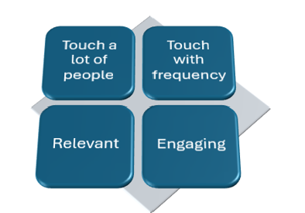
Touch a lot of people
It may sound simple, but you would be surprised how many people don’t estimate the number of customers that experience the issue you are addressing. If the issue you are solving only touches 1% of the customers, mathematically it won’t move the overall retention rate. It doesn’t mean don’t fix the problem; it just means don’t expect to have broad impact.
Touch with some level of frequency
I used to say that if we made a change at Starbucks, most customers would experience the change within a few days, at T-Mobile, within a few hours. But when I worked in the insurance industry, it might take months or years for the customers to experience whatever was deployed. Unless the moment is highly impactful, one touch every 6 months won’t provide enough exposure to shift perceptions.
Relevant/Important
Given that resources are limited, I’ve seen many companies not prioritize the moments that matter most. This requires an understanding of not only how important the moment is, but how well you are performing. Determining the importance of the moment can be challenging. A frequent approach is to use some form of analytical approach (i.e. Baysian or regression) applied to a customer satisfaction study. My preferred approach is to use some form or tradeoff exercise like Max Diff. It is also important to know where you are on the experience curve. In most instances it’s a “soft S” curve, not a line. At the low end, improvements will be highly noticeable, in the middle not so much, at the high end, you can create some “delight” moments.

Engaging
Companies are often solely focused on fixing customer experiences that are low in satisfaction, where in reality, a company might yield more benefit from investments that create relevant engagement with customers. Not to continue to pick on the insurance category, but do you focus on endless cycles to make the bill clearer, or do you create more products and services that focus on prevention and security?

Customer experience can be significantly enhanced in any industry, but there are a lot of factors to consider beyond just improving low satisfaction areas.

whiteboard-consulting.com

