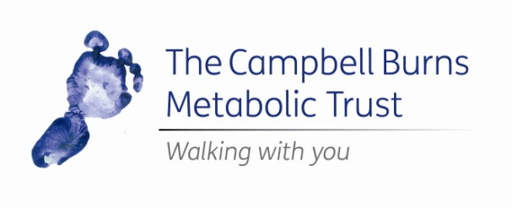

Small Grant Application Form (Food Preparation)

A small grants programme for children aged ten and under diagnosed with a metabolic disorder

1. About the Applicant. (Parents or guardians should fill this in on behalf of the child)
Name of applicant
Date of birth
Address

Home phone number
Mobile number
Email address
Does the applicant have a metabolic disorder?
Is the applicant ten or under at the time of application?

Office use only

Reference

Date of application

Approved Y/N

Amount

2. About Your Application
How much money are you requesting from the Trust? (£50 max)
Please provide details of the food preparation items you would like to buy – type, model, cost etc. Items you might need include (but are not limited to): breadmakers, food processors, blenders, fryers
What difference would this grant make to your family life?

3. Financial – who should the cheque be made payable to if your application is successful?
Name
Address

Relationship to child with metabolic disorder
Home phone number
Mobile number
Email address

4. Section to be completed by Professional Supporter only
This should be completed by a medical professional who is able to comment on the application. The professional, not parent, MUST fully complete this section and should be provided with the guidance notes that accompany the application.
For the purposes of this application, an applicant must have a metabolic disorder and be aged ten or under at the time of the application
Are you satisfied that the child for whom the application is made meets the above criteria?

Professional Supporter’s name
Job title
Work address

Work telephone number
Work mobile number
Work email address
How do you feel the purchase of the food preparation items will benefit the patient and his/her family?

Signature (typed is fine on this form)

5. Signature (to be completed by the parent/guardian on behalf of the applicant)
I confirm that to the best of my knowledge all the information given on this form is correct and accurate. I also confirm that I will spend the grant awarded on the activity described in this application. I also agree to be contacted by The Campbell Burns Metabolic Trust if my application is successful.
Name (block capitals)

Relationship to child with metabolic disorder
Signature (typed is fine on this form)
Date

We may need to contact you to discuss your application. If English is not your first language, please can you provide the name and telephone number of a relative who does speak English, and can discuss your application on your behalf.
Name
Relation to patient
Telephone number

6. Lawful Basis for Processing Your Data
The Campbell Burns Metabolic Trust will only use data for the purposes of processing grant applications and maintaining charity records relating to those applications. Data will not be shared with third parties.
The lawful basis for The Campbell Burns Metabolic Trust to process data is “Legitimate Interest”. Data will be stored in line with the Trust’s Data Retention Policy. Please refer to the Guidance Document, Data Retention Policy and Privacy Policy for more information. These documents can be downloaded from the Trust website.
Further, as the data contained in the application form is Special Category Data, explicit consent must be given before the data can be processed.
Please sign the declaration below if you consent to the charity using the Special Category data you have provided in the way described above.
“I consent to The Campbell Burns Metabolic Trust using the data I have provided in this application in order to process my application.”

Signed (typed is fine)_________________________________________________________

Name (Block Capitals) _____________________________________________

Date ___________________________________________________________

7. Consent for us to store data
The Campbell Burns Metabolic Trust needs to retain data from successful applications for a period of seven years, in order to maintain accurate records. This is in line with our Data Retention Policy.
You have the right to request that your data be removed from our systems and can contact us to request this. However, in order to maintain accurate records about the grants awarded, the Trust requires a record of basic data to be kept for seven years. This basic data is the applicant’s surname, date of birth, type of grant, and date the grant was awarded.
Please sign below if you consent to our charity retaining your data in the way described above.
“I consent to The Campbell Burns Metabolic Trust retaining the data I provided in my application for a period of seven years, in line with their Data Retention Policy.”

Signed (typed is fine)_________________________________________________________

Name (Block Capitals) _____________________________________________

Date ___________________________________________________________

Please send your completed application form to:
The Campbell Burns Metabolic Trust
3 Merganser Way
Coalville
Leicestershire
LE67 4QA
Or arrange for the medical professional counter-signing your form to email it – from their NHS email account – to bekki.burns@campbellstrust.co.uk

