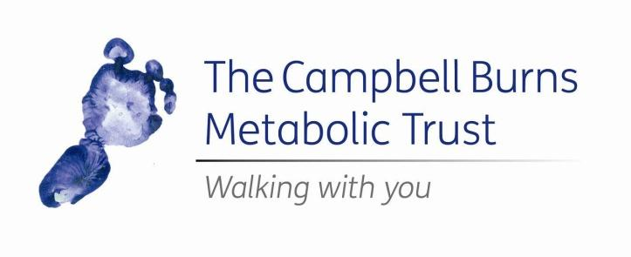

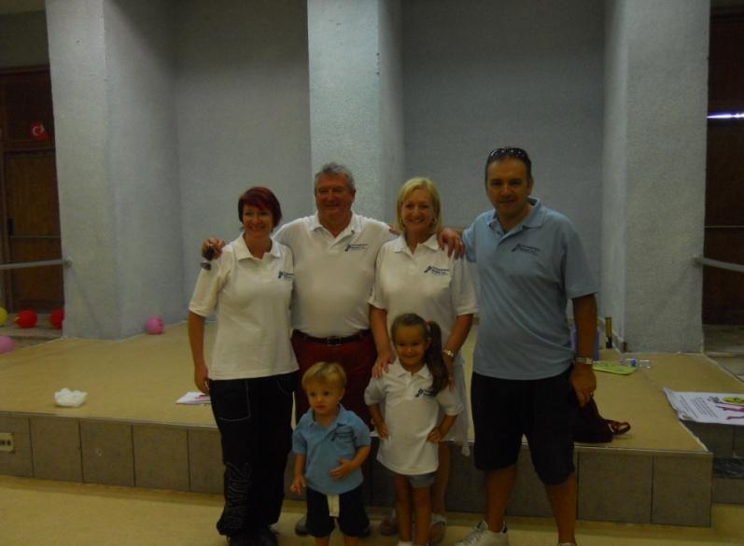
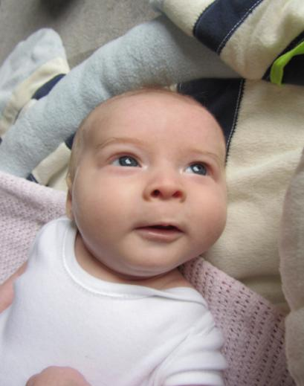

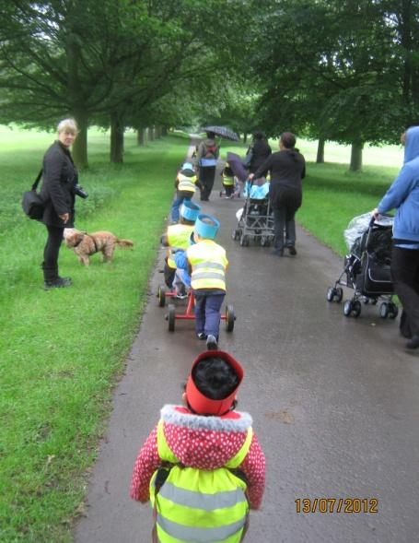
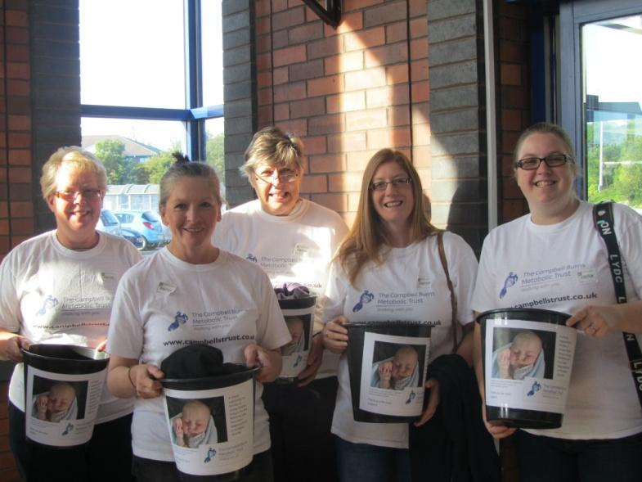

Text CBMT01 £3 to 70070
to make an instant donation

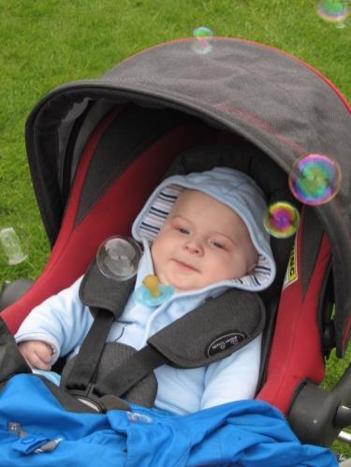
About Campbell

The Campbell Burns Metabolic Trust was established in
May 2012 in the name of Campbell Burns, the baby son of
Mark and Bekki Burns, founders of the Trust.

Born in January 2012, Campbell appeared normal and healthy; however, at the age of nine weeks, he suddenly became ill and tests revealed that he had a life-limiting metabolic disorder called Leigh’s Disease.

Campbell sadly passed away in September 2012 aged just eight months. However, the Trust established in his name continues to grow and will help the families of children aged ten and under, diagnosed with a metabolic disorder.

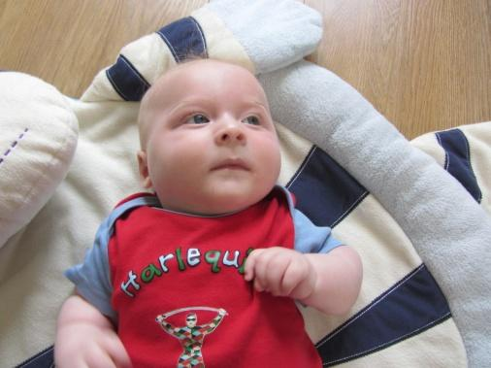
Metabolic Disorders

Metabolism is the process your body uses to get or make energy from the food you eat. Food is made up of proteins, carbohydrates and fats.

Chemicals in your digestive system break the food parts down into sugars and acids, your body's fuel. Your body can use this fuel right away, or it can store the energy in your body tissues, such as your liver, muscles and body fat.

A metabolic disorder occurs when abnormal chemical reactions in your body disrupt this process. When this happens, you might have too much of some substances or too little of other ones that you need to stay healthy. All metabolic disorders have a genetic background, and some of them are expressed as specific genetic diseases.

There are many hundreds of metabolic disorders.

The Campbell Burns Metabolic Trust does not offer medical
advice and its volunteers are not medically trained. If you have
any queries about metabolic disorders, please speak to your
doctor.

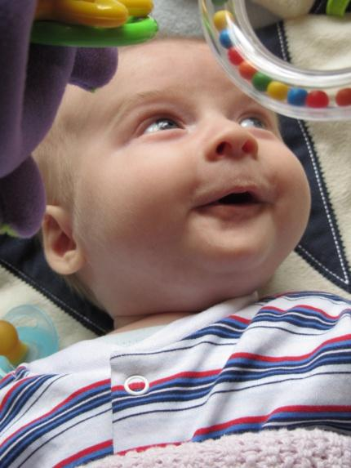
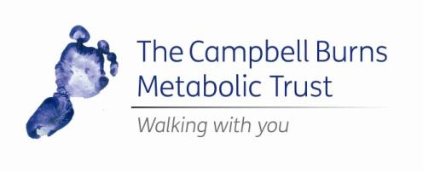

Living with
Metabolic Disorders

Caring for a child with a metabolic disorder can be challenging. There is a wide variety of metabolic disorders and the needs of each child will differ; however, some will need regular medication or a restricted diet, and regular hospital visits.
As there are a limited number of hospitals in England and Wales that can diagnose and treat metabolic disorders, families may have to travel to seek treatment. This can add to the pressure of caring for a child; parents may have to take time off work and meet the travel costs themselves.
Some of the more severe metabolic disorders are life- limiting and some families may be given the terrible news that their child will not survive into adulthood. Time become extremely precious and families may want to go on special days out with their child, in order to make
memories and share new experiences. One or both parents may decide to take a break from work, in order to spend time with their child.
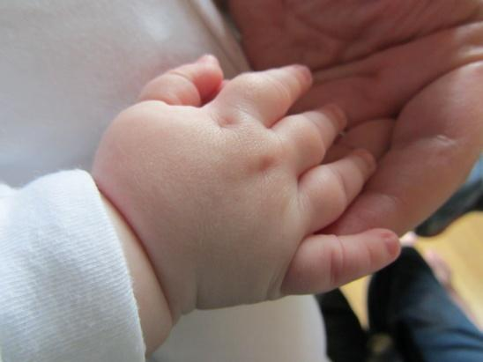

What we do

The Campbell Burns Metabolic Trust helps the families of children, aged ten and under, who have been diagnosed with a metabolic disorder. We provide financial assistance to relieve the worries of every day living.

Families can apply for four kinds of grants from the Trust:

Essentials – up to £100 to cover travel costs when taking a child to their hospital appointment. We can also help cover the cost of some household bills.

Experience – up to £100 towards a fun, family day out with your child.

Food Preparation – up to £100 towards the cost of buying kitchen equipment, such as breadmakers, blenders, food processors etc. Essential items for children on special diets

Emergency – providing emergency funding to families when it is most needed e.g. at point of diagnosis where parents may be unable to work or during an unexpected hospital stay.

Get involved

There are many ways you can support the Trust and help us to continue to help the families who so desperately need us.

To support us financially you can donate by:
• Texting CBMT01 £3 to 70070
• Gathering sponsorship through JustGiving at justgiving.com/thecampbellburnsmetabolictrust
• Sending us a cheque using the enclosed form at
the back of this pack
• Host a fundraising event

If you would like to volunteer your time to help at our organised fundraising events please contact us at fundraising@campbellstrust.co.uk

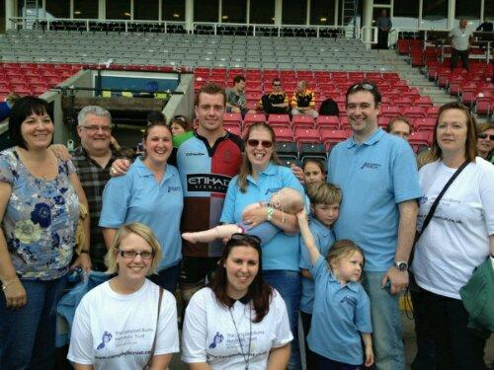

Event ideas

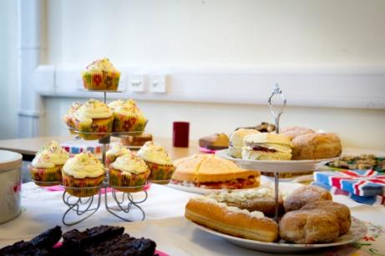
It is only thanks to the support of fantastic fundraisers like you that we’re able to offer much needed support to families affected by metabolic conditions. Here are a few ways you could get involved…

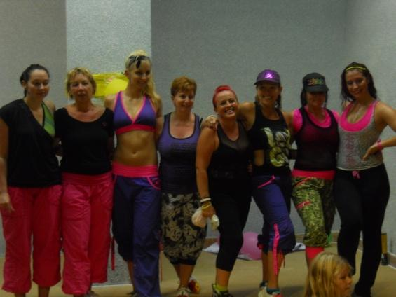
• Arrange a cake bake sale, at home or at work
• Sponsored events such as running a marathon or a sponsored silence
• If you like exercise, organise a sponsored aerobics class or Zumbathon
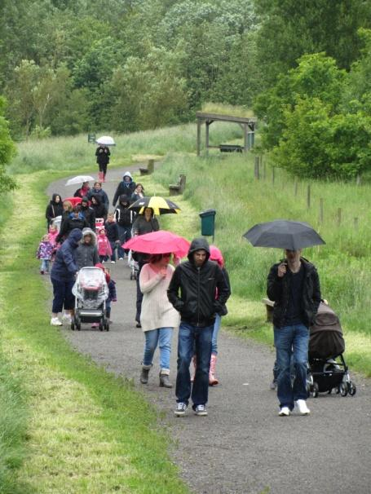
• Have a “dress down” or “themed fancy dress” at work
• Sell home-made goodies at local
craft sales
• Hold a pub quiz
• Contact local supermarkets for permission to bag-pack at the tills
• Wash cars at your local school or college
• No pain, no gain – chest wax!

What you might need

You’ve chosen your event… now you need to tell everyone
about it! Below is a list of resources to help you make the
most of your fundraising.

• Local radio and press – contact local radio stations or your local paper to see if they will cover and promote your event.
• Ask your friends to spread the word – talk to friends at
your child’s playground, at work or social clubs.
• Use your Facebook or Twitter account to create and promote your event to friends and family.
• “Like” the Trust’s Facebook account at facebook.com/TheCampbellBurnsMetabolicTrust and post a message about your fundraising.
• Follow the Trust on Twitter @CampbellsTrust and send us a tweet about what you have planned.

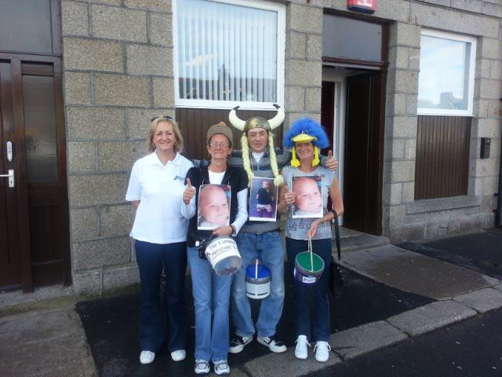

Legal information

Thank you for raising money for The Campbell Burns Metabolic Trust. When you fundraise for us, you are doing so “in aid of” the Trust, rather than “on behalf of” or as a “representative of”. This means that you are fundraising independently of The Campbell Burns Metabolic Trust and the event you arrange is not under the control of the
Trust.

Please make sure that if you produce leaflets and posters, you use the wording “in aid of The Campbell Burns Metabolic Trust, registered charity number 1148667; Scottish Charity Registration SCO44647

If you have any questions about the Trust or would like advice on how best to fundraise for us, please contact us on the below details:

Email: contact@campbellstrust.co.uk
Web: www.campbellstrust.co.uk

Legal information (continued)

If you are organising a large event that will be attended by lots of people, you may need first aid cover. Please check with your local council.

If you hold an event with live music or where you plan on selling alcohol, you may need a license. You will also need a license if you are selling food to the public. Again, please check with your local council.

If you plan on collecting funds in a supermarket or outside a building (a library, a train station, for example), you will need to ask permission from the building manager. A written copy of that permission must be sent to the Trust with your donation.

It is illegal to carry out door-to-door collections or in the street without a license.

If you are holding a raffle and a single prize is worth more than £200, you may need a license. This is also true if you sell raffle tickets before the date the raffle is drawn. Please check with your local council.

Thank you

Finally, please accept a huge thank you for raising money for
The Campbell Burns Metabolic Trust. We simply cannot help the
families of children in the UK living with a metabolic disorder diagnosis without your fantastic support.

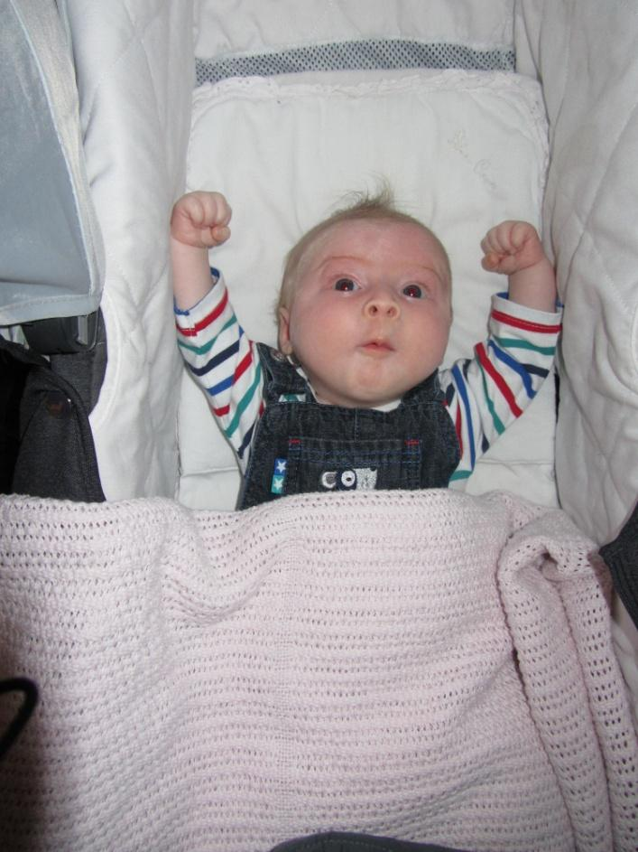

To send us your donation by cheque (please do not send cash), simply complete the form below;

Title: First name: Surname:

Tel No: Email: Address:

Please fill in the relevant section:
1. I enclose a cheque payable to “The Campbell Burns Metabolic Trust” for
£
2. I have deposited a donation into your account to the value of £
The reference I used against this deposit is

Signature: Printed name:
Please post cheques to: The Campbell Burns Metabolic Trust, 3 Merganser Way, Coalville, Leicestershire LE67 4QA
Please pay your donations into our bank account:
Bank: Lloyds TSB Account Name: The Campbell Burns Metabolic Trust
Account Number: 10883768 Sort: 771523

How did you raise your donation?

Please sign and date below if you are a UK taxpayer and happy for us to claim Gift
Aid on your donation.
Signature: Date:
To benefit from Gift Aid you must pay income tax to an amount at least equal to the amount The Campbell Burns Metabolic Trust claims on your donations – currently 25p for every £1 you give.

12

