Steve Rondinaro – a career communicator
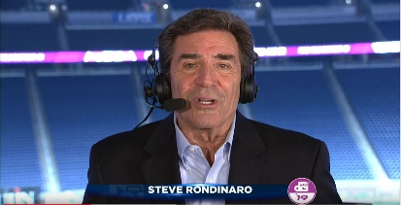
Emmy & Telly Award winning video storyteller
Journalist, PR Pro, Marketer, Manager, Writer & Teacher

CURRENTLY: Part-time Marketing Manager @ French Lick Resort, French Lick, IN (since May 2011) 2021 Gold Telly Award winner now working part-time, remotely. Created and managed
the video operation, specializing in online video and broadcast media. Write, narrate, and produce video pieces and radio spots.
Part-time Marketing Content Creator @ Drum Corps International.
Freelance On-camera & Voice Talent through RondoWorks.
PBS/ESPN2/National Cinemedia host of Drum Corps International World Championships (since 1979) and DCI Tour Premiere shows.

BUSINESS OWNERSHIP/MANAGEMENT:
2003-2007 - Owner/General Manager/News Director of WLNN-TV Boone, NC
1996-2003 - Owner/General Manager/News Director of RBI radio group in Boone, NC.
Created and ran news operations, developed websites, and managed marketing and promotion.

TV NEWS:
2007 – 2010 Managing Editor, Acting News Director, Main Anchor WWAY-TV, Wilmington, NC Helped guide the operation through difficult times.
Four-time Emmy award winning main anchor/reporter WESH & WFTV, Orlando, FL 1986-1995, 2001-2002 and WSVN & WTVJ, Miami, FL 1979-1986. Specialized in space, environmental, tourism, and political reporting. Reported from Beirut, Lebanon, Central America, and Europe.
Reporter/Weatherman WROC-TV, Rochester, NY, 1976-1979; WENY-TV, Elmira, NY 1973-1975.

PAST CORPORATE/DOCUMENTARY: Anchor/reporter National Auto Dealers Association convention and issue coverage… Web host IBM Institute for Electronic Government, Washington D.C… Host/co-producer Emmy winning doc “Orlando ER”… Host/co-producer Associated Press Best Documentary Award “Our Boys in Beirut.”

ACADEMIC: Master’s Degree in Communications from Clarion University of PA (2020)… Public Relations certificate Clarion (2019)… BA in Communications with Teaching Certificate SUNY Geneseo (1976)… Former adjunct professor at Florida International University, Miami; SUNY Brockport; Lees-McRae College, Banner Elk, NC.

MEMBERSHIPS: Public Relations Society of America (PRSA); Drum Corps International Hall of Fame (Chairman); Past President French Lick West Baden Museum.

CONTACT: 812-788-0984 * steverondinaro@yahoo.com * www.rondoworks.com

