Steve Rondinaro – a career communicator
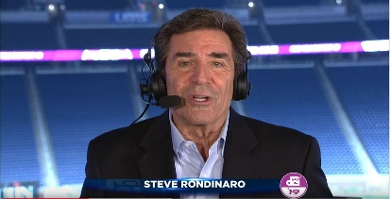
Emmy & Telly Award winning video storyteller
Voice-over and on-camera talent

CURRENTLY: Freelance On-camera & Voice Talent through RondoWorks.
Part-time remote Marketing Content Creator @ Drum Corps International.
PBS/ESPN2/National Cinemedia host of Drum Corps International World Championships (since 1979) and DCI Tour Premiere shows.
Faculty - Coastal Carolina University Communications Dept.

MOST RECENTLY: Marketing Manager @ French Lick Resort, French Lick, IN
May 2011 – May 2022. Created and managed Telly Award winning video operation, specializing in online video and broadcast media. Wrote, narrated, hosted and produced video pieces and radio spots. Hosted live resort events, did seasonal media swings, and served as resort PR face and voice..

TV NEWS: Managing Editor, Acting News Director, Main Anchor WWAY-TV, Wilmington, NC 2007-2010. Four-time Emmy award winning main anchor/reporter WESH & WFTV, Orlando, FL 1986-1995, 2001-2002 and WSVN & WTVJ, Miami, FL 1979-1986. Specialized in space, environmental, tourism, and political reporting. Reported from Beirut, Lebanon, Central America, and Europe. Reporter/Weatherman WROC-TV, Rochester, NY, 1976-1979;

BUSINESS OWNERSHIP/MANAGEMENT:
2003-2007 - Owner/General Manager/News Director of WLNN-TV Boone, NC
1996-2003 - Owner/General Manager/News Director of RBI radio group in Boone, NC.
Created and ran news operations, developed websites, and managed marketing and promotion.

ACADEMIC: Master’s Degree in Communications from Clarion University of PA (2020)… Public Relations certificate Clarion (2019)… BA in Communications with Teaching Certificate SUNY Geneseo (1976)… Former adjunct professor at Florida International University, Miami; SUNY Brockport; Lees-McRae College, Banner Elk, NC… Substitute teacher Horry County Schools (2022)

CORPORATE/DOCUMENTARY: Anchor/reporter National Auto Dealers Association convention and issue coverage… Web host IBM Institute for Electronic Government… Host/co-producer Emmy winning doc “Orlando ER”… Host/co-producer AP Best Doc “Our Boys in Beirut.”

FILM CREDIT: Making Mr. Right (1987) On-camera speaking role.

THEATRE: Numerous roles with Lees-McRae Summer Theatre, Banner Elk, NC including John Hancock in “1776”. (1997-2002)

MEMBERSHIPS: DCI Hall of Fame (Chairman); Public Relations Society of America (PRSA)
CONTACT: 812-788-0984 * steverondinaro@yahoo.com * www.rondoworks.com

