**¡BIENVENIDOS/WELCOME!**

**May 9 2021**

**10:30 AM**

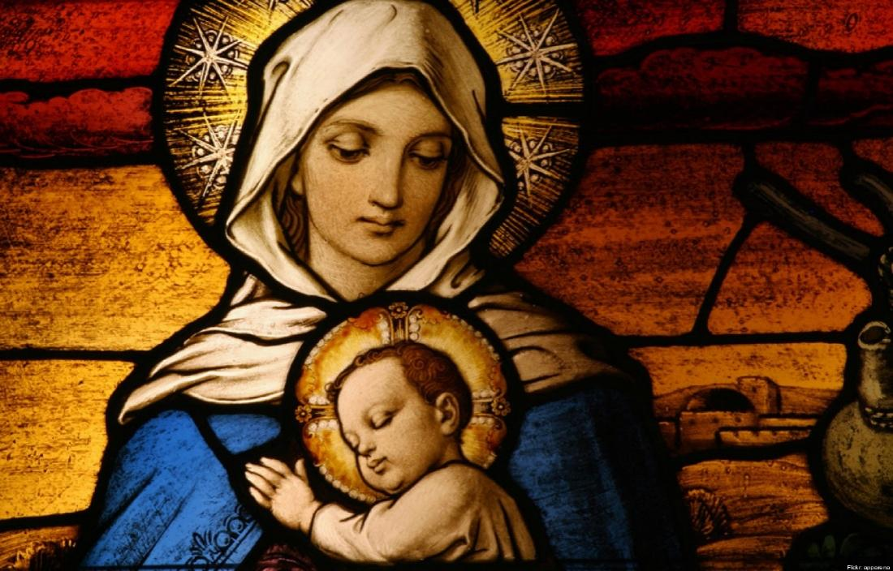

***Casa Emanuel United Methodist Church***

***9998 Ferguson Road***

***Dallas, TX 75228***

***(214)321-6483 Church***

***Rev. Paul Barton, Pastor***

***(512) 922-8815 Pastor’s Cell***

[***www.casaemanueldallas.org***](http://www.casaemanueldallas.org)

**PRELUDE:** "Blessed Jesus, We Are Here"

**WELCOME:** Rev. Paul Barton

**\*CALL TO WORSHIP**:

Welcome to the community of faith, the family of God!

***We come as members of families, large and small in number, seeking God’s love.***

God’s love is here for you.

***Help us to understand how we are connected to God.***

We abide in Christ Jesus, in love and compassion.

***May our spirits be renewed and our connection to God be strengthened through our worship today. AMEN.***

**OPENING PRAYER:**

On this day, we honor women.

***We honor all who give life, all who sustain life,***

all who nurture and care, all who mend and strengthen.

***We remember and we rejoice in their presence in our lives.***

At the same time, we grieve.

***We grieve with those who remember their loss. For mothers no longer present among us in bodily form. For women who wished to be biological mothers, but whose lives or bodies took a different path.***

We mourn also the pain of broken relationships,

***the sorrow of those who could not be what they wanted to be, those who could not be what we needed, those who could not be what the world needed, we remember and we grieve. Where forgiveness is called for, we work to forgive.***

We lift up to you all women.

***We lift up all women who give of themselves in the raising of a child, regardless of whether that child is theirs by blood. We are grateful for the presence of so many who give so much.***

This day we honor women,

***whose gifts and spirits have blessed our lives. We lift up our gratitude. We lift up our prayers for forgiveness. We lift up our joy and our sorrow. And we release it all into God’s loving presence. Amen.***

**\*OPENING HYMN UMH 384:** "Love Divine, All Loves Excelling"

1. Love divine, all loves excelling,

joy of heaven, to earth come down;

fix in us thy humble dwelling;

all thy faithful mercies crown!

Jesus, thou art all compassion,

pure, unbounded love thou art;

visit us with thy salvation;

enter every trembling heart.

2. Breathe, O breathe thy loving Spirit

into every troubled breast!

Let us all in thee inherit;

let us find that second rest.

Take away our bent to sinning;

Alpha and Omega be;

end of faith, as its beginning,

set our hearts at liberty.

3. Come, Almighty to deliver,

let us all thy life receive;

suddenly return and never,

nevermore thy temples leave.

Thee we would be always blessing,

serve thee as thy hosts above,

pray and praise thee without ceasing,

glory in thy perfect love.

4. Finish, then, thy new creation;

pure and spotless let us be.

Let us see thy great salvation

perfectly restored in thee;

changed from glory into glory,

till in heaven we take our place,

till we cast our crowns before thee,

lost in wonder, love, and praise.

**NEW TESTAMENT READING:** 1 John 5:1-6Whoever believes that Jesus is the Messiah is a child of God; and whoever loves a father loves his child also. 2 This is how we know that we love God's children: it is by loving God and obeying his commands. 3 For our love for God means that we obey his commands. And his commands are not too hard for us, 4 because every child of God is able to defeat the world. And we win the victory over the world by means of our faith. 5 Who can defeat the world? Only the person who believes that Jesus is the Son of God. 6 Jesus Christ is the one who came with the water of his baptism and the blood of his death. He came not only with the water, but with both the water and the blood. And the Spirit himself testifies that this is true, because the Spirit is truth.

**CHILDREN’S SERMON:** Karen Eaker

**HYMN TFWS 2050:** "Mothering God"

1 Mothering God, you gave me birth

in the bright morning of this world.

Creator, source of every breath,

you are my rain, my wind, my sun.

2 Mothering Christ, you took my form,

offering me your food of light,

grain...of life, and grape of love,

your very body for my peace.

3 Mothering Spirit, nurturing one,

in arms of patience hold me close,

so that in faith I root and grow

until I flower, until I know.

**THE OFFERING:**

**OFFERTORY ANTHEM:** "Love One Another"

**BLESSING OF THE OFFERINGS:** Rev. Paul Barton

**A TESTIMONY ABOUT MOTHERHOOD**

**PASTORAL PRAYER:** Rev. Paul Barton

(Response: (L) God in your Mercy, (P) ***Hear our prayers***)

**\*THE LORD’S PRAYER:**

Our father, who art in heaven, hallowed by thy name.

Thy kingdom come; thy will be done in earth as it is in heaven.

Give us this day our daily bread. And forgive us our trespasses, as we forgive those who have trespassed against us. And lead us not into temptation, but deliver us from evil. For thine is the kingdom, the power, and the glory, forever and ever. Amen

**\*GOSPEL READING:** John 15:9-17

9 I love you just as the Father loves me; remain in my love. 10 If you obey my commands, you will remain in my love, just as I have obeyed my Father's commands and remain in his love. 11 “I have told you this so that my joy may be in you and that your joy may be complete. 12 My commandment is this: love one another, just as I love you. 13 The greatest love you can have for your friends is to give your life for them. 14 And you are my friends if you do what I command you. 15 I do not call you servants any longer, because servants do not know what their master is doing. Instead, I call you friends, because I have told you everything I heard from my Father. 16 You did not choose me; I chose you and appointed you to go and bear much fruit, the kind of fruit that endures. And so the Father will give you whatever you ask of him in my name. 17 This, then, is what I command you: love one another.

**INTERLUDE:** "O, How He Loves You and Me"

**SERMON:**  Rev. Paul Barton

**\*CLOSING HYMN TFWS 2223/MVPC 267:**

**“**We are one in the Spirit/Somos uno en Espíritu”

We are one in the Spirit, we are one in the Lord;

We are one int he Spirit, we are one in the Lord;

And we pray that all unity will one day be restored.

(Refrain:) And they'll know we are Christians by our love, by our love,

yes, they'll know we are Christians by our love.

We will walk with each other, we will walk hand in hand;

We will walk with each other, we will walk hand in hand;

And together we'll spread the news that God is in our land. (Refrain)

Trabajemos unidos lado a lado en amor,

Trabajemos unidos lado a lado en amor,

como guardas celosos de la gente en su honor. (Estribillo)

(Estribillo:) y que somos cristianos lo sabrán, lo sabrán,

porque unidos estamos en amor.

Gloria al Padre que es fuente de toda bendición

gloria A Cristo su hijo que nos da la salvación

y al Espíritu Santo que nos une en communion. (Estribillo:)

**\*BLESSING:** Rev. Paul Barton

**POSTLUDE:** “We are one in the Spirit "

***WORSHIP PARTICIPANTS:***

***Pastor: Rev. Paul Barton***

***Music director: Ryan Lake***

***Liturgist: Jacqueline Greiner***

***Reader: Anice Greiner***

***Children’s Sermon: Karen Eaker***

***At Casa Emanu-El, we seek to follow Christ, grow in faith, and connect all through justice, service, and grace!***

***¡En Casa Emanu-El, buscamos seguir a Cristo, crecer en fe, y conectar a todos a traves de la justicia, el servicio y la gracia!***

***www.casaemanueldallas.org***

***Like us on Facebook!***

[***https://facebook.com/casaemanueldallas/***](https://facebook.com/casaemanueldallas/)

