¡BIENVENIDOS/WELCOME!
September 20, 2020
11:00 AM

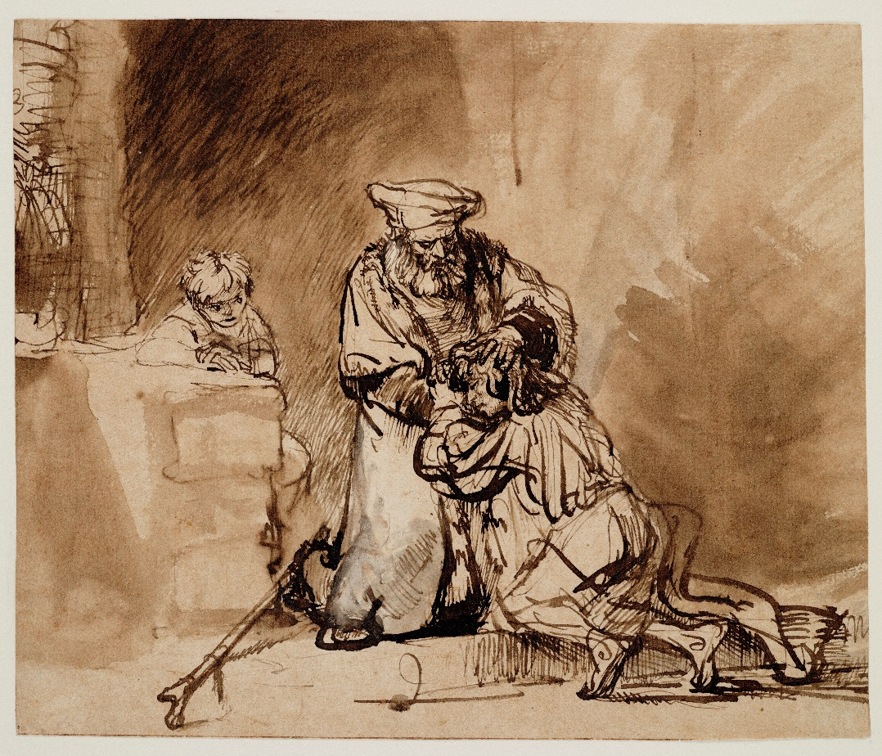

Casa Emanuel United Methodist Church
Dallas, TX 75228
(214)321-6483 Church
(214) 543-9457 Pastor’s Cell

PRELUDE:

WORDS OF ASSURANCE:
Come, let us celebrate the forgiving, reconciling love of God.
For once we were lost and felt so far away; now we have been found and welcomed home.
Know that God’s love is lavished upon you forever.
We rejoice at the news of forgiveness and hope!
Come, let us celebrate and praise the God of Love.
AMEN!

OPENING PRAYER:
How incredible is your love, O God! We have been made new in your love and reconciled to you and to each other in peace and joy. Be with us this day as we hear your words of comfort and hope. Guide our lives that we may serve you more fully all of our days. AMEN.

OPENING HYMN 89: "Joyful, Joyful, We Adore Thee"
1. Joyful, joyful, we adore thee, God of glory, Lord of love;
hearts unfold like flowers before thee, opening to the sun above.
Melt the clouds of sin and sadness; drive the dark of doubt away.
Giver of immortal gladness, fill us with the light of day!

2. All thy works with joy surround thee, earth and heaven reflect thy rays,
stars and angels sing around thee, center of unbroken praise.
Field and forest, vale and mountain, flowery meadow, flashing sea, chanting bird and flowing fountain, call us to rejoice in thee.

3. Thou art giving and forgiving, ever blessing, ever blest,
well-spring of the joy of living, ocean depth of happy rest!
Thou our Father, Christ our brother, all who live in love are thine;
teach us how to love each other, lift us to the joy divine.

4. Mortals, join the mighty chorus which the morning stars began;
love divine is reigning o'er us, binding all within its span.
Ever singing, march we onward, victors in the midst of strife;
joyful music leads us sunward, in the triumph song of life.

OLD TESTAMENT UMH 766: Psalm 32
(Response:) Be glad in the Lord and rejoice; shout for you, you upright in heart.

Blessed are those whose transgression is forgiven; whose sin
is covered.
Blessed are those whom the Lord does not hold guilty, and in whose spirit, there is no deceit.
When I did not declare my sin, my body wasted away through my groaning all day long.
For day and night your hand was heavy upon me: my strength was dried up as by the heat of summer.
I acknowledged my sin to you, and I did not hide my iniquity;
I said, "I will confess my transgressions to the Lord"; then you forgave the guilt of my sin.

(Response)
Therefore, let those who are godly offer prayer to you;
at a time of distress, the rush of great waters shall not
reach them.
You are a hiding place for me, you preserve me from trouble; you encompass me with deliverance.
I will instruct you and teach you the way you should go; I will counsel you with my eye upon you.
Do not be like an unruly horse or a mule, without understanding, whose temper must be curbed with bit and bridle.
Many are the pangs of the wicked; but steadfast love surrounds those who trust in the Lord.
L: Be glad in the Lord, an rejoice, O righteous;
shout for you, all you upright in heart!
(Response)

CHILDREN'S SERMON: Karen Eaker
NEW TESTAMENT: 2 Cor. 5:16-21
16 So then, from this point on we won’t recognize people by human standards. Even though we used to know Christ by human standards, that isn’t how we know him now. 17 So then, if anyone is in Christ, that person is part of the new creation. The old things have gone away, and look, new things have arrived! 18 All of these new things are from God, who reconciled us to himself through Christ and who gave us the ministry of reconciliation. 19 In other words, God was reconciling the world to himself through Christ, by not counting people’s sins against them. He has trusted us with this message of reconciliation. 20 So we are ambassadors who represent Christ. God is negotiating with you through us. We beg you as Christ’s representatives, “Be reconciled to God!” 21 God caused the one who didn’t know sin to be sin for our sake so that through him we could become the righteousness of God.

*HYMN 390: "Forgive Our Sins as We Forgive"
1. “Forgive our sins as we forgive,” you taught us, Lord, to pray,
but you alone can grant us grace to live the words we say.

2. How can your pardon reach and bless the unforgiving heart
that broods on wrongs and will not let old bitterness depart?

3. In blazing light Your cross reveals the truth we dimly knew:
what trivial debts are owed to us, how great our debt to you!

4. Lord, cleanse the depths within our souls, and bid resentment cease; then, bound to all in bonds of love, our lives will spread your peace.

PRAYER OF CONFESSION:
Lord, we listen to this familiar story about the “Prodigal Son, but do we really understand what it is about? Do we realize that we, too, been stubborn and selfish, angry and unforgiving, sorrowful and caught between two conflicting factions? In our own unique way, we are no different from these characters. Yet, in God’s infinite love, we also are forgiven and healed. We are called to turn our lives back to God’s care, which is always extended to us. Forgive us and heal us, gracious God. Open our hearts and our spirits to truly receive the blessings of your healing love. For it is in the name of your Son, Jesus Christ, that we pray. AMEN.

WORDS OF ASSURANCE:
Once we were “dead” to all the things that God hoped for us; but in God’s love we are again brought to life. Rejoice, dear ones, you are forgiven!

ANTHEM: by Ryan Lake "Give Us Grace"

BLESSING OF THE OFFERINGS:
OFFERTORY: “Lord, Be Glorified”
RESPONSE UMH 95: “Praise God from Whom All Blessings Flow”
Praise God, from whom all blessings flow;
Praise Him, all creatures here below;
Praise Him above, ye heav'nly host;
Praise Father, Son, and Holy Ghost. Amen.

JOYS AND CONCERNS:
*THE LORD’S PRAYER:

GOSPEL READING: Luke 15:11-24
11 Jesus said, “A certain man had two sons. 12 The younger son said to his father, ‘Father, give me my share of the inheritance.’ Then the father divided his estate between them. 13 Soon afterward, the younger son gathered everything together and took a trip to a land far away. There, he wasted his wealth through extravagant living. 14 “When he had used up his resources, a severe food shortage arose in that country and he began to be in need. 15 He hired himself out to one of the citizens of that country, who sent him into his fields to feed pigs. 16 He longed to eat his fill from what the pigs ate, but no one gave him anything. 17 When he came to his senses, he said, ‘How many of my father’s hired hands have more than enough food, but I’m starving to death! 18 I will get up and go to my father, and say to him, “Father, I have sinned against heaven and against you. 19 I no longer deserve to be called your son. Take me on as one of your hired hands.”’ 20 So he got up and went to his father. “While he was still a long way off, his father saw him and was moved with compassion. His father ran to him, hugged him, and kissed him. 21 Then his son said, ‘Father, I have sinned against heaven and against you. I no longer deserve to be called your son.’ 22 But the father said to his servants, ‘Quickly, bring out the best robe and put it on him! Put a ring on his finger and sandals on his feet! 23 Fetch the fattened calf and slaughter it. We must celebrate with feasting 24 because this son of mine was dead and has come back to life! He was lost and is found!’ And they began to celebrate.

SERMON: “A Story of Love and Redemption”
CLOSING HYMN UMH 378: (verses 1-3; 6) "Amazing Grace"
1. Amazing grace! How sweet the sound
That saved a wretch like me.
I once was lost, but now am found,
Was blind, but now I see.

2. 'Twas grace that taught my heart to fear,
And grace my fears relieved.
How precious did that grace appear
The hour I first believed.

3.Through many dangers, toils and snares
I have already come;
'Tis grace hath brought me safe thus far
And grace will lead me home

6. When we've been there ten thousand years
Bright shining as the sun,
We've no less days to sing God's praise
Than when we've first begun.

BENEDICTION:
WORSHIP PARTICIPANTS:
Pastor: Rev. Dr Javier Escalera
Music Director: Ryan Lake
Children’s Sermon/Camera: Karen Eaker

At Casa Emanu-El, we seek to follow Christ, grow in faith, and connect all through justice, service, and grace!

¡En Casa Emanu-El, buscamos seguir a Cristo, crecer en fe, y conectar a todos a traves de la justicia, el servicio y la gracia!

Like us on Facebook!
https://facebook.com/casaemanueldallas/

