**¡BIENVENIDOS/WELCOME!**

**January 10, 2021**

**10:30 AM**

**First Sunday after Epiphany**

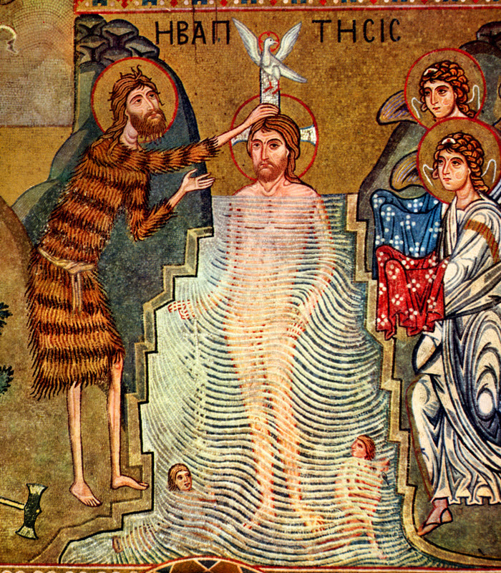

***Casa Emanuel United Methodist Church***

***9998 Ferguson Road***

***Dallas, TX 75228***

***(214)321-6483 Church***

***(512) 922-8815 Pastor’s Cell***

***www.casaemanueldallas.org***

**PRELUDE:** “Morning Has Broken”

**CALL TO WORSHIP**:

From the waters of Creation, the earth sprang forth.

***From the waters of a womb, God’s blessed Son was given to us.***

From the waters of a river, people were baptized and marked as God’s Children

***Praise be to God, whose loving gifts and presence have called us together. AMEN.***

**OPENING PRAYER:**

**\*OPENING HYMN UMH 188:** "Christ Is the World's Light"

1 Christ is the world’s light, Christ and none other;

Born in our darkness, he became our brother.

If we have seen him we have seen the Father:

Glory to God on high!

2 Christ is the world’s peace, Christ and none other;

No one can serve him and despise another.

Who else unites us one in God the Father?

Glory to God on high!

3 Christ is the world’s life, Christ and none other;

Sold once for silver, murdered here, our brother.

He who redeems us reigns with God the Father.

Glory to God on high!

4 Give God the glory, God and none other;

Give God the glory, Spirit, Son, and Father.

Give God the glory, God with us our brother;

Glory to God on high!

**OLD TESTAMENT READING:** Genesis 1:1-5

In the beginning when God created the heavens and the earth, the earth was a formless void and darkness covered the face of the deep, while a wind from God swept over the face of the waters. Then God said, “Let there be light”; and there was light. And God saw that the light was good; and God separated the light from the darkness. God called the light Day, and the darkness he called Night. And there was evening and there was morning, the first day.

**CHILDREN’S SERMON:** Karen Eaker

**NEW TESTAMENT READING:** Acts 19:1-7

While Apollos was in Corinth, Paul passed through the interior regions and came to Ephesus, where he found some disciples. He said to them, “Did you receive the Holy Spirit when you became believers?” They replied, “No, we have not even heard that there is a Holy Spirit.” Then he said, “Into what then were you baptized?” They answered, “Into John’s baptism.” Paul said, “John baptized with the baptism of repentance, telling the people to believe in the one who was to come after him, that is, in Jesus.” On hearing this, they were baptized in the name of the Lord Jesus. When Paul had laid his hands on them, the Holy Spirit came upon them, and they spoke in tongues and prophesied— altogether there were about twelve of them.

**HYMN UMH 420: “**Breathe on Me Breath of God"

1 Breathe on me, Breath of God,

Fill me with life anew,

That I may love what Thou dost love,

And do what Thou wouldst do.

2 Breathe on me, Breath of God,

Until my heart is pure,

Until with Thee I will one will,

To do and to endure.

3 Breathe on me, Breath of God,

Till I am wholly Thine,

Until this earthly part of me

Glows with Thy fire divine.

4 Breathe on me, Breath of God,

So shall I never die,

But live with Thee the perfect life

Of Thine eternity.

**OFFERTORY ANTHEM:** "Down to the River to Pray"

**BLESSING OF THE OFFERINGS:**

**\*RESPONSE UMH 95:**“Praise God from Whom All Blessings Flow”

Praise, God from whom all blessings flow,

Praise Him all creatures here below;

Praise Him above, ye heavenly host;

Praise Father, Son, and Holy Ghost.

**PASTORAL PRAYER:**

**\*THE LORD’S PRAYER:**

**\*GOSPEL READING:** Mark 4:1-11

4 So John appeared in the desert, baptizing and preaching.[a] “Turn away from your sins and be baptized,” he told the people, “and God will forgive your sins.” 5 Many people from the province of Judea and the city of Jerusalem went out to hear John. They confessed their sins, and he baptized them in the Jordan River. 6 John wore clothes made of camel's hair, with a leather belt around his waist, and his food was locusts and wild honey. 7 He announced to the people, “The man who will come after me is much greater than I am. I am not good enough even to bend down and untie his sandals. 8 I baptize you with water, but he will baptize you with the Holy Spirit.” 9 Not long afterward Jesus came from Nazareth in the province of Galilee, and was baptized by John in the Jordan. 10 As soon as Jesus came up out of the water, he saw heaven opening and the Spirit coming down on him like a dove. 11 And a voice came from heaven, “You are my own dear Son. I am pleased with you.”

**SERMON:**  Rev. Paul Barton

**\*CLOSING HYMN UMH 347:** "Spirit Song"

1 Oh let the Son of God enfold you

With His Spirit and His love

Let Him fill your heart and satisfy your soul

Oh let Him have those things that hold you

And His Spirit like a dove

Will descend upon your life and make you whole

(Chorus) Jesus oh Jesus

Come and fill Your lambs

Jesus oh Jesus

Come and fill Your lambs

2 Oh come and sing the song with gladness

As your hearts are filled with joy

Lift your hands in sweet surrender to His name

Oh give Him all your tears and sadness

Give Him all your years of pain

And you'll enter into life in Jesus' name

(Chorus)

**\*BENEDICTION:**

**POSTLUDE:** "When Jesus Came to Jordan"

***WORSHIP PARTICIPANTS:***

***Pastor: Rev. Paul Barton***

***Music director: Ryan Lake***

***Reader: Pat Hatcher***

***Children’s Sermon/Karen Eaker***

***At Casa Emanu-El, we seek to follow Christ, grow in faith, and connect all through justice, service, and grace!***

***¡En Casa Emanu-El, buscamos seguir a Cristo, crecer en fe, y conectar a todos a traves de la justicia, el servicio y la gracia!***

***www.casaemanueldallas.org***

***Like us on Facebook!***

[***https://facebook.com/casaemanueldallas/***](https://facebook.com/casaemanueldallas/)