**¡BIENVENIDOS/WELCOME!**

**August 2, 2020**

**11:00 AM**

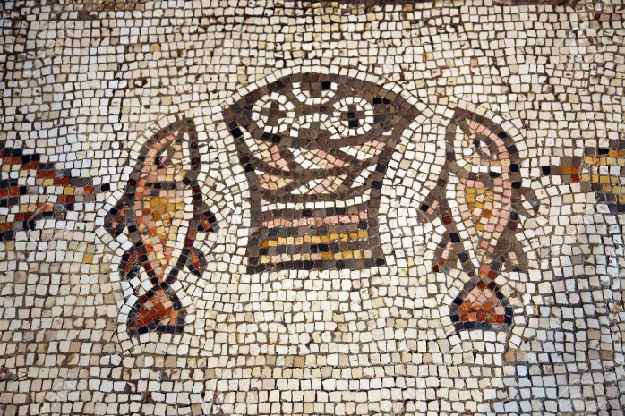

***Casa Emanuel United Methodist Church***

***9998 Ferguson Road***

***Dallas, TX 75228***

***(214)321-6483 Church***

***(214) 543-9457 Pastor’s Cell***

**PRELUDE:**

**CALL TO WORSHIP**

Even in the middle of summer, our hearts can be burdened.  
***Stress and worry do not seem to take vacations.***You have come to a special place where you can find relief and healing.  
***Thanks be to God for providing us with such blessings.***Come, prepare your hearts to receive God’s gracious gift of love.  
***We open our hearts and spirits in thanksgiving to God. AMEN.***

**OPENING PRAYER:**

***Saving God, we come to you this day from times that are hectic. We are pulled in many directions. Open our hearts to receive you. Deliver us from the temptation to just give up and flounder in the rough waters of life. Reach out to us with your strength and power and bring us closer to you. In Jesus’ Name, we pray. Amen.***

**\*OPENING HYMN UMH 66: “**Praise My Soul the King of Heaven”

1. Praise, my soul, the King of Heaven

To the throne thy tribute bring;

Ransomed, healed, restored, forgiven

evermore God's praises sing.

Alleluia! Alleluia! Praise the everlasting King!

2. Praise Him for his grace and favor

to our fathers in distress.

Praise Him, still the same forever.

Slow to chide, and swift to bless.

Alleluia! Alleluia! Glorious now God's faithfulness!

3. Father-like, He tends and spares us.

Well our feeble frame God knows.

Mother-like God gently bears us

rescues us from all our foes.

Alleluia! Alleluia! Widely as His mercy flows!

4. Angels in the height adoring

you behold God face to face,

Saints triumphant now adoring

gathered in from every race

Alleluia! Alleluia! Praise with us the God of grace!

**OLD TESTAMENT READING:** Exodus 32:22-35

22 Aaron replied, “Don’t get angry with me, sir. You know yourself that these people are out of control. 23 They said to me, ‘Make us gods who can lead us. As for this man Moses who brought us up out of the land of Egypt, we don’t have a clue what has happened to him.’ 24 So I said to them, ‘Whoever has gold, take it off!’ So, they gave it to me, I threw it into the fire, and out came this bull calf!” 25 Moses saw that the people were out of control because Aaron had let them get out of control, making them an easy target for their enemies. 26 So Moses stood at the camp’s gate and said, “Whoever is on the Lord’s side, come to me!” All the Levites gathered around him. 27 Moses said to them, “This is what the Lord, Israel’s God, says: Each of you, strap on your sword! Go back and forth from one end of the camp to the other. Each of you, kill your brother, your friend, and your neighbor!” 28 The Levites did as Moses commanded. About three thousand people were killed that day. 29 Moses said, “Today you’ve been ordained to the Lord, each one of you at the cost of a son or a brother. Today you’ve gained a special blessing for yourselves.” 30 The next day Moses said to the people, “You’ve committed a terrible sin. So now I will go up to the Lord. Maybe I can arrange reconciliation on account of your sin.” 31 So Moses went back to the Lord and said, “Oh, what a terrible sin these people have committed! They made for themselves gods of gold. 32 But now, please forgive their sin! And if not, then wipe me out of your scroll that you’ve written.” 33 But the Lord said to Moses, “The ones I’ll wipe out of my scroll are those who sinned against me. 34 Now go and lead the people to the place I described to you. My messenger here will go in front of you. When the day of reckoning comes, I’ll count their sin against them.” 35 Then the Lord sent a plague on the people because of what they did with the bull calf that Aaron made.

**CHILDRENS SERMON:** Karen Eaker

**NEW TESTAMENT READING:** Romans 9:1-5

1 I’m speaking the truth in Christ—I’m not lying, as my conscience assures me with the Holy Spirit: 2 I have great sadness and constant pain in my heart. 3 I wish I could be cursed, cut off from Christ if it helped my brothers and sisters, who are my flesh-and-blood relatives. 4 They are Israelites. The adoption as God’s children, the glory, the covenants, the giving of the Law, the worship, and the promises belong to them. 5 The Jewish ancestors are theirs, and the Christ descended from those ancestors. He is the one who rules over all things, who is God, and who is blessed forever. Amen.

**HYMN UMH 209: “**Blessed Be the God of Israel”

1. Blessed be the God of Israel, who comes to set us free;

he visits and redeems us; he grants us liberty.

The prophets spoke of mercy, of freedom and release;

God shall fulfill his promise and bring his people peace.

2. He from the house of David, a child of grace has given;

a Savior comes among us, to raise us up to heaven.

Before him goes his herald, forerunner in the way,

the prophet of salvation, the harbinger of day.

3, On prisoners of darkness, the sun begins to rise,

the dawning of forgiveness upon the sinner’s eyes.

He guides the feet of pilgrims along the paths of peace.

O bless our God and Savior with songs that never cease.

**PRAYER OF CONFESSION:**

***Gracious Lord, we are filled with a mixture of feelings today. Some of us are rejoicing in the wonderful time of rest and relaxation; while others continue to seek relief from the burdens and worries that they bear. All of us stand in need of your refreshing and nourishing love and forgiveness. You know how many times we have turned our backs on those in need; we have been too busy, to preoccupied with our own problems. Cause us to turn around and see instances in which we can be of help and comfort to someone else. Give us strength and courage to truly be your loving disciples in the ways in which we care for others. Forgive us when we stray from the paths of righteousness and peace. These things we offer in Jesus’ Name. AMEN***

**WORDS OF ASSURANCE**.

***Rejoice! God’s love is poured over you this day for healing, restoration, and hope. Feel the power of God’s mercy in your life. Go into God’s world knowing you are forgiven and blessed, and be a blessing to others. AMEN.***

**ANTHEM: “**All Who Hunger”

**BLESSING OF THE OFFERINGS:**

**OFFERTORY: “**Taste and See”

**\*RESPONSE UMH****95:** “PraiseGod from Whom All Blessings Flow”

Praise God, from whom all blessings flow;

Praise Him, all creatures here below;

Praise Him above, ye heav'nly host;

Praise Father, Son, and Holy Ghost!

**\*THE LORD’S PRAYER:**

**GOSPEL READING:** Luke 9:10-17

10 When the apostles returned, they reported to Jesus what they had done. Then he took them with him and they withdrew by themselves to a town called Bethsaida, 11 but the crowds learned about it and followed him. He welcomed them and spoke to them about the kingdom of God, and healed those who needed healing. 12 Late in the afternoon the Twelve came to him and said, “Send the crowd away so they can go to the surrounding villages and countryside and find food and lodging, because we are in a remote place here.”13 He replied, “You give them something to eat.”They answered, “We have only five loaves of bread and two fish—unless we go and buy food for all this crowd.” 14 (About five thousand men were there.) But he said to his disciples, “Have them sit down in groups of about fifty each.” 15 The disciples did so, and everyone sat down. 16 Taking the five loaves and the two fish and looking up to heaven, he gave thanks and broke them. Then he gave them to the disciples to distribute to the people. 17 They all ate and were satisfied, and the disciples picked up twelve basketfuls of broken pieces that were left over.

**SERMON:**  “I Am the Bread from Heaven”

**\*CLOSING HYMN: 617:** “I Come with Joy”

1. I come with joy to meet my Lord,

forgiven, loved, and free;

in awe and wonder to recall

his life laid down for me.

2. I come with Christians far and near

to find, as all are fed,

the new community of love

in Christ's communion bread.

3. As Christ breaks bread and bids us share,

each proud division ends;

the love that made us, makes us one,

and strangers now are friends.

4. And thus with joy we meet our Lord;

his presence, always near,

is in such friendship better known:

we see and praise him here.

5. Together met, together bound,

we'll go our different ways;

and as his people in the world,

we'll live and speak his praise.

**\*BENEDICTION:**

***WORSHIP PARTICIPANTS:***

***Pastor Rev. Dr Javier Escalera***

***Music Director Ryan Lake***

***Children’s Sermon Karen Eaker***

***At Casa Emanu-El, we seek to follow Christ, grow in faith, and connect all through justice, service, and grace!***

***¡En Casa Emanu-El, buscamos seguir a Cristo, crecer en fe, y conectar a todos a traves de la justicia, el servicio y la gracia!***

***Like us on Facebook!***

[***https://facebook.com/CEUMCDallas***](https://facebook.com/CEUMCDallas)

[***www.casaemanueldallas.org***](http://www.casaemanueldallas.org)