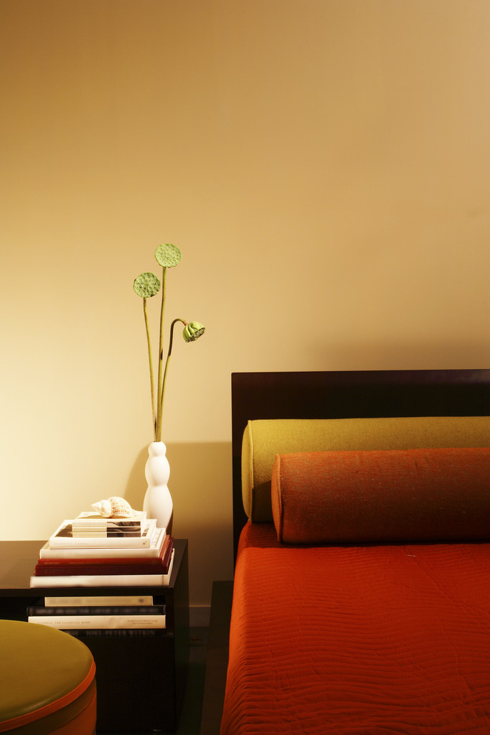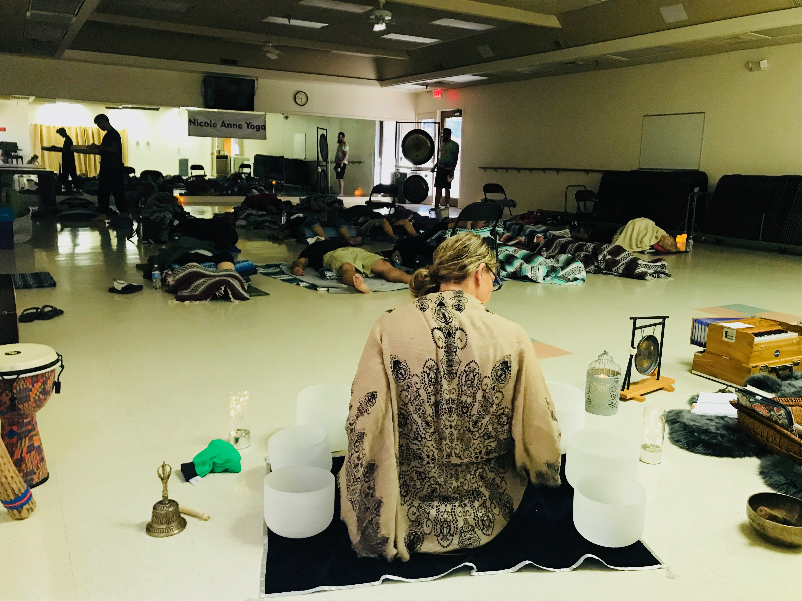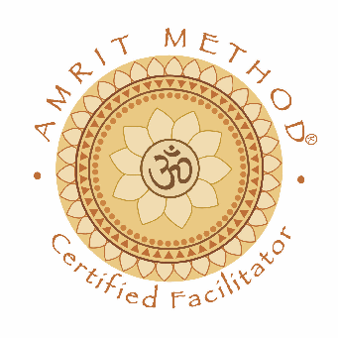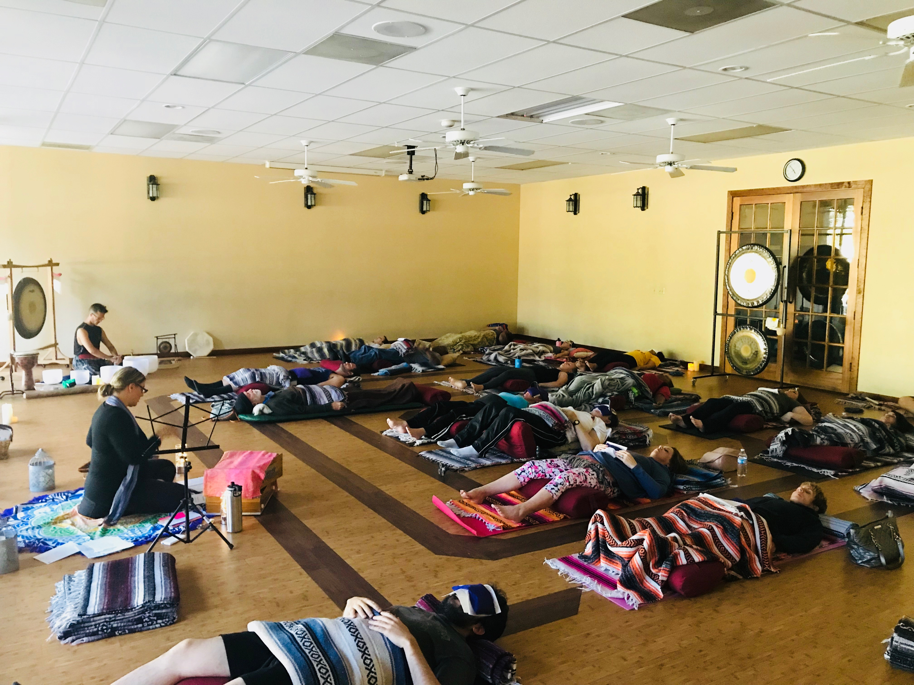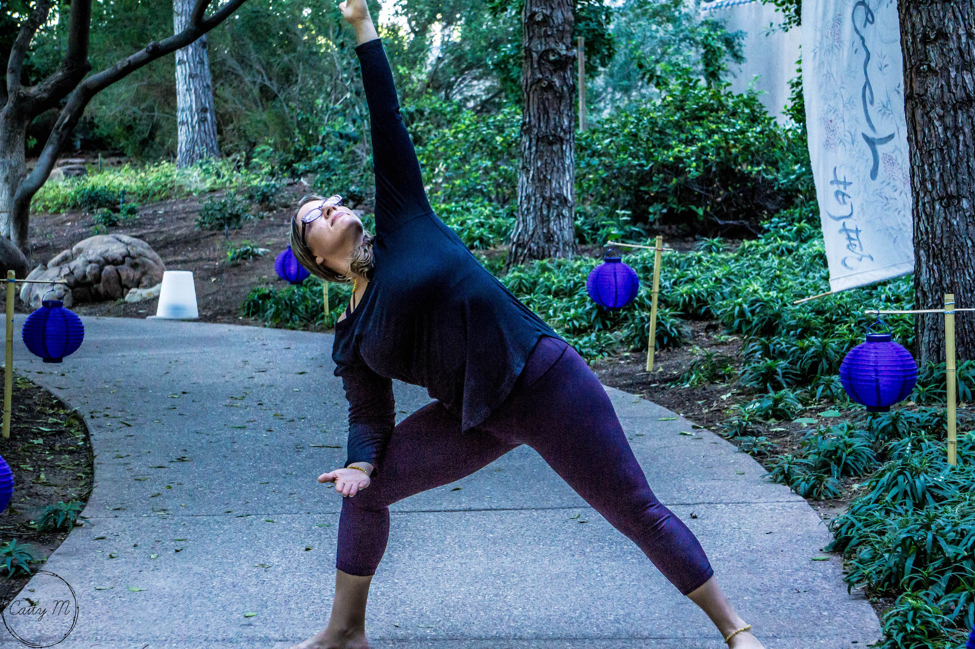

* Meditation
* Yoga – all levels
* Sound Healing
* Gong Master
* Kirtan
* Holistic Nutritionist
* Health Coach
* Life Coach
* Restorative Yoga
* Transformational Yoga Coaching
* Packages ( 3, 6, & 12 )

**RYT500 Certified**

**Call to book a session or book online!**

Vibrations cause alternating compression and relaxation in the cells of the body. While the cells get compressed, they lose some of the fluid, detoxifying from your body waste products and toxins. As the cell decompresses, fresh nutrients are pulled into the cells, which starts the therapeutic healing process. It allows DNA cells to heal themselves. The human body is made up of 70% water; sound travels 5x faster through water. Natural healing at it’s finest!

We use a series of medical grade gongs, crystal quartz healing bowls, Himalayan bell and bowl, chimes, ocean drum, rain sticks, harmonium, and other meditative instruments to facilitate what is known as a sound bath. It is not about the sound, rather the vibration.

## Why Vibration Works…

Nicole Anne Yoga

**(847) 840-7277**  
Chandler, AZ 85249  
[www.NicoleAnneYoga.com](http://www.NicoleAnneYoga.com)

e-mail: nicole@nicoleanneyoga.com

## Offerings…

Nicole

Anne

Yoga

Holistic Practitioner, Life Coach, Yoga & Meditation Instructor, Holistic Nutritionist

Yoga Nidra (Guided Sleeping Meditation) is a sleep based meditation technique that is as restorative as 3 hours of sleep! It uses a series of body, breath, and awareness techniques to allow you to drop into a sleep like state where true healing takes place. It is very therapeutic as it helps release blocked energy or emotion that can be stuck or stored in the body.

- Nicole Fonovich, MEd.,RYT.

**Benefits:**  
* Helps with insomnia, stress, trauma, PTSD, anxiety, depression, Parkinson's, Alzheimer’s, chronic pain, smoking, recovery from a injury or surgery, grief or loss, weight loss or overeating, addictions or habits that you want to break, diabetes, menopause, fertility, terminal illness, and best of all, it's anti-aging!

* Hormones like melatonin, serotonin, oxytocin, endorphins, & dopamine are all released naturally

* Restores harmony and inner peace

* Shifts consciousness

* The mind becomes still

* Body is brought into it’s greatest state of relaxation

* Promotes self discovery, self absorption, awakens intuition, moves energy

* Follow us on Facebook at Nicole Anne Yoga
* Follow us on Instagram

Watch for our monthly events around the Valley or schedule us for a private session. We’d love to work with you!

- Donec vehicula mauris in est

“Duis at neque eu ligula vehicula feugiat.”

# Yoga Nidra / Meditation…