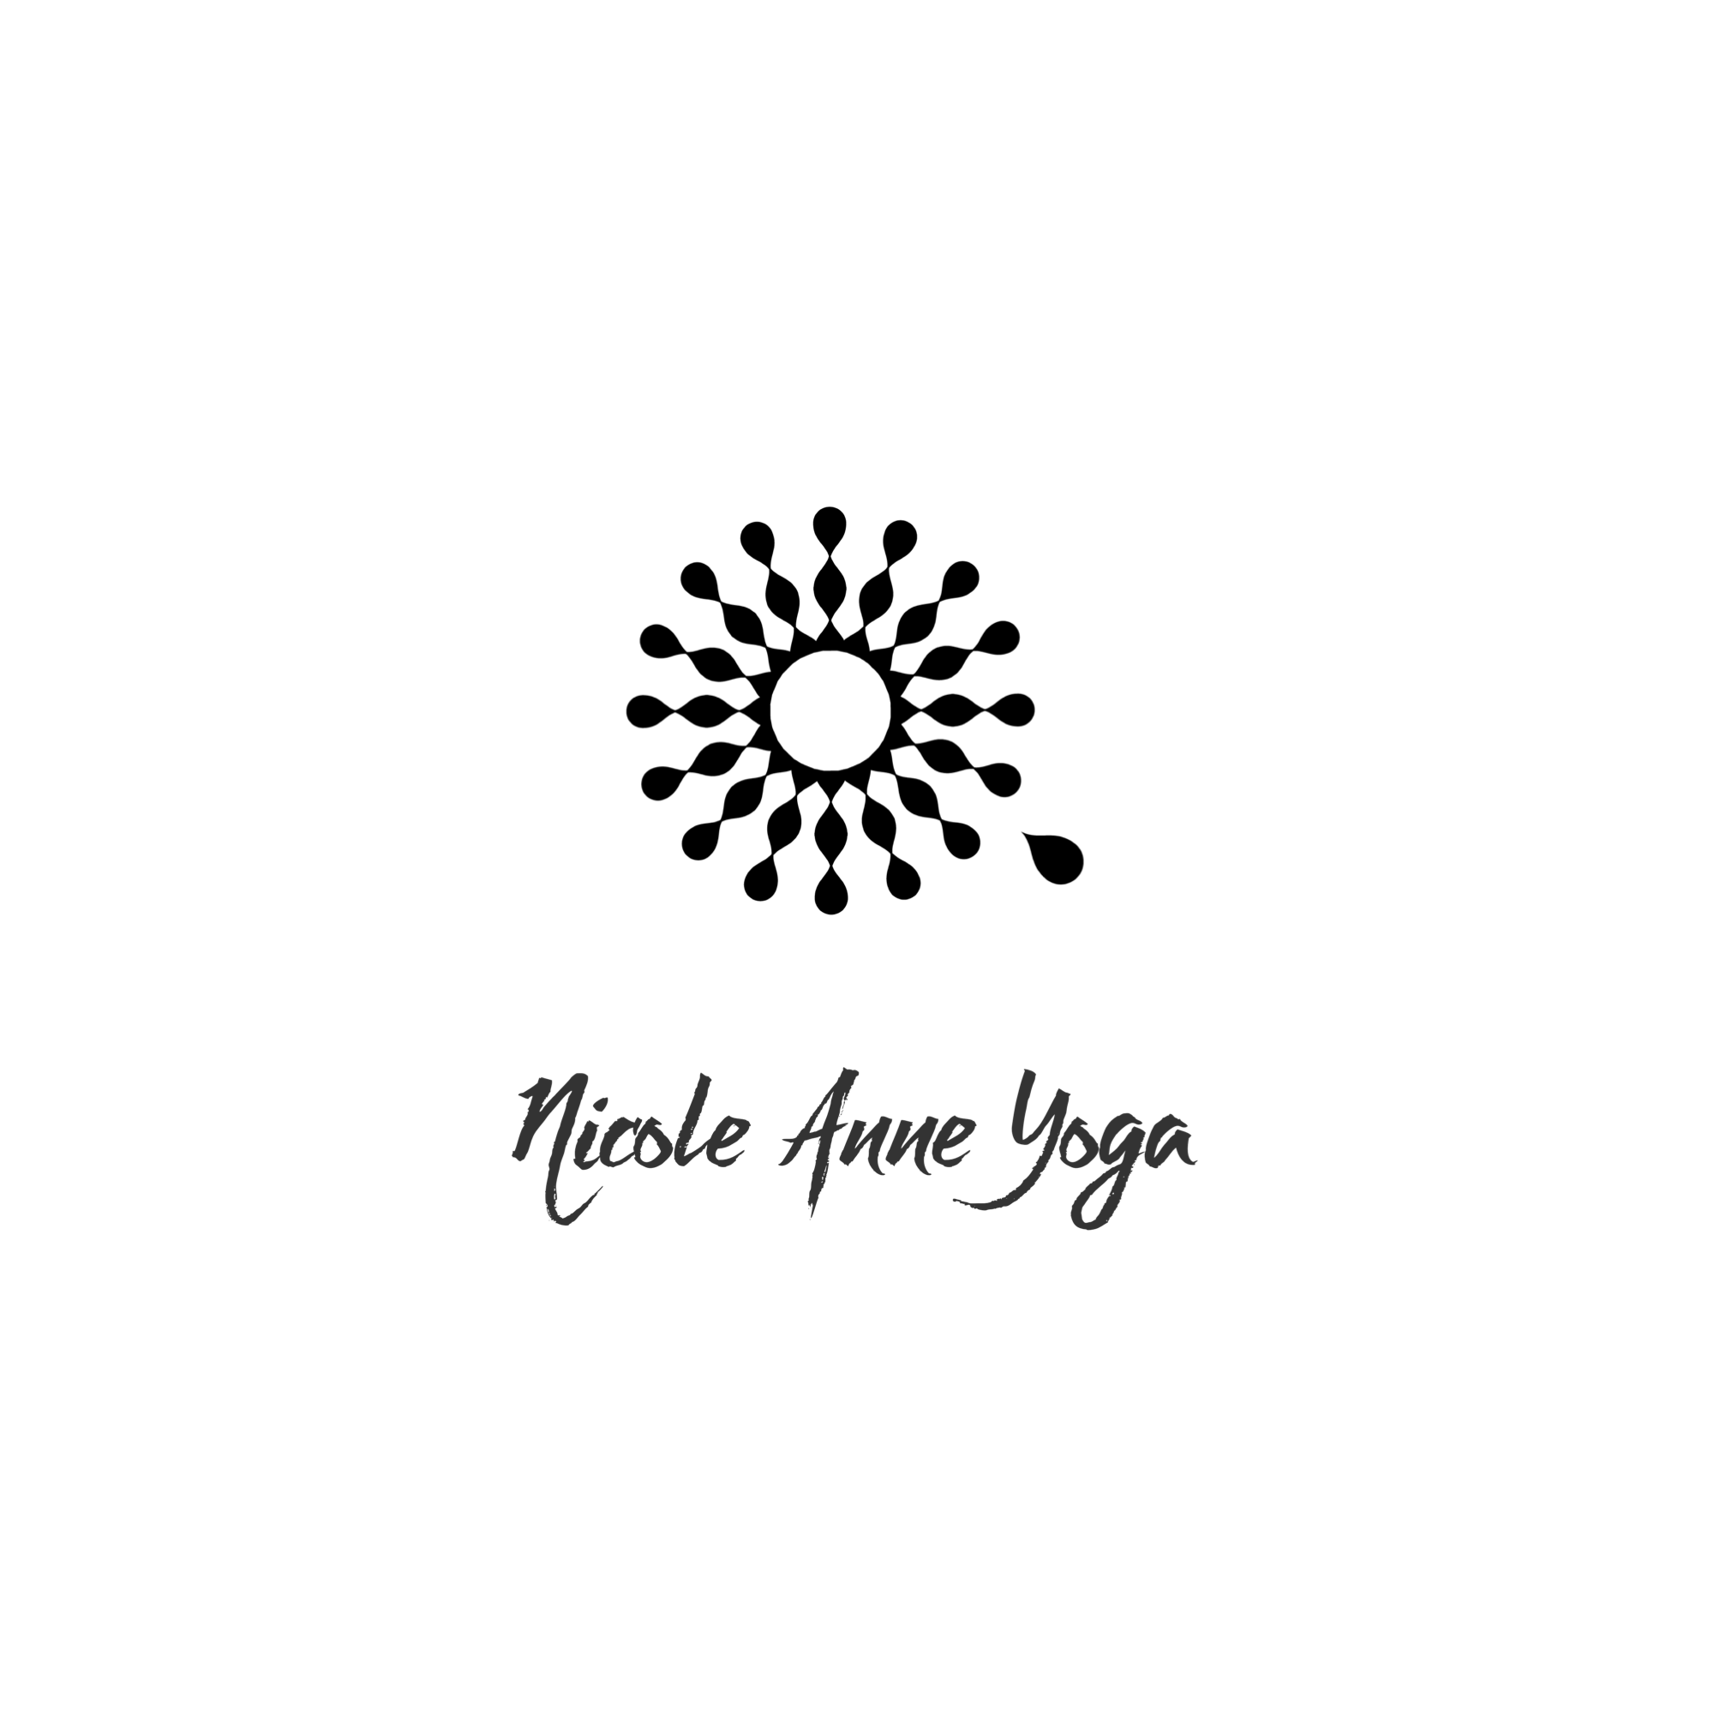
Goat Yoga: Hold Harmless Agreement
Have Fun at your own risk and care!
There is no retirement age for a Professional Yoga Goat, and sometimes they forget how big they are, so you may get any given size at any time.
Please use caution… Goats have hooves, horns, teeth, and adorable waggy tails.
It is your responsibility to watch out for yourself and your child.
PHOTO RELEASE: I grant permission and consent to Nicole Anne Yoga for the release of any photos taken by Employees of Nicole Anne Yoga, including their Professional Photographer, for the use to any Publicity, Copyright, Illustration, Advertising, Web Content and Social Media. **If I do not consent, I will inform any and all photographers taking my picture during class
GOOD PHYSICAL HEALTH: I represent and warrant that I am in good physical health and do not suffer from any medical condition, which would limit my participation in the classes offered at Nicole Anne Yoga. I understand that it is my responsibility to consult with a physician prior to and regarding my participation in any of the yoga classes, programs, or workshops. I understand the risks associated with the activities offered by Nicole Anne Yoga, LLC and I agree to follow all instructions so that I may safely participate in classes, workshops, or other activities. It is your responsibility to inform the instructor of your limitations before class begins.
LIABILITY: I hereby WAIVE AND RELEASE Nicole Anne Yoga and Feel Like a Kid Again Ranch, its owners, officers, employees, and instructors from any claim, demand, cause of action of any kind resulting from or related to my participation in the programs offered at the facility. In taking part in the Goat yoga classes, workshops, or other activities at Nicole Anne Yoga, I understand and acknowledge that I am fully responsible for any and all risks, injuries, damages, known or unknown, which might occur as a result of my participation to me, my clothing, minor children, or my property. I will not do anything that I do not feel physically comfortable with. I am aware that these Goats, (although very trained, gentle and docile), are still animals that can weigh up to 80 lbs, that poo and pee, with hooves, horns, and teeth that can scratch, buck, bruise, rip cut, nibble, step on valuables, etc. I am aware that there is no retirement age for a Yoga Goat, so I may get any sized goat jumping on me at any given moment up to 80 lbs. Please use caution and common sense. All of this applies to any and all animals such as alpacas, cows, horses, turtles, hedgehogs, bunnies, chickens and any other animal that may be in or around Feel Like a Kid Again Ranch.
ASSUMPTION OF RISK: I understand and agree that I and/or my child will be taking part in the Activities offered by Nicole Anne Yoga and I/we do so voluntarily. I, on behalf of myself and/or my child, assume all risk involved with my participation or the participation by my child in the Activities, including but not limited to all risk of personal injury, death, or disability to myself and/or my child that may result from participation in the Activities, or any damage, loss, or theft of any personal property which may be incurred by me and/or my child. I understand that these Activities include but are not limited to Goats, Yoga, and the premises. In spite of the above and clearly stated risks I elect to participate freely and elect to allow my child to participate of my own free will and accord and as such I assume all responsibility for any injury or death that I or my child may incur from goats or yoga.
Now I am ready to have fun!
Printed Name ___________________________________________
Printed Guardian Name __________________________________

Student
X_______________________________________________________
Guardian
X _______________________________________________________
Date: __________________________________________________

