EVENT NAME/DATE:

INSTUCTOR SIGN OFF:

PAID VENMO

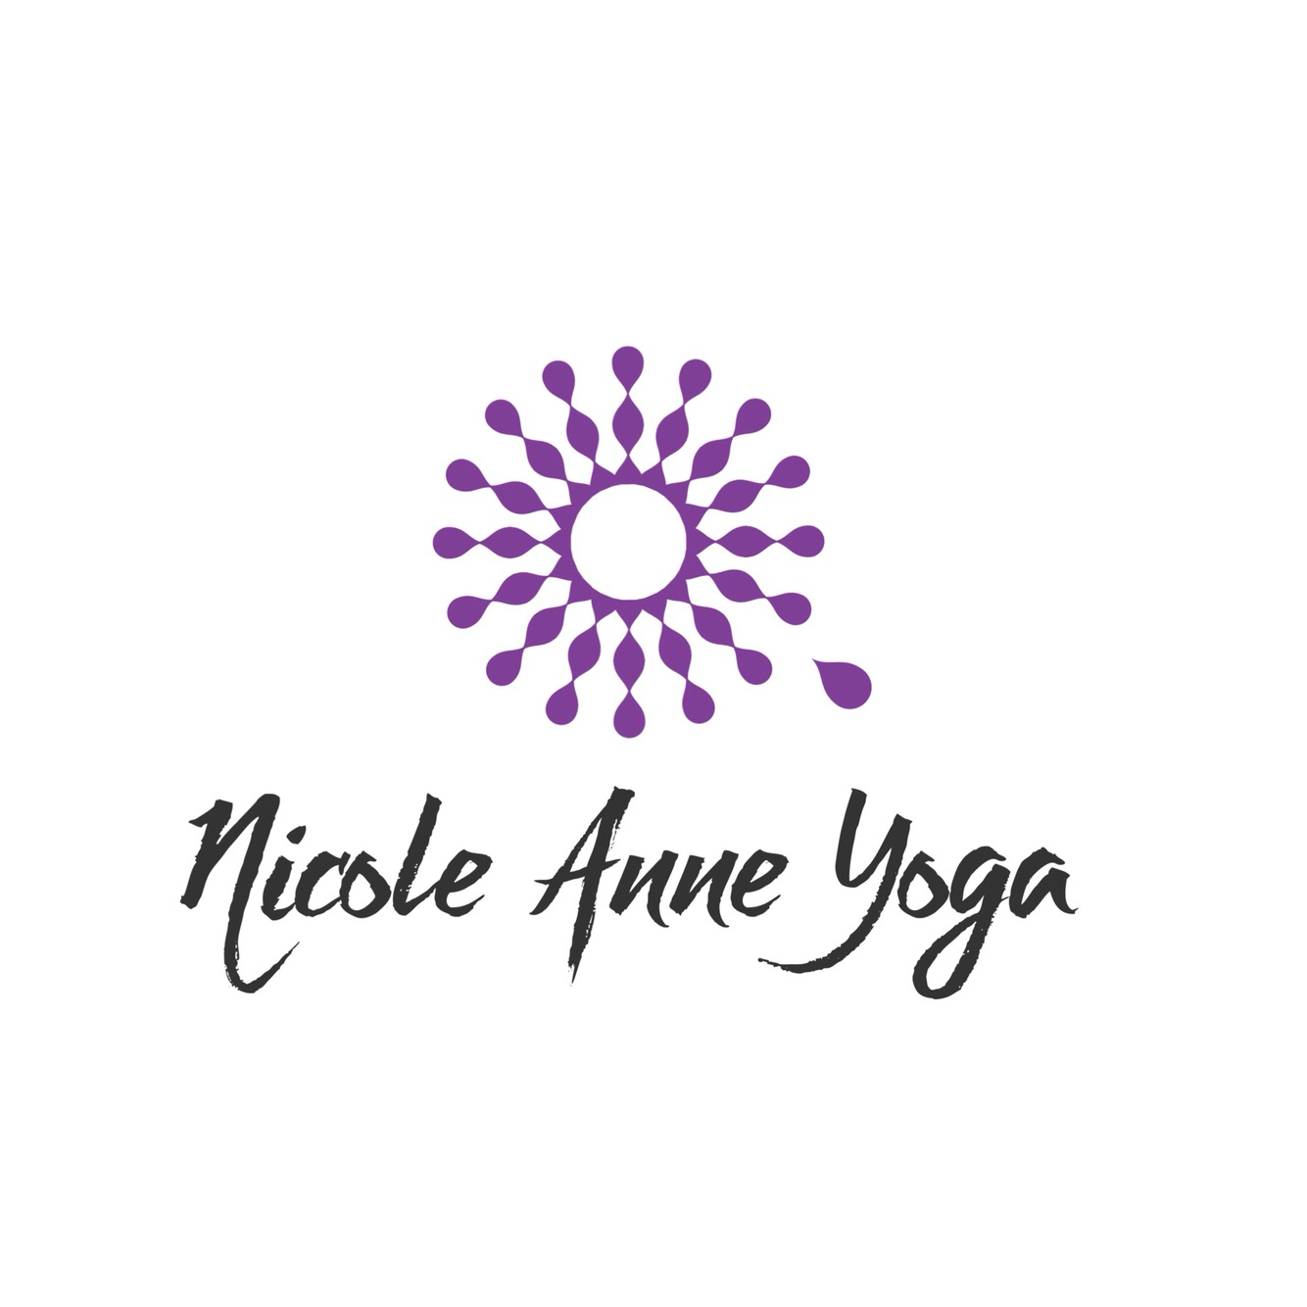
Guest Waiver
Please read carefully and sign below:
If you have a specific medical condition or specific symptoms, yoga classes may be contrary to your health benefits. It is your responsibility to inform the instructor and Nicole Anne Yoga to be informed about your condition(s). I understand the implications of participating in a Yoga program / class and the instructors may ask me to not participate either for all or part of the class upon his or her discretion and professionalism. I assume all liability if I fail to disclose any condition. If I am under the care of a Doctor in any way, I will make the instructor aware of this condition. I understand that Yoga classes are provided for the basic purpose of relaxation, as well as body, mind and spirit integration. Should I experience pain or discomfort during the class, I will immediately inform the instructor so that the instruction may be adjusted to my level of comfort. I understand and agree that Nicole Anne Yoga is NOT responsible for any personal injury, or any loss of personal property while attending any classes with Nicole Anne Yoga.

NAME | 1ST TIME ATTENDEE | PHONE NUMBER | EMAIL ADDRESS  (PRINT NEATLY PLZ) | SIGNATURE | HOW DID YOU HEAR ABOUT US?

