

Shot Schedule

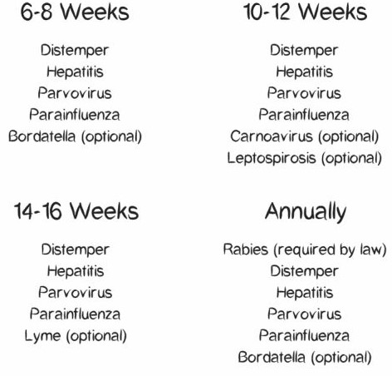

[www.kitandkboodlesdoodles.com](http://www.kitandkboodlesdoodles.com)