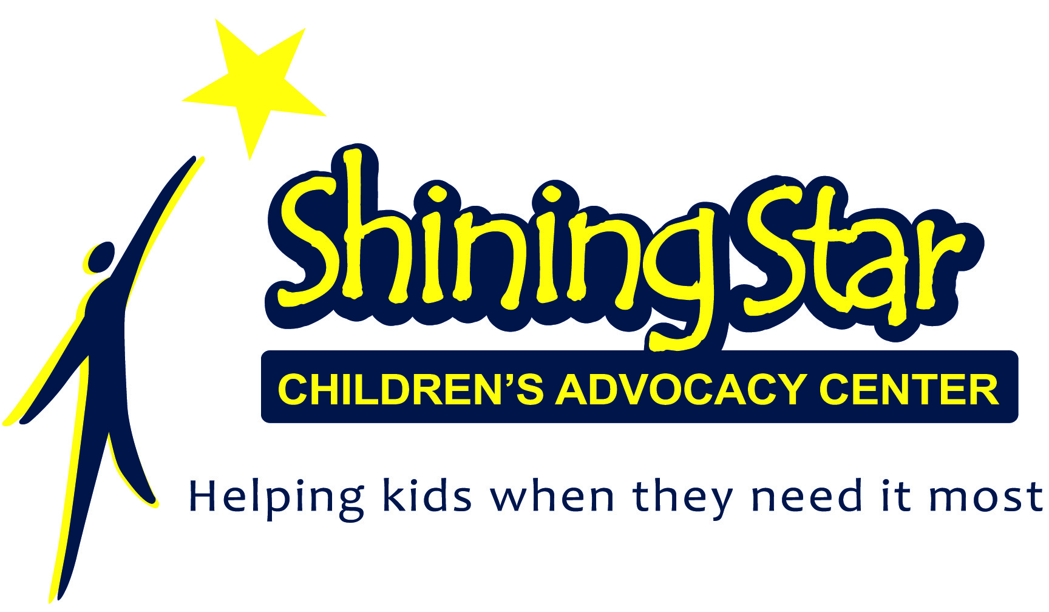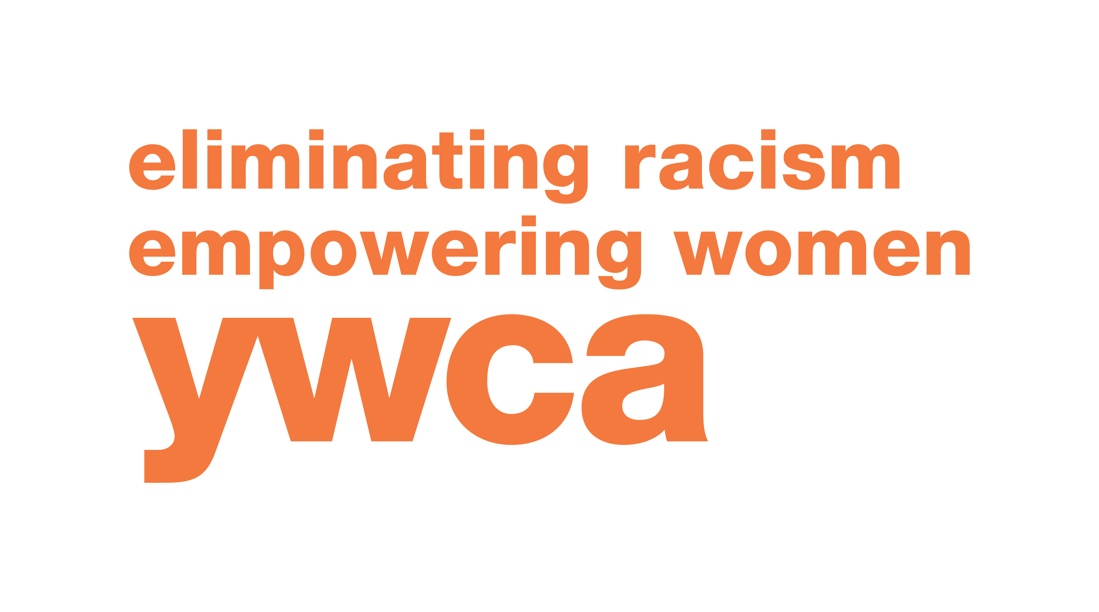

The 10th Annual Multi-Disciplinary Team Conference
on Crimes Against Children
March 25th and 26th, 2019

The Conference will be held at the Dixon Elks Lodge
1279 Franklin Grove Rd, Dixon, IL 61021

Registration Fee: $25.00 - Light Breakfast and Lunch Included

To register online click this link: https://www.eventbrite.com/e/shining-star-cac-10th-annual-mdt-conference-on-crimes-against-children-registration-55009422664
OR
Search “Shining Star CAC 10th Annual MDT Conference on Crimes Against Children” at www.eventbrite.com

Monday, March 25, 2019

8:00-8:30 Registration (Light Breakfast Provided)

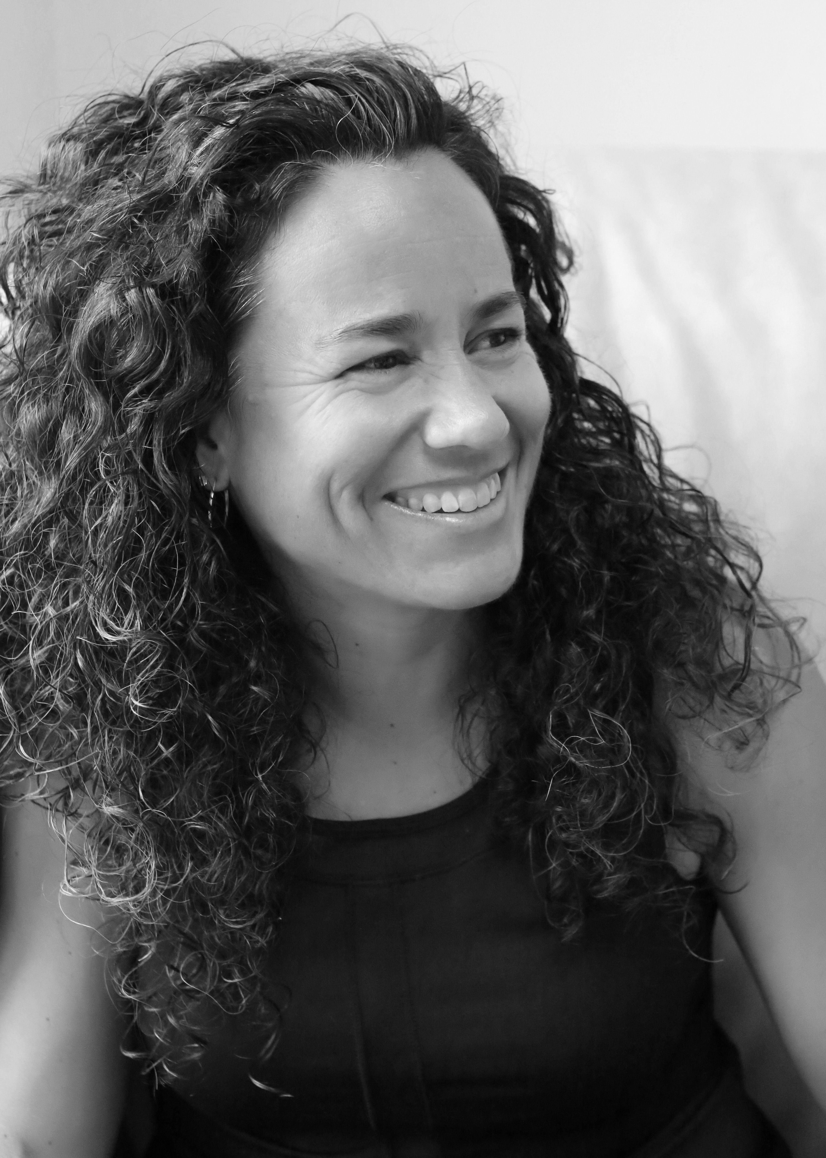
8:30-10:00 Keynote Presenter: Transforming Trauma: How to do this work and sustain: Laura van Dernoot Lipsky, Founder and Director of The Trauma Stewardship Institute, and author of Trauma Stewardship: An Everyday Guide to Caring for Self While Caring for Others, has worked directly with trauma survivors for more than three decades.

Setting the Context for Cumulative Toll: Laura van Dernoot Lipsky, Founder and Director of The Trauma Stewardship Institute.

Laura will discuss the context for how a cumulative toll arises and how we’ll engage in this conversation. Laura will further discuss principals that may be helpful in taking in the information.

The Trauma Exposure Response: Laura van Dernoot Lipsky, Founder and Director of The Trauma Stewardship Institute.

Laura will discuss the specific manifestations of cumulative toll. From numbing the anger to cynicism, she will dive deeply into how one is impacted individually and collectively.

10:00-10:15 Break

10:15-11:30 How to Sustain Individually: Laura van Dernoot Lipsky, Founder and
Director of The Trauma Stewardship Institute.

Laura will look at very concrete strategies for how to create sustainability
for oneself individually.

How to Sustain Collectively: Laura van Dernoot Lipsky, Founder and
Director of The Trauma Stewardship Institute.

Laura will broaden the conversation by looking at how to create
sustainability for oneself within a larger context as well as how to create
larger organizational, institutional, and movement-level change.

11:30-12:00 Honorary Award

12:00-1:00 Lunch (provided)

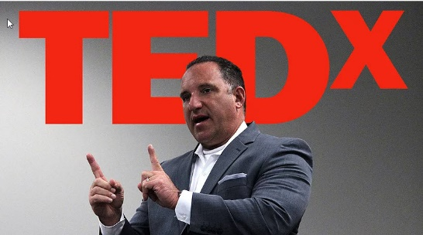
1:00-2:15 Social Network and Cell Phone Investigations: Detective Richard Wistocki
(Ret. Naperville Police Department), Be Sure Consulting; Technology Training for Police, Schools, Parents, and Communities.

In this workshop, participants will learn how to investigate the social
network applications that are used in cases to understand how to find out
who the persons involved are. We will learn how to investigation social
media and find out who the perpetrators are in the many different types
of online criminal cases. We will examine the simple 3 step process of
investigating internet crime according to the Electronics Communications
Privacy Act (ECPA).

2:15-2:30 Break

2:30-4:30 Social Network and Cell Phone Investigations Continued: Detective Richard Wistocki (Ret. Naperville Police Department), Be Sure Consulting; Technology Training for Police, Schools, Parents, and Communities.

Tuesday, March 26, 2019

8:30-8:45 Welcome and Training Overview: Amy Russell,
MSEd, JD, NCC, Executive Director Arthur D. Curtis Children’s
Justice Center, Russell Consulting Specialists, LLC.

8:45-10:15 In Search of “True” Memories: Recovered Memory Syndrome in the Courts. Amy Russell, MSEd, JD, NCC, Executive Director Arthur D. Curtis Children’s Justice Center, Russell Consulting Specialists, LLC.

State legislatures continue to debate the merits of extending statutes of limitations, while legal and mental health experts dispute repressed and recovered memories of sexual victimization. This session will examine issues of false-memory creation, repressed memories, recovered memories of childhood trauma, and how it relates to legal and psychological practice.

10:15-10:30 Break

10:30-12:00 Transgenerational Trauma and Child Abuse: Amy Russell, MSEd, JD, NCC, Executive Director Arthur D. Curtis Children’s Justice Center, Russell Consulting Specialists, LLC.

Trauma passes from one generation to the next through genetics and
experiences, and can result in neurological and physiological changes. In
child abuse cases, these changes not only impact how a child experiences
their victimization, but also how a non-offending parent with personal
history of trauma responds to his/her child when they disclose
maltreatment. Learn how past trauma impacts future generations,
identify ways parents with trauma histories respond to disclosures of
abuse by their children, and discuss tips and techniques for working with
non-offending parents with trauma histories.

12:00-1:00 Lunch (provided)

1:00-2:30 Juvenile Perpetrators of Sex Crimes and youth with Sexual Behavior Problems: Amy Russell, MSEd, JD, NCC, Executive Director Arthur D. Curtis Children’s Justice Center, Russell Consulting Specialists, LLC.

Sexual perpetration of youth by youth is becoming an increasingly development in children; identify characteristics of juveniles who sexually offend; and address legal consequences for youth who sexually offend.

2:30-2:45 Break

2:45-4:15 Interviewing for All Forms of Maltreatment: The Importance of
Understanding Polyvictimization. Amy Russell,
MSEd, JD, NCC, Executive Director Arthur D. Curtis Children’s
Justice Center, Russell Consulting Specialists, LLC.

Allegations of child abuse frequently include only one form of
maltreatment; however, two-thirds of youth who are victimized in one
way also experience other forms of violence. We also know that
polyvictimization is more closely associated with symptoms of trauma than
experiences of any single form of maltreatment or violence, even
if experienced multiple times. This session will discuss the research on
youth’s experiences of multiple victimization of different types, will
address risk factors youth face for polyvictimiztion, and techniques
professional can use to screen youth for multiple forms of violence and
maltreatment.

4:15-4:30 Questions or Comments?

If you are unable to register online, please complete the registration form
below and return with payment by March 11th to:
Shining Star Children’s Advocacy Center
215 E. First Street, Suite 110, Dixon, IL 61021
Email: jfriday@shiningstarcac.org with any questions

10th Annual Multi-Disciplinary Team Conference
on Crimes Against Children
March 25th and 26th, 2019

__________________________________ _________________________________________
First Name Last Name

______________________________________________________________________________
Organization/Agency Name

______________________________________________________________________________
Address

_______________________________________ ____________________________________
Email Address Phone Number

CEUs Requested: □ None □ MCLE □ ICDVP □ DCFS □ Social Work

Children’s Advocacy Centers of Illinois will provide opportunities to receive MCLEs and CEUs for DCFS employees, Social Workers, and Professional Counselors.
YWCA of the Sauk Valley will offer ICDVP CEUs.
The Northwest Illinois Criminal Justice Commission/MTU#1 has submitted this training for certification by the Illinois Law Enforcement Training and Standards Board.

