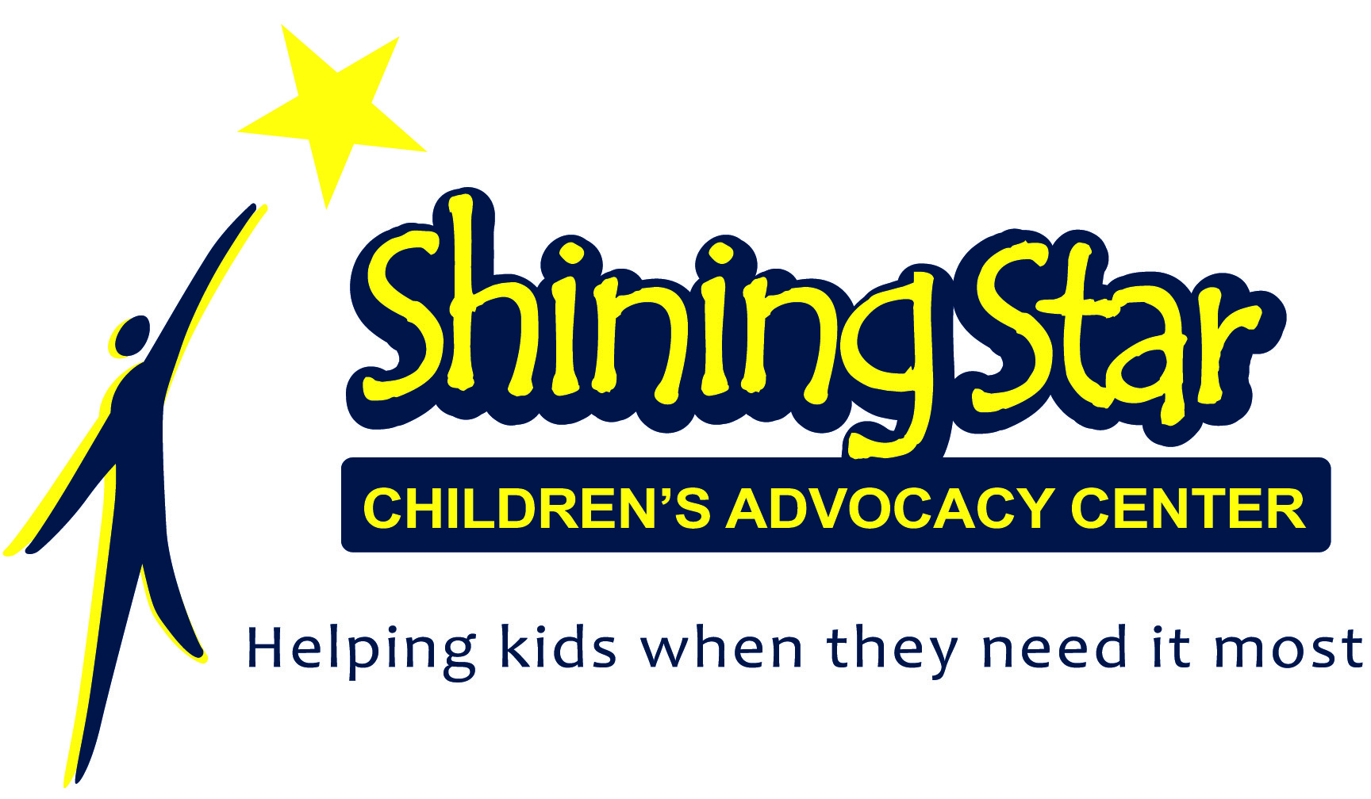

Shining Star Children’s Advocacy Center
Wish List

Thank you for your interest in our organization and for wanting to make a difference in the lives of children in your community! Our Mission at Shining Star CAC is to transform victims of child sexual abuse and serious physical abuse into survivors. With community support and assistance, we can accomplish this. You can help us, help the kids we serve, by donating new items to the Center. Below is a wish list for Shining Star CAC….

Bottled Water
Individual Juice Boxes
Individual Snack Packages
Children’s Movies
Superhero Capes
Children’s Books
Board Games
Art Supplies
Blank Journals
Gift Cards (Walmart, Grocery, Payless Shoes, Gas)
Band Aids
Liquid Hand Soap
Hand Sanitizer
Xbox 360 or Kinect & Games
Monetary Donations

Thank you for your support!

