

2026 Corporate Sponsorship Levels
Title $5,000 | - 5 VIP Event tickets  - Title sponsor plaque presented during opening comments  - Title sponsor mention in all advertising/media & headline in program  - One minute description of your company during plaque presentation  - Company banner displayed at event  - Company branded promo items included in all gift bags (200) and/or auction handbags**  - Access to Genesis House learning opportunities
Platinum $2,500 | - 3 VIP Event tickets  - Certificate of appreciation presented during opening comments  - Name & logo in program, on event banner & all print advertising/media  - Company branded promo items included in all gift bags (200) and/or auction handbags**  - Access to Genesis House learning opportunities
Gold $1000 | - 2 VIP Event tickets  - Company mention during opening comments  - Name & logo in program & on event banner  - Company branded promo items included in all gift bags (200) and/or auction handbags**  - Access to Genesis House learning opportunities
Silver $500 | - 1 VIP Event ticket  - Company name in program & on event banner  - Company branded promo items included in all gift bags (200) and/or auction handbags**  - Access to Genesis House learning opportunities
Bronze $250 | - Company name in program  - Company branded promo items included in all gift bags (200) and/or auction handbags**  - Access to Genesis House learning opportunities
We depend strongly on our corporate partners for sponsorships, purses, auction items, gift cards/certificates and other items for goody bags and purses, etc. We are happy to brainstorm with you about our needs and how you can best help. Contact Susan Evans at 931-252-6205 or Kim Vondra at 931-319-4034.


** Any company branded promotional items are welcome, as well as gift cards/certificates, purses, scarves, makeup, jewelry, hygiene products, etc. There are 200 gift bags and usually around 100 auction purses, however, you can provide whatever number works for your business. We have created an Amazon wish list of items that you may purchase to donate as well. Please consider sharing with your staff who may wish to donate individually.

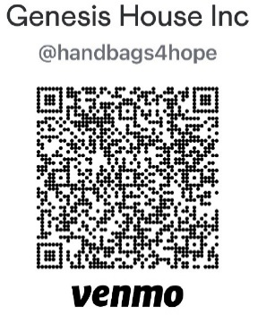

We want to be flexible in our sponsorships. For convenience, you can send your sponsorship payment via Venmo, Credit Card, Check or Cash. The Venmo QR code is below. Simply note your sponsorship level in the “What is this for?” section, along with a name & phone number so that we may contact you. The paper sponsorship for is also included.

