“He did it again! Not only does Richard Battle fill you up with motivation as you read his patriotic words but he also sparks great hope for what’s to come in the future. Each detail written about the prominent leaders of our nation in the 20th century is interesting, inspiring, and really just makes you want to make a big difference in the world too. It’s moving, it’s compelling and it teaches us all to remember to keep fighting the good fight. Everyone needs to read this!”
-Bucleigh Kernodle, author including I Would Love You Even if You Were a Pickle series.”

Fourth in the AmeriCANS Series
https://amzn.to/4g8CGOc
ISBN 13-9781882658435
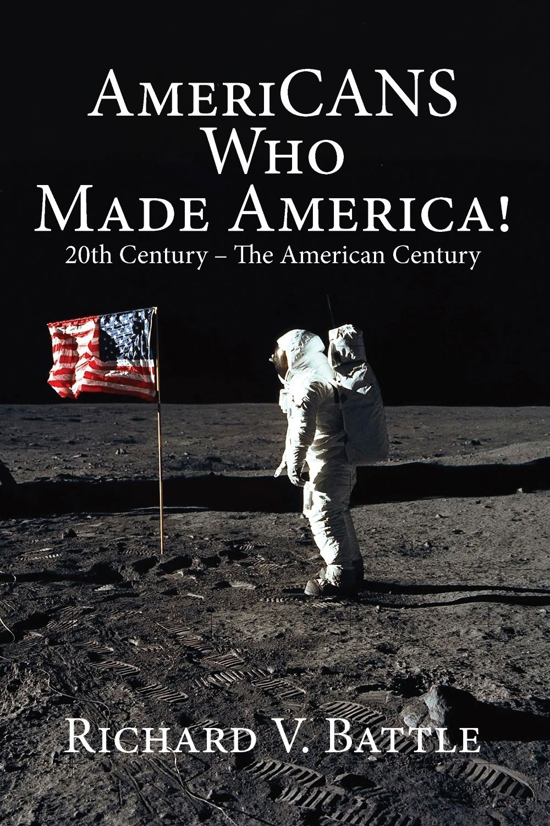
“On behalf of the entire Joint Force, thank you for supporting the remarkable men and women of the United States Armed Forces. Your patriotic commitment strengthens our Nation in countless ways by honoring their service, reinforcing the values they defend, and helping sustain the spirit that unites communities across America.

Your dedication to sharing positive messages to encourage others to succeed is truly appreciated. Your books will be a welcome addition to my collection.” – J. Daniel Crane, General, U. S. Air Force and Chairman of the Joint Chiefs of Staff
--
“I was honored to have an early copy and what Richard does to bring great American stories to life is amazing. You will be surprised at how you’ll keep turning the pages because the next story is just as good as the one you just finished!” – Doug Wagner, WMT 600 radio
--
“Richard Battle is the antidote to that which brings you down.” – Gail Fallen, 1310KFKA

Available for Interview: Contact Richard: 512-987-2058
43 Ordinary Americans whose AmeriCAN-do efforts contributed to our prosperity.

Their stories will give you hope for the future and motivate you to reach for the stars of your dreams!

A Great tool for students, teachers, leaders and speakers.

- It includes:
- 43 Stories of examples
of the AmeriCAN-do spirit
- 458 Motivational and inspirational quotations
- 58 Illustrations
- The stories of the men and women
AmeriCANS in this volume will
inspire, encourage, and make you
proud to be an AmeriCAN!
- Concise and Easy-to-read.
- It is a great tool for teaching
children and grandchildren.
- Third in the Series
……. And much more!
“This book is a history book, an inspirational book, a record book, a chronicle of multiple generations and a vital reminder of who we are!
I am proud to be an AmeriCAN as described by Richard Battle. This book will make you proud as well. It is the kind of book you can read aloud with your kids.” - Jim Cathcart, Author and Proud Patriotic AmeriCAN. Founder of Cathcart.com

“What a trip ...! Just finished your 20th Century edition of AmeriCANS who made America. You have captured the essence of what these people did for all of us. And you continue to educate me about so many unknown facts about ALL included in this work. Now I am going to get your 19th century Edition to complete the trilogy!!” - Tom Van Fossen, Dallas Sons of the American Revolution Vice President

“This book is an easy-to-read collection of well-written stories. Richard’s storytelling makes these accounts both inspirational and deeply encouraging. – David Gillian, Director of Development, Texas Baptist Children’s Home

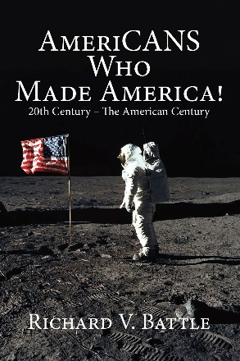

Richard V. Battle’s previous award-winning books include: AmeriCANS Who Made America: 19th Century AmeriCANS Who Made America: 18th Century, The Unopened Present, Made in America by AmeriCANS not AmeriCANTS, Life’s Daily Treasure, Navigating Life’s Journey, Conquering Life’s Course, Unwelcome Opportunity, The Four-Letter Word That Builds Character, The Master’s Sales Secrets, Surviving Grief by God’s Grace and The Volunteer Handbook – How to Organize and Manage a Successful Organization.

And his passport book – The 5 Leadership Secrets of Old McDonald

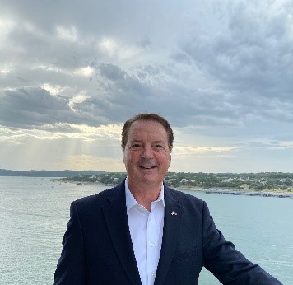

Richard V. Battle is an award-winning and Amazon best-seller author of thirteen books.

He is a media commentator frequently appearing on radio and television and has been a motivational speaker and trainer for over 30 years on leadership, sales, and faith.

His servant leadership includes the boards of many organizations, including Alpha Kappa Psi (past chairman), The Shepperd Leadership Institute (past chairman), Boy Scouts of America, Muscular Dystrophy Association, and Keep Austin Beautiful.

Texas Governor Rick Perry appointed him to The Texas Judicial Council and The Texas Emerging Technology Fund.

As president of the Austin Junior Chamber of Commerce, the U.S. Junior Chamber of Commerce recognized the chapter as the Most Outstanding chapter in the United States. The Junior Chamber of Commerce International recognized Richard as the Outstanding Chapter President in the world.

Richard is an experienced corporate executive and non-profit leader who serves organizations in an advisory role.

AmeriCANS who Made America: 20th Century… signed copies are available at www.richardbattle.com. Also, at Amazon.com or any bookstore. Also available in paperback, Kindle, and audio versions.

https://amzn.to/4g8CGOc

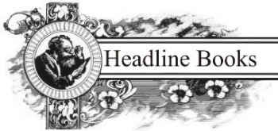
P O Box 52
Terra Alta WV 26764
www.HeadlineBooks.com

Headline News
For Immediate Release

CELEBRATING AMERICA AT 250: RICHARD BATTLE'S NEW BOOK HONORS 20TH-CENTURY AMERICAN HEROES ~AmeriCANS Who Made America! 20th Century – The American Century.
Available NOW!

Fourth Inspirational Volume of the AmeriCANS series.

Award-winning author Richard Battle's upcoming book, AmeriCANS Who Made America! 20th Century – The American Century celebrates the remarkable men and women whose courage, innovation, and determination shaped modern America. As the nation marks the 250th anniversary of its independence, the book is a reminder that America's greatest achievements have always been driven by ordinary people accomplishing extraordinary things.

Battle profiles the pioneers, inventors, scientists, military leaders, entrepreneurs, and visionaries who guided America through World Wars I and II, the Spanish flu pandemic, the Great Depression, the Civil Rights Movement, and the Space Race—including the innovators whose work made the Moon landing possible and laid the foundation for America's return to the Moon and future missions to Mars.

"America's greatest accomplishments have always come from people willing to dream big, work hard, and serve something greater than themselves," said Battle. "The same AmeriCAN-do spirit that helped win world wars, overcome national crises, and land astronauts on the Moon is the spirit that will carry America into the future."

Published by Headline Books, the fourth volume in Battle's acclaimed AmeriCANS series follows 18th Century – Birth of the Republic and 19th Century – Growth, Division, and Reunification and Made in America by AmeriCANS not Americants.

Together, the series provides leadership lessons to expand readers’ AmeriCAN-do achievements, and chronicles the Americans whose character, leadership, and perseverance built the nation from its founding through the 20th century, serving as inspiration and examples

AmeriCANS Who Made America! 20th Century – The American Century is available now for order on Amazon, and signed copies are available at Richard’s website: Books +Motivational Merch

For media requests, please contact Allen Media Strategies’ Shaili Priya at shaili@allenmediastratgies.com or 703-589-8960

Reviews for “AmeriCANS Who Made America”
“He did it again! Not only does Richard Battle fill you up with motivation as you read his patriotic words but he also sparks great hope for what’s to come in the future. Each detail written about the prominent leaders of our nation in the 20th century is interesting, inspiring, and really just makes you want to make a big difference in the world too. It’s moving, it’s compelling and it teaches us all to remember to keep fighting the good fight. Everyone needs to read this!”
-Bucleigh Kernodle, author of the I Would Love You Even if You Were a Pickle series.

“This book is a history book, an inspirational book, a record book, a chronicle of multiple generations, and a vital reminder of who we are!
I am proud to be an AmeriCAN as described by Richard Battle. This book will make you proud as well. It is the kind of book you can read aloud with your kids.
Keep this culture alive and pass it on. A vital reminder with insights beyond most people’s perspective.” - Jim Cathcart, Mentor to Professional Experts, Author and Proud Patriotic AmeriCAN. Founder of Cathcart.com

About the Author

Austin, Texas-based award-winning author Richard V. Battle has written fourteen books and has been a public speaker on leadership, motivation, faith, and sales for over 30 years. He is an experienced corporate executive and non-profit leader who was appointed by former Texas Governor Rick Perry to serve on advisory councils and who serves as the Master of Ceremonies for the annual Texas State Prayer Breakfast with Governor Greg Abbott.

For author interview requests, more information, or to request a review copy, please contact Allen Media Strategies Burke Allen at burke@allenmediastrategies.com or call 703-589-8960.

Advance Praise

“This book is a history book, an inspirational book, a record book, a chronicle of multiple generations and a vital reminder of who we are!
I am proud to be an AmeriCAN as described by Richard Battle. This book will make you proud as well. It is the kind of book you can read aloud with your kids.
Keep this culture alive and pass it on. A vital reminder with insights beyond most people’s perspective.” - Jim Cathcart, Mentor to Professional Experts, Author and Proud Patriotic AmeriCAN. Founder of Cathcart.com

“Regardless of whether it’s his written or spoken word, what makes Richard Battle so unique is that he can find common sense and conservative ideas even in areas of our society in which few conservatives might exist.

This group of AmeriCANS is a great example. As you flip through the pages, you may wonder how one person is connected to another. Look closely and you see how Richard sounds his web to catch each of them being AmeriCANS.” – Doug Wagner, host of The Doug Wagner Show-WMT/WOC-AM”

“This book is an easy-to-read collection of well-written stories highlighting ordinary Americans whose courage and resilience lead to extraordinary lives. Richard’s storytelling makes these accounts both inspirational and deeply encouraging. – David Gillian, Director of Development, Texas Baptist Children’s Home

“What a trip ...! Just finished your 20th Century edition of AmeriCANS who made America.
From Armstrong to the Wright Brothers, you have captured the essence of what these people did for all of us. And you continue to educate me about so many unknown facts about ALL included in this work. Now I am going to get your 19th century Edition to complete the trilogy!!” - Tom Van Fossen, Dallas Sons of the American Revolution Vice President

“He did it again! Not only does Richard Battle fill you up with motivation as you read his patriotic words but he also sparks great hope for what’s to come in the future. Each detail written about the prominent leaders of our nation in the 20th century is interesting, inspiring, and really just makes you want to make a big difference in the world too. It’s moving, it’s compelling and it teaches us all to remember to keep fighting the good fight. Everyone needs to read this!”
-Bucleigh Kernodle, author including I Would Love You Even if You Were a Pickle series.”

Potential Interview Questions

AmeriCANS who Made America – 20th Century

How did you decide to write AmeriCANS who Made America

What did you learn from your experiences that form your philosophy of AmeriCANism?

Who should read AmeriCANS who Made America, and how would they benefit?

Why will people want to read your sister book, Made in America by AmeriCANS not AmeriCANTS for the rest of their life?

What is the message of AmeriCANS who Made America? Please, share one example.

Why is it so important to share AmeriCANS who Made America at this time?

You use motivational quotes, birthdays, scripture, and anniversaries to inspire readers. Please tell us why you feel that best communicates your message and benefits the reader.

What is the most important fact should readers take away from AmeriCANS who Made America

What other ways are you spreading the message of AmeriCANS who Made America

Where can our listeners obtain additional information, or place their order for AmeriCANS who Made America

FOR ADDITIONAL INFORMATION
EDITORS/PRODUCERS:
For review copies contact: Author: Richard V. Battle
Allen Media Strategies richard@richardbattle.com
Burke Allen at burke@allenmediastrategies.com 512-987-2058
or call 703-589-8960.

HOW TO BOOK RICHARD FOR A SHOW
Available on holidays

- Email this page back to Richard today at richard@richardbattle.com

- Then call 512-987-2058 and we will set up a time and date…
Or check here and I will call you back at _________ or _________.
TIME DATE

Who Richard should contact at your station __________________/_______________
NAME TITLE

Phone____________ Fax ___________ e-mail __________________

Address ________________/_____________/____/______________
# & STREET CITY STATE ZIP CODE

Station ________/________ Market Served _____________________
CALL LETTERS FREQUENCY

Program ________________/________________/_______________
HOST PROGRAM NAME PROGRAM TIME SPAN

Station Format _______________________

Date Requested for Interview ________/__________/_____________
DAY OF WEEK DATE START TIME

Approximate length allocated to interview _______________________

___ Check here if you want a copy of Richard’s book prior to interview.
We require a confirmed booking date prior to sending out books.

Here is how to get an immediate copy of Richard’s book.

FOR ADDITIONAL INFORMATION
EDITORS/PRODUCERS:
For review copies contact: Author: Richard V. Battle
Allen Media Strategies richard@richardbattle.com
Burke Allen at burke@allenmediastrategies.com 512-987-2058
or call 703-589-8960.

Radio/TV Programs That have Featured Richard and his works.

- Collin Lambert, Prime Time Chicago, WMBI, Chicago, Illinois, 312-329-4290

- Jim Schneider, host, VCY America (99 stations), Milwaukee, Wisconsin, 414-607-1757

- The Harvest Show (TV), LeSea Broadcasting, South Bend Indiana,
Vijoya Chappelear, Producer, 574-291-8200

- Dr. Karen Hayter, producer, Reality Talks, FamilyNet TV, Ft. Worth, Texas
817-570-1400

- Dan Wales, host, KCHB, Houston, Texas (9 station network), 713-520-5200

- Warren Duffy, host of Duffy & Co., KKLA, Los Angeles, California
Natasha Nelson, producer, 714-847-9685

- Dr. Debra Peppers, host, Talk From The Heart, KJSL, St. Louis, Missouri
314-878-3600

- Dr. Randy Carlson, host, Parent Talk, Family Life Communications, 520-742-6976
(Gigi Cook, Associate Producer) (110 stations)

- Ken Inlow, host/GM, Christian Author’s Show, KKGT, Portland, 503-222-1150

- Jim Zimmer, host, Christian Interviews Today, KGDP, Santa Maria, Ca., 805-928-7707

- Steve Davis, host, Christianity in a Changing Culture, Minneapolis, 763-417-8270

- Ed Sossen, host, Sossen’s World, KIXL, Austin, Texas,512-372-9700

- Sam DeCasper, host, Christian Perspectives, WULS, Douglas, Georgia, 912-384-9857

- Kimberly Sarale, host, Book Nook, KYCC, Stockton, California, 209-477-3690

- David Wright, host, WDCD, Albany, New York, 518-862-1540

- Don Karnes, host, WFAX, Falls Church, Virginia, 703-532-1220

- P.J. Oliver, host. Wanda Sanchez, Producer, Life! Line, KFAX 1100
San Francisco, Ca., 510-713-1300

- Edna Parrish, host, Keeping You Informed, WFAX, Cincinnati, Ohio, 513-542-9393

- Gino Geraci, Sr. Pastor Calvary Chapel South Denver and host of the Gino
Geraci Show, KRKS, Denver, Colorado,303-933-8733

- Jim Taylor, host of Author’s Corner, KNEO, Neosho, Missouri, 417-451-5636

- Jim Galipeau, Program Director and host, WJIE, Louisville, Kentucky,
502-968-1220

- Ron Thulin, host, The Ron Thulin Show, KSLR-630, San Antonio, 210-344-8181

- Dan Whitley, host, Essential Wellness Health Ministry, Nashville, 423-727-0651

- Tamala Coleman, Spiritually Speaking, Iheart Radio, tcpraise14@gmail.com

- Dr. Faye Live (television), New Covenant Television Network, sterling@nctntv.org

- Jemsbooks blog with Janice Spina
https://jemsbooks.blog/2019/12/02/award-winning-author-interview-richard-v-battle/

- The Authors Show, Don McCauley, 910-202-6020

- Paul Kretschmer, WIHS radio, Middeltown, Ct., 800-346-1049

- BlogTalk Radio with Burke Allen – January 2020, (703) 589-8960

- Ryan Wrecker, Overnight America, KMOX, St. Louis, Mo., February and June 2020, 314-436-7900

- Mike Schikman, Mike Schikman show, WSVA, Harrisonburg, Va., February 2020, 540-434-0331

- Chris DeSimone, Wake Up Tucson, KVOI, Tucson, Az. Feb., Jul., Aug., Sept. 2020, 520-790-2836

- Gordon Griffin, 660AM the Answer, Dallas, Tx., February 2020, 469-359-5216

- Kerri Brinkoeter, Love Talk, 101.1Fm, Austin, Tx., February 2020, 512-349-5899

- Charles Heller, Liberty Watch Radio, KVOI, Tucson, March 20 Jan/June 21, 520-790-2836

- ZoomIntoBooks, Headline Books, April 2020, Cathy Teets

- Fox5 – Washington D.C., May 3 and July 18-2020, Tom Fitzgerald and Marie, 202-895-3000

- Stars and Stripes Radio, “The Specialist Radio Hour”, Chris Kettner, 757-646-1719

- Millennium Media, Gallup, New Mexico, Sammy Chioda, May 2020, 505-863-6851

- WERC, Birmingham, Alabama, JT Nysewander, May 20-Jun 21, 205-439-9372

- WMT, Cedar Rapids, Iowa, Doug Wagner, May and July 2020, Jun 21, 319-365-0600

- Faith Radio, Montgomery, Alabama, Bob Crittenden, June 2020, 800-239-8900

- The Big Talker, Wilmington, N. C., Joe Catenacci, June & Dec 20 weekly 21, 910-299-7535

- WOWO, Ft. Wayne, Indiana, Pat Miller, June 2020, 260-447-1190

- The Schatkin Show, New York, Andrew Schatkin, June 2020, (718) 229-2761

- I Inc. and Beyond, Michigan, Mike Callahan, July 2020, (248)909-1153

- KTOE, Mankato, Mn., Al Travis, July and August 2020, (507)625-1420

- KXYL, Brownwood, Tx., Celinda Hawkins, Jul., Aug., Sept. 2020 & Apr 2021, 325-646-3535

- KLZ, Denver, Co., John Rush, Jul - Dec. 20, and weekly 21, 303-481-1800

- KPRL, Paso Robles, Ca., Jamie Umphenour, Aug 2020 & Apr 2021, 805-238-1414

- Eagle 93.9, Columbia, Missouri, Brandon Rathert, August 2020, 573-874-9390

- WURD, Reality Check with Troy Wilmore and Charles Ellison, Philadelphia, Pa., August 2020, 215-634-5209

- WHO, Doug Wagner, Des Moines, Ia., September 2020, 515-283-1429

- KSAL, Jeff Garretson, Salina, Ks., Sept. 2020, 800-608-1150

- GSMC Podcast Network, Sarah Meckler, Sacramento, Ca., Oct. 2020, 888-805-5529

- The Booking Connection Podcast, John Valeri, Dec 2020, 860-984-6144

- KPRC, Jimmy Barrett, Houston, Tx., Dec 2020, (713) 212-8000

- WTKI, Fred Holland, Huntsville, Al., Dec 2020, 256-684-8000

- WSMN, Keith Hanson, Nashua, N.H., Dec 20-Jan 21, 603-816-1590

- Keeping It Real, Alex Garrett, New York, N.Y., Dec 2020, 718-751-6549

- WORD 106.3, Charlie James, Greenville, S.C., Jan. 2021, 864-720-1523

- KABC, All-American Radio, Jennifer Kerns, Los Angeles, Ca., Jan 2021, 901-260-5926

- KQAM, The Voice of Reason, Andy Hooser, Wichita, Ks., Jan Feb Apr Jun 2021, 316-226-8460

- Y’all Show, Jon Rawl, Oxford, Ms., Jan 2021, 662-801-7295

- Newstalk 101, Brian Rust, Panama City, Fl., Jan 2021,Nov 22, 850-230-5855

- CBN News, Gary Lane, Virginia Beach, Va., Jan 2021, 757-226-2030

- The Exceptional Conservative Show, TECN TV, Ken McClenton, Wash.DC, Jan/Aug 21, 2026601329

- KXEL, Jeff Stein, Waterloo, Ia., Jan and Mar. 21, May 22,

- WTKN-Talk94.5, Liz Callaway, Myrtle Beach, S.C., Jan 2021, 843-236-2891

- KZIM, Faune Riggin, Cape Girardeau, Mo, Feb 2021, 573-335-5763

- Clarity from Chaos, Dave Campbell, Colorado, Feb 2021, 480-993-6720

- WNTP, Chris Stigall, Philadelphia, Mar 2021, 610-825-2531

- KSRM, Bob Bird, Kenai, AK., Mar 2021, 907-398-9373

- WDTK, Brandon Brice, Detroit, Mi., Mar 2021-Nov 22, 313-778-7600

- America’s Voice News, David Zere, New York, Mar 2021, https://americasvoice.news

- WIHS 104.9, Paul Kretschmer, Middletown, Ct., Mar 2021, 860-346-1049

- Alan Nathan Show, alan@alannathan.com, Mar, Jun, Aug, 2021,Nov 22

- WLW, Gary Jeff Walker, Cincinnati, Oh, Mar & June 2021, 513-651-0324

- KSCJ, Mark Hahn, Sioux City, Ia. Mar 2021, 712-239-2101

- WATR, Steve Noxon, Waterbury, Ct., Mar & Aug 21, 203-757-1320

- WAEB, Bobby Gunther Walsh, Pennsylvania, Mar 2021, 610-289-0780

- Jim Bohannon show, Jim Bohannon, national, Mar 21/May 22, 202-840-7909

- KBAR, Sharon Mills, Idaho, Mar 2021, 208-436-2244

- WSMN, Karen Kateline, NH, Mar 2021, 603-816-1590

- KFKA, Gail Fallen, Colorado, Mar 2021, 970-353-1310

- WFLA, American Medicine Today, Tampa, Fl, Mar 2021

- SiriusXM The Patriot, Stacy Washington, New York, Mar 2021/Nov 22, 212-607-4063

- The King’s Report, Tim Elder, Pa., Mar 2021

- KCOL, Jimmy Lakey, Colorado Springs, Mar 21 & 22, 970-613-4018

- Borderline, Frankie D, Weslaco, Tx, Mar 2021, 800-622-5839

- Charles Moscowitz Podcast, New York, Feb and Mar 2021, 617-271-5044

- KAHI, Mary Jane Popp, Sacramento, Apr 2021, 530-885-3565

- KBAR, Zeb Bell, Burley, Id., Apr 2021, 208-436-4757

- America’s Voice News, Miranda Kahn, New York, Apr 2021, https://americasvoice.news

- WRON, Scott Canterbury, Greenbrier, WV, May 21, 304-645-1327

- Cold War Radio Podcast, Hutch Bailey, June 21

- WGSO, Jeff Crouere, New Orleans, Jun 21, 504-558-9963

- WDUN, Bill Maine, Gainesville, Ga., July 21, 770-535-2911

- WTIC, Todd Feinburg, Hartford, Ct., July 21, (860) 677-6700

- PIJN News with Dr. Chaps, Colorado Sps, Aug 21, 719-360-5132

- WTSN, Jack Heath, New Hampshire, Aug 21, 603- 230-9000

- KFTK, Mike Ferguson, Mo., Aug 21, 866 - 455-9797

- WDDQ, Denise Simon Experience, Aug 21/Jan23, founderscode@gmail.com

- USA Radio, Greg Young, national, Aug 21, 214- 628-3111

- WSKW, John James, Maine, Aug 21, 207-621-WSKW

- WJJF, Chet Martin, NY, Aug 21, 631-603-7851

- The Schaftlein Report, Mark Schaftlein, Sep 21, 561-866-6108

- WJIM, Steve Gruber Show, Sep 21, 517-301-8255

- WORL, Matt Buff Show, Sep 21, 407-774-8255

- WGMD, Jake Smith, De., Oct 21, 302-945-9292

- KFTK, Vic Porcelli, Mo., Oct 21, 866 - 455-9797

- TalkZone, David Campbell, Oct 21/Nov 22, 480-993-6720

- Bright Side radio, Ben Fuchs, Ca., Dec 21, 855-660-4261

- KWAM, Jeff Stein, Tn., Dec 21, 901-260-5926

- The Jim Masters TV show, Jan 22

- KWAM, Tim Van Horn, Tn, Jan 22, 901-260-5926

- KMZQ, Kevin Wall, Las Vegas, Mar 22,

- The Jane Carroll Show, Jane Carroll, Portland, Mar 22

- NTD TV, Kevin Hogan, Mar 22

- KSAL, Jeff Garretson & Bob Protzman, Salina, Apr 22, 800-608-1150

- Tapp Into Truth, Tim Tapp, Apr 22, 865-385-4453

- WHBC, Bill Morgan, Ohio, May 22, 330-451-0914

- WAKR, Ray Horner, Ohio, May 22, 330-869-9724

- GBN, Mark Dolan, London, May 22, 44 20 3989 3800

- OAN, Addison Smith, May 22

- WOND, Anne Baker, NJ, May 22, 609-927-9646

- Black and White Podcast, Dan Perkins, May 22, 973-687-4826

- USA Radio, Gary Nolan, May/Nov 22, 214-396-7231

- Deprogram, TNT radio, Michael Parker, Jun 22, studio@tntradio.live

- Vernuccio-Novak Report, Frank Vernuccio, July 22, anlpolgov@gmail.com

- WELI, Vinnie Penn, Ct., July 22, 203-281-9600 / 203-288-9354

- KUIK, Jayne Carroll, Or., Nov 22 ,503-998-3108

- TNT radio, Bryan “Hesher” McClain, Nov 22, 313-778-7600

- WIND, Shaun Thompson, Chicago, Nov 22, 847-956-9535

- KSMA, Andy Caldwell, California, Jan 23, andy@colabsbc.org

- Conservative Commandos Radio, Ca-Nv, Feb 23, Rick Trader, 609-230-4065

- WTBQ, Frank Truatt, NYC, Mar 23, 845-651-1110

- WHO, Simon Conway, Iowa, Apr 23, 515-284-8615

- Westwood One, Rich Valdes, Apr 23, 202-840-7930

- Priority Talk, WXJC, Greg Davis, Birmingham, May 23, 205-879-3324

- WELI, Vinnie Penn, New Haven, May 23, 203-281-2780

- Newstalk KFTK, Randy Tobler MD, St. Louis, May 23, 314-912-1019

- KVOI, Kathleen Winn, Tucson, May 23, 520-790-2836

- Wilkow, Andrew Wilkow, Salem News, May 23

- KDKA, Rose Tennent, Pittsburgh, May 23, 412-906-7845

- KRC, Brian Thomas, Cincinnati, July 23, 513-686-8497

- KSGF, Nick Reed, Springfield, Mo, July 23, 417-447-5743

- Family Life, Greg Gillespie, New York, June 23, 607-776-4151

- Chosen Generation, Greg Young, June 23

- The Tenpenny Files, Dr. Sherri Tenpenny, Aug 2023.

- Bill Martinez Show, National, Bill Martinez, Oct 2023, 714-235-8900

- Steve Gruber show, Michigan, Steve Gtuber, Jan 2024, 517-394-7272

- Mornings with Gary Byron, WDRC, Ct., Jan 2024, 860-286-3082

- Jon Justice show, KTLK, Twin Cities, Jan 2024,

- Paul Kretschmer, WIHS, Ct., June 2024, (959)204-2486.

- Ron Edwards American Experience, Liberty Talk FM, Oct 2024

- Larry Connors, NewstalkStL, Mo., Dec. 2024, 618-699-8949

- Dan Rea, WBZ Nightside, Boston, Dec. 2024,

- Andrea Kaye, 1170TheAnswer, San Diego, May, 2025, 888-344-1170.

- Robb Francis, KONA, Seattle, May, 2025, 509547-1610

- NTD Capitol Report, May, 2025, 516-988-2698

- Jon Gordon, The One Truth, May, 2025, 404-432-2322

- Scott Canterbury, Radio Greenbriar, WV, June, 2025, 304-645-1400

- Matt Deal, WHIS, WV, June, 2025, 304-327-5200

- Dave Allen, Metro News, WV, June, 2025, 304-345-5858

- Kate Dalley, Kate Dalley Show, Ut, June, 2025, 888-673-1450

- Michael Klassen, 5am Podcast-Seize the Day, Canada, July, 2025, 403-331-0319

- Dan Holzman, WAEB, Allentown, Pa, Aug, 2025, 610-439-1092

- Doc Kirby, WTBF, Alabama, Aug, 2025, 334-566-0300

- George Bonzagni, SRN News/Townhall.com, Aug, 25, 703-236-7769

- John Anthony, 92.7, Detroit, Sept 25, 847-378-0247

- Adam and Jordana show, WCCO, Minneapolis, Sept 25, 218-579-9269

- Brian Thomas, 55KRC, Cincinnati, Oct 25, 513-686-8498

- Maria Shilaos, KSL, Salt Lake City, Feb 26, 801-575-5809

- Brandon Vogt, KKOB, Albuquerque, Mar 26

- Kim Kennedy, Facing the Culture, National, Apr 26.

- Valder Beebe, The Valder Beebe Show, National, Apr. 26.

- Melody Himel Clarke, Politics on the Edge, WESR, Eastern Shore, Apr 26.

- Charlotte Today, WCNC Charlotte at 9, Charlotte, Apr 26.

- Gauthier Giacomoni, CBS News Radio, National, Apr 26, 212-975-3615.

- Laura Ingle, News Nation, National TV, Jun 26, Myah Lake producer

- Lucy Ann Lance, WLBY, Ann Arbor, July 26, 7347172182

Fast Facts About: AmeriCANS who Made America: 20th Century
Fourth of a Five Book Series
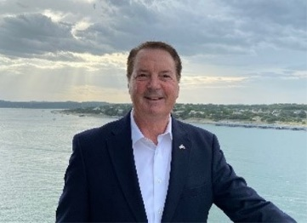 | WHY THIS BOOK? WHY NOW?  A Great tool for students, teachers, leaders, and speakers  You may have learned of these in school, but it is up to us to make sure our children and grandchildren learn of them and their AmeriCAN-do spirit. Their example will inspire you and your family to live richer lives.  www.richardbattle.com
WHO ARE YOU?  - Recognized by the Junior Chamber of Commerce International as “The Outstanding Local Chapter President in the World”. Chapter awarded Outstanding Chapter in the United States  - Amazon Best Seller and award-winning author:  - AmeriCANS Who Made America – 19th Century  - Gold Award – Mom’s Choice 2026  - Gold Award – Reader Views – Young Adult 16+ NF  -AmeriCANS Who Made America – 18th Century  - Gold Award – Mom’s Choice 2025  - Bronze Medal – Reader Views – 2025 -Young Adult NF  - The Unopened Present  - - Gold Medal – Family/Parenting – Illumination Awards  - - Gold Award – Mom’s Choice – 2024  - - Bronze Medal – Readers Favorite - 2024  - - Finalist in Memoir & Motivation – Next Gen Indie Awards  - Made in America by AmeriCANS not AmeriCANTS  -Honorable Mention -How-To, New England Book Fest 2022  -Honorable Mention-How-To, So Cal Book Fest 2022  - Life’s Daily Treasure: 366 Doses of Hope, Optimism, Personal  growth, and Encouragement  - Finalist-Next Generation Book Awards - 2022  - Surviving Grief by God’s Grace  -Writer’s Digest – Honorable Mention- Religion  - Navigating Life’s Journey  - 2nd Place – Self-Help – Reader Views 2021  - 3rd Place – Self-Help – CIPA EVVY Awards 2021  - Conquering Life’s Course  -First Place – Self-Help – Reader Views 2020  -3rd Place – Self-Help – CIPA EVVY Awards 2020  -Finalist-Motivational – Readers’ Favorite 2020  - Unwelcome Opportunity  -Gold Medal – Readers’ Favorite 2019  -2nd Place – Reader Views 2019  -Bronze Medal- Illumination Book Awards 2020  - The Four-Letter Word That Builds Character 2006  - Finalist - USA Today’s Best Books –Business Motivation - |  |  | - The Volunteer Handbook: How to Organize  and Manage a Successful Organization.  - The Master’s Sales Secrets  --  “This book is a history book, an inspirational book, a record book, a chronicle of multiple generations and a vital reminder of who we are!  I am proud to be an AmeriCAN as described by Richard Battle. This book will make you proud as well. It is the kind of book you can read aloud with your kids.” - Jim Cathcart, Author and Proud Patriotic AmeriCAN. Founder of Cathcart.com  “What a trip ...! Just finished your 20th Century edition of AmeriCANS who made America. You have captured the essence of what these people did for all of us. And you continue to educate me about so many unknown facts about ALL included in this work. Now I am going to get your 19th century Edition to complete the trilogy!!” - Tom Van Fossen, Dallas Sons of the American Revolution Vice President  “This book is an easy-to-read collection of well-written stories. Richard’s storytelling makes these accounts both inspirational and deeply encouraging. – David Gillian, Director of Development, Texas Baptist Children’s Home  https://amzn.to/4g8CGOc
WHAT IS THE PLATFORM TO DRIVE SALES?  - 30-plus years as a speaker and trainer committed to reinforcing its message to ensure maximum promotion.  - Powerful keynote and workshops based on the book will promote back-of-room sales.  - National campaign for Radio and TV interviews. Experience and contacts from previous books.  - Bulk sales to businesses. |  | 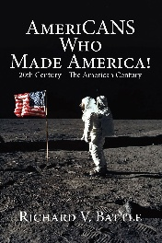
WHAT CAN WE TELL BOOK BUYERS?  Readers will learn of ordinary people with the AmeriCAN-do spirit that left us the gift of this uniquely prosperous country. |  | WHAT’S IN THE BOOK?  - 43 Stories of 20th Century AmeriCANS  - 458 motivational / inspirational quotations  - 58 Illustrations

Note sheet

Richard V. Battle

Author of AmeriCANS who Made America: 20th Century – The AmeriCAN Century

and
Author of AmeriCANS who Made America: 19th Century – Growth, Division and Reunification 2025

Author of AmeriCANS who Made America: 18th Century – Birth of the Republic 2024

The Unopened Present 2023

Made in America by AmeriCANS not AmeriCANTS 2022

Life’s Daily Treasure: 366 Doses of Hope, Optimism, Personal growth and Encouragement 2021
Navigating Life’s Journey: Common Sense in Uncommon Times 2020
Conquering Life’s Course: Common Sense in Chaotic Times 2019
Unwelcome Opportunity: Overcoming Life’s Greatest Challenges 2018
The Master’s Sales Secrets: 44 Strategies for Sensational Sales Success 2018
The Four-Letter Word that Builds Character 2006
Surviving Grief by God’s Grace 2002
The Volunteer Handbook: How to Organize and Manage a Successful Organization 1988

FOR ADDITIONAL INFORMATION
EDITORS/PRODUCERS:
For review copies contact: Author: Richard V. Battle
Allen Media Strategies richard@richardbattle.com
Burke Allen at burke@allenmediastrategies.com 512-987-2058
or call 703-589-8960.

Cover Images

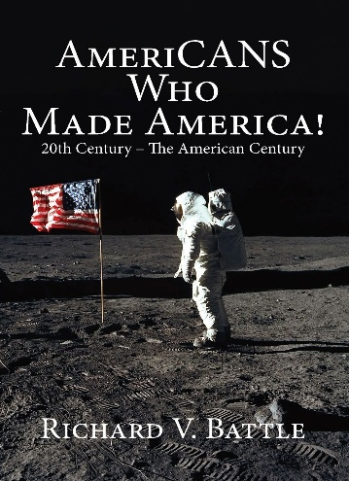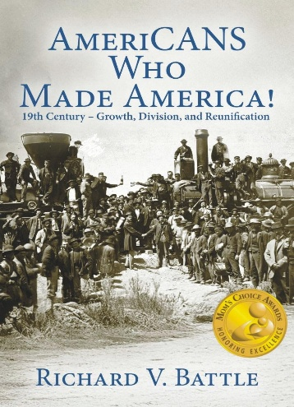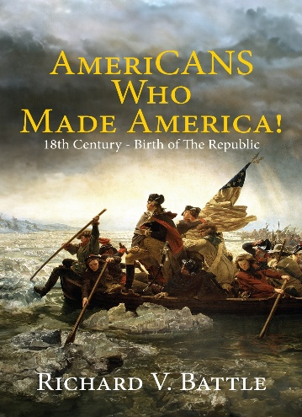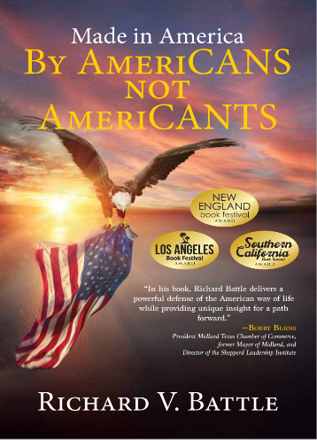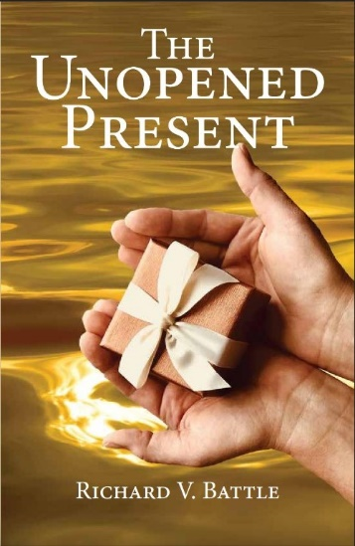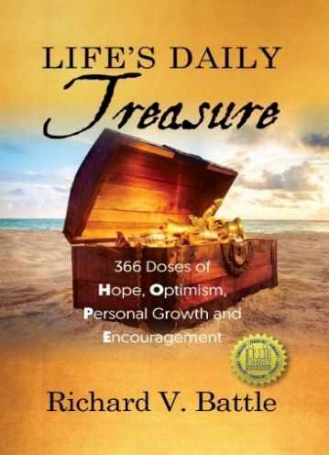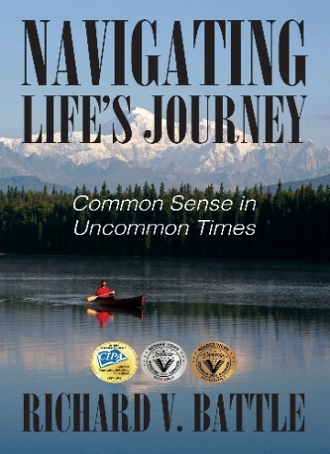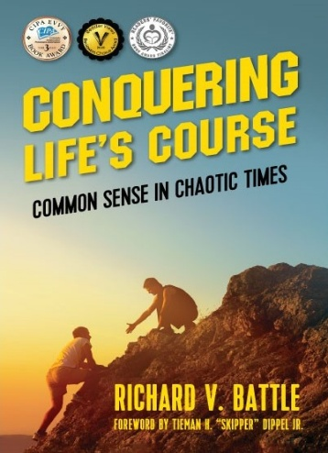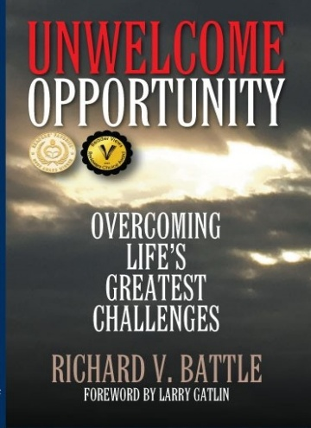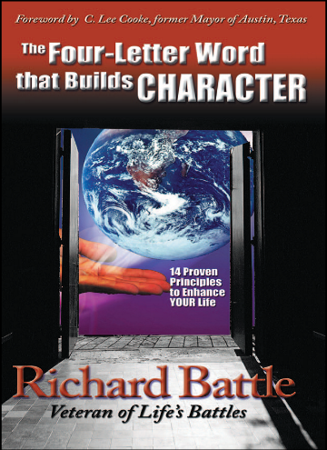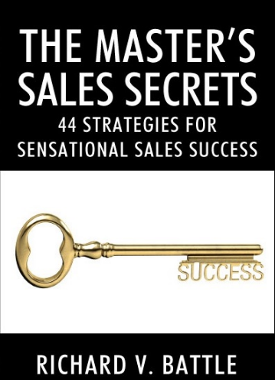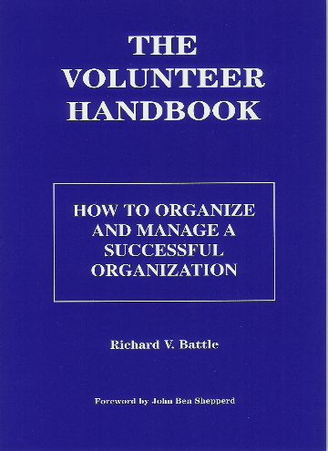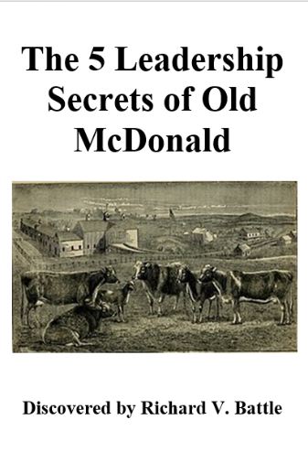

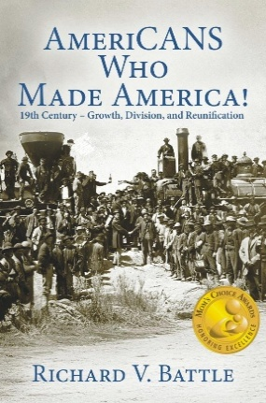  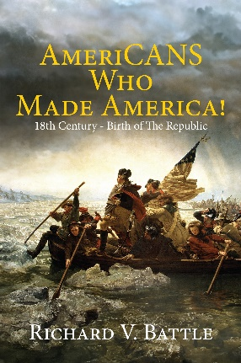  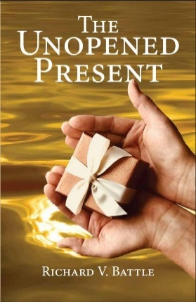  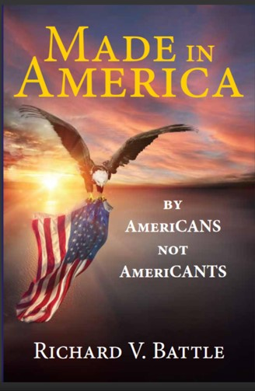  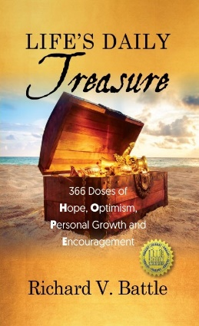 | Richard V. Battle Books  AmeriCANS Who Made America:  19th Century – Growth, Division, and Reunification  For young adults +, this is a great source to inspire readers, increase their patriotism and love for America, and a resource for students, teachers, leaders, and speakers!  It includes:  - 40 Stories of 18th Century AmeriCANS  - 358 Motivational & inspirational quotations  - 58 Illustrations  Available in paperback, Kindle, Nook, and audio editions.  AmeriCANS Who Made America:  18th Century – Birth of The Republic  From the very first page of this book, inspiration will fill you with the AmeriCAN-do spirit of the people who forged American success! You will see how their life examples can help you positively impact yourself, your community, and your country and impact the future.  It includes 40 Stories of 18th Century AmeriCANS, and 245 quotes.  Available in paperback, Kindle, Nook, and audio editions.  The Unopened Present  What life lessons do you want to teach your children? What if you do not live to communicate them?  Richard’s son passed prematurely, leaving the 43 essential life lessons unopened.  Richard added commentary and depth to the 43 lessons from the letter, and the present awaits you to open.  It includes 50 Scriptures, 51 quotes, and 18 Battle’s Bullets.  Available in paperback, Kindle, Nook, and audio editions.  Made in America  By AmeriCANS not AmeriCANTS  Made In America by AmeriCANS not AmeriCANTS is an uplifting volume providing readers the tools to learn, lead, and leave a legacy benefitting those who follow us.  If you want to fulfill your dreams and destiny, this book's AmeriCAN principles and examples will accelerate your quest.  It includes 103 quotes, 108 Battle’s Bullets, and 135 Sage Sayings.  Available in paperback, Kindle, Nook, and audio editions.  Life’s Daily Treasure  366 Doses of Hope, Optimism, Personal growth, and Encouragement  Does It Seem Like Hope Has Vanished?  You’re Not Alone – Here are 366 Daily Doses.  Life’s Daily Treasure is for adults seeking hope and encouragement in an ever-challenging world.  It is a book of hope for today and every day and an excellent gift for all occasions!  Its 2,196 entries of inspiration, motivation, and American celebration are wonderful resources for speakers, pastors, teachers, and others.  Available in Hardback, Paperback, and Kindle editions.
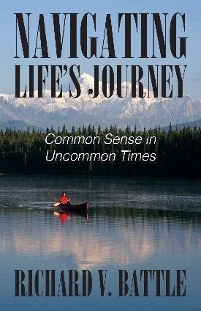  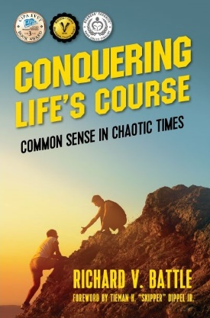 | Navigating Life’s Journey  Common Sense in Uncommon Times  If you liked Conquering Life’s Course, you’ll love this successor to it.  Forty bite-sized, easy-to-read chapters of time-proven principles will restore your confidence in your beliefs, encourage you to defend them, and inspire you to teach your sacred values to your loved ones. It will lift your spirits and restore your hope in America.  It includes 250 examples and 75 motivational quotes.  Available in paperback, Kindle, and audio editions.  Conquering Life’s Course  Common Sense in Chaotic Times  Do you wonder if Common Sense is vanishing?  It will entertain and inspire the reader to think, laugh and undertake actions to realize a more fulfilling life.  If you or a loved one has given up on understanding the world of today, Conquering Life's Course is a must-read. It assures readers that age-old traditions and wisdom still rule over unproven theories.  It is concise, easy to read, and offers invaluable insights that readers can share with the entire family.  Available in paperback, Kindle, and audio editions.
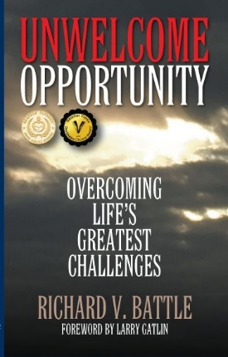 | Unwelcome Opportunity –  Overcoming Life’s Greatest Challenges  What do you do when you experience divorce, two heart procedures, and a cancer diagnosis within ten months? It is the story of an ordinary man facing multiple life challenges in one ten-month period.  In it, you will see an example of God's presence and provision that helped Richard Battle traverse this turbulent period of his life.  Available in paperback, Kindle, Nook, and audio editions.
 | Surviving Grief by God’s Grace  There is no greater loss in this world than losing one's child. This book is the first-person account of the author's loss of his first and then only child. It is a story of the grief, spiritual quest, and grace that helped Richard and his family survive and to live with hope for the future.  Available in paperback and Kindle editions.
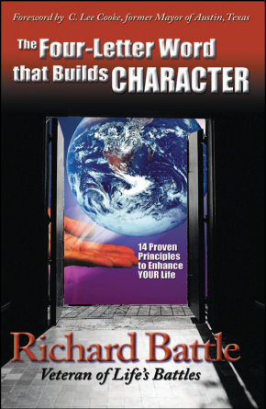 | The Four-Letter Word That Builds Character  Why are so many young people having a problem adapting to society today? Where have we gone wrong? Is it the parents or society in general? The Four-Letter Word That Builds Character can make a difference in this scattered and cluttered world. Based on the lessons learned from the author’s first job and parental teaching of traditional values that have proven to be the foundation for lifelong success, this volume teaches 14 proven principles of a good work ethic and character.  Available in paperback Kindle and audio editions.
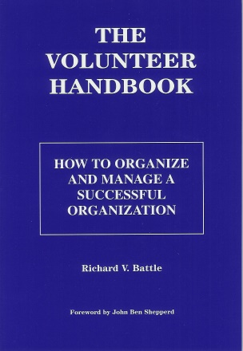 | The Volunteer Handbook  How to Organize and Manage a Successful Organization  More than 75 topics provide specific ideas to help volunteer leaders maximize their efforts. Topics include Long-range, annual and event planning; Training board and prospective board members; how to recruit new members; ten steps to activate or reactivate a member; six steps to building a successful team; and how to motivate your membership. Effective Delegation. Managing non-performers.  Available in paperback
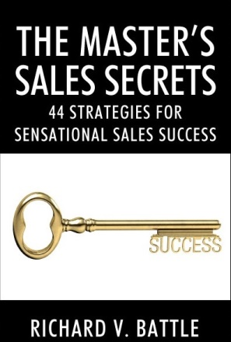   | The Master’s Sales Secrets  44 Strategies for Sensational Sales Success  Richard V. Battle offers business leaders a graduate-level class in what he learned over forty-plus years in sales and sales management. It is Practical, sharp, and clearly communicated. The Master's Sales Secrets can be read cover to cover or referenced strategy by strategy.  Available in paperback and Kindle editions.  The 5 Leadership Secrets of Old McDonald  Inspiration appears at various times in a multitude of ways. People have wondered since the song began in the 1720s what Old McDonald meant by E-I-E-I-O. Now we know that they are his leadership secrets that I received by inspiration.  You can benefit from those secrets in The Five Leadership Secrets of Old McDonald, NOW



www.richardbattle.com

