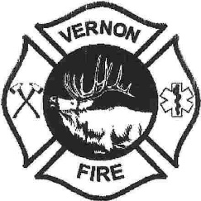

Courtesy Notice

THAT A QUORUM OF THE VERNON FIRE DISTRICT BOARD MEMBERS MAY BE PRESENT

WHAT: Vernon Fire District Open House

WHEN: Saturday, June 28th, 2025 -10am to 2pm

WHERE: 25 County Rd 3142, Vernon AZ 85940

Notice to the Public that a quorum of Vernon Fire District Board Members may be attending this event. There will be NO Vernon Fire District Business conducted.

DATED THIS 26th, June 2025- BY Wendy Sharp

