Courtesy Notice

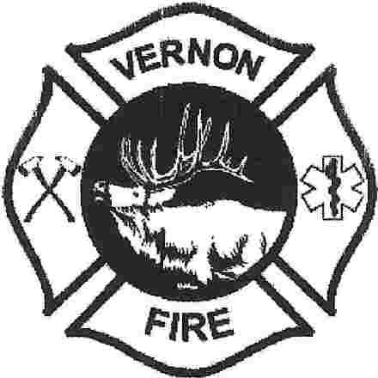

**THAT A QUORUM OF THE VERNON FIRE DISTRICT BOARD MEMBERS MAY BE PRESENT.**

**WHAT:** **FALLEN FIRE FIGHTER MEMORIAL**

**WHEN: JUNE 30TH AT 3:30**

**WHERE:** **PINETOP COUNTRY CLUB ESTATES**

**7213 GERONIMO RD.**

**PINETOP, AZ 85935**

Notice to the Public that a quorum of Vernon Fire District Board Members will be attending. There will be NO Vernon Fire District Business conducted.

POSTED THIS JUNE 28th, 2023 BY Wendy Sharp