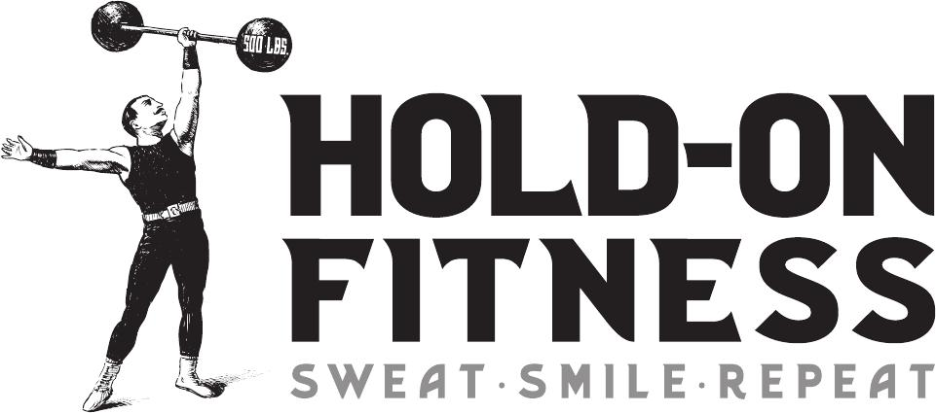

Come sign up for class
or email to schedule a free intro fitness class

Group Class Times: Tuesday and Thursday
4pm to 5pm and 5:30 to 6:30

Personal Training Sessions: Monday, Wednesday, Friday
4pm to 6:30pm (30 minute or 1 hour sessions)

