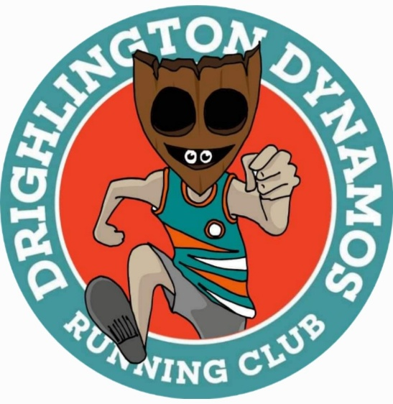
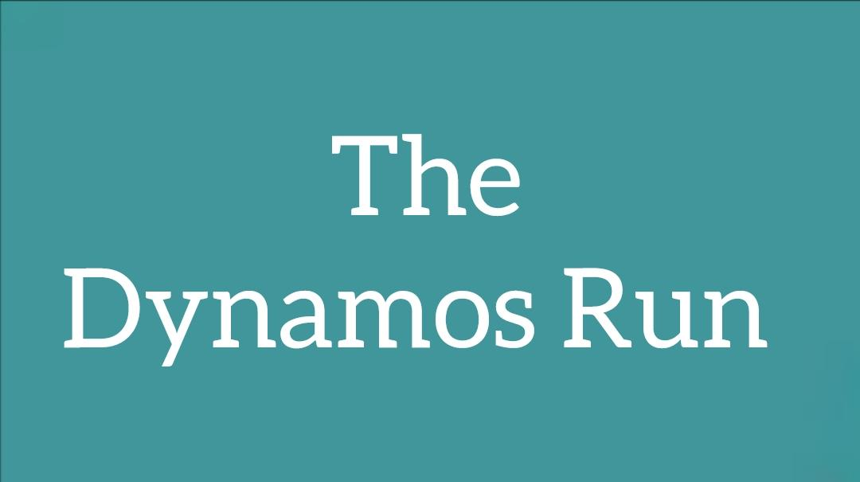
September 2023
Welcome Dynamos to your September 2023 newsletter. We hope that you are enjoying the fabulous late summer weather we are currently experiencing. Darker evenings are unfortunately on the horizon and are beginning to show on our longer routes. So whilst summer is still in the air let’s have a look back on a superb summer of running and walking. We’ll take a look too at what’s coming up for Drighlington Dynamos.

The Great North Run
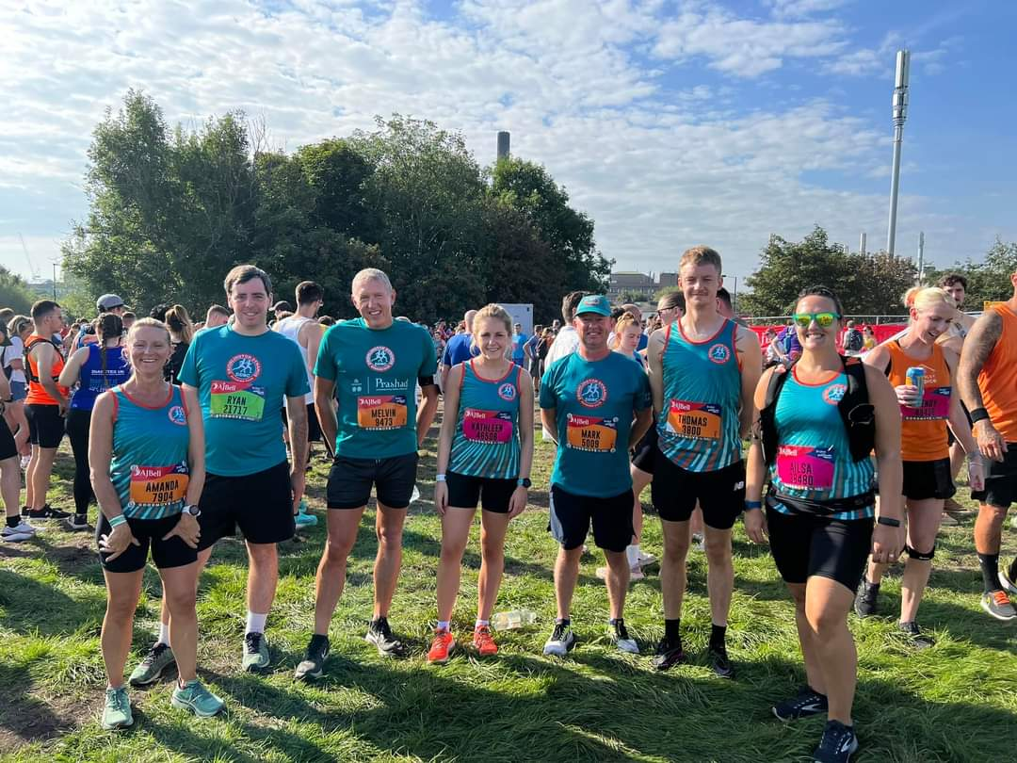
10th September 2023 saw the Drighlington Dynamos and an army of their supporters take part in one of the largest half marathon events in the country. The Great North Run was really a day of two halves for many and a day they will not forget for a while. Superb weather to start with celebrating Mo Farah’s last GNR soon turned into a nightmare for runners when flash flooding engulfed South Shields forcing the Metro to suspend its services. Thankfully everyone returned home safe and well with medals proudly received.

Marathon Du Medoc

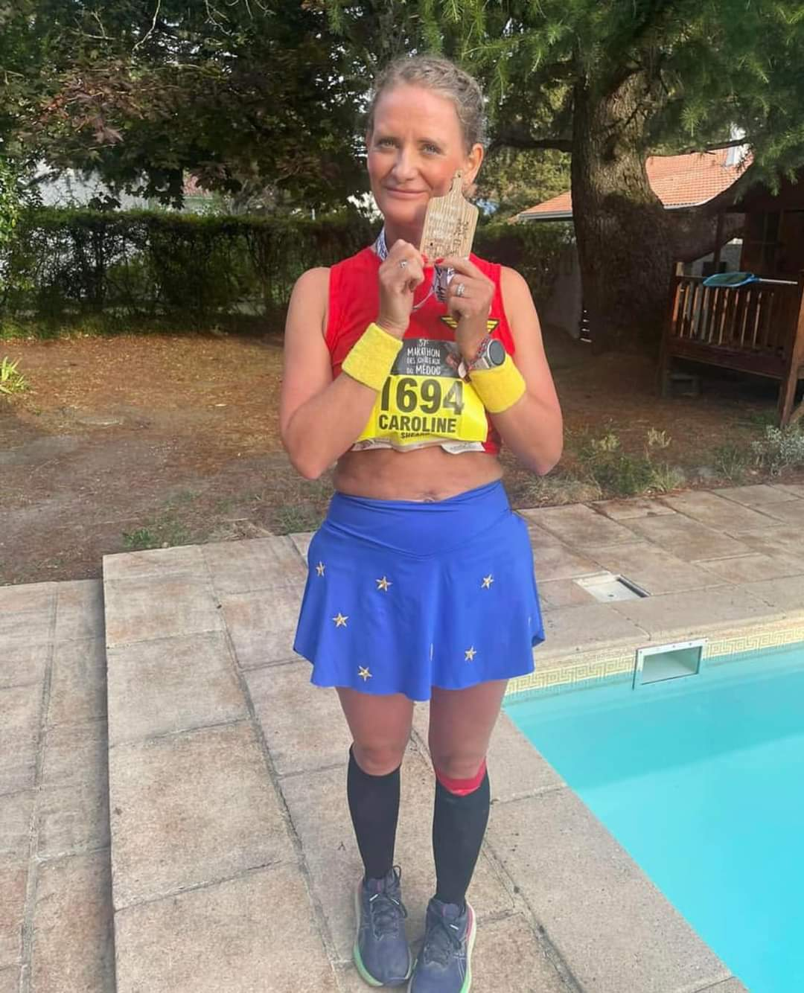
Dynamos have been on tour this year far and wide. Even reaching as far as Australia. However this particular Dynamo on tour has really stood out for a number of reasons this summer. Caroline Sugden or valued committee member and Membership Secretary has had to overcome injuries this year. She’s got back into running through supporting the fabulous Drighlington Dynamos Walkie Talkies. Not only that but has just completed her first marathon and in the process raised hundreds of pounds for charity. Congratulations “Chicken”.

A Summer Of Parkrun
Summertime, the traditional season for holidays with the family. This hasn’t stopped our fabulous members getting out, staying fit and keeping active whilst taking a break from the normal. Parkrun has continued to be a popular choice for our members and their families, even the very youngest getting involved. Great to see everyone getting involved and sharing their exploits. Keep up the amazing work everyone. Remember too that Parkrun is suitable for walkers as well. Parkrun takes place every Saturday at 9am with events worldwide! What are you waiting for? Give it a go. Information about Parkrun and how to register and join in for free can be found at https://www.parkrun.org.uk/register/
Leeds 10km

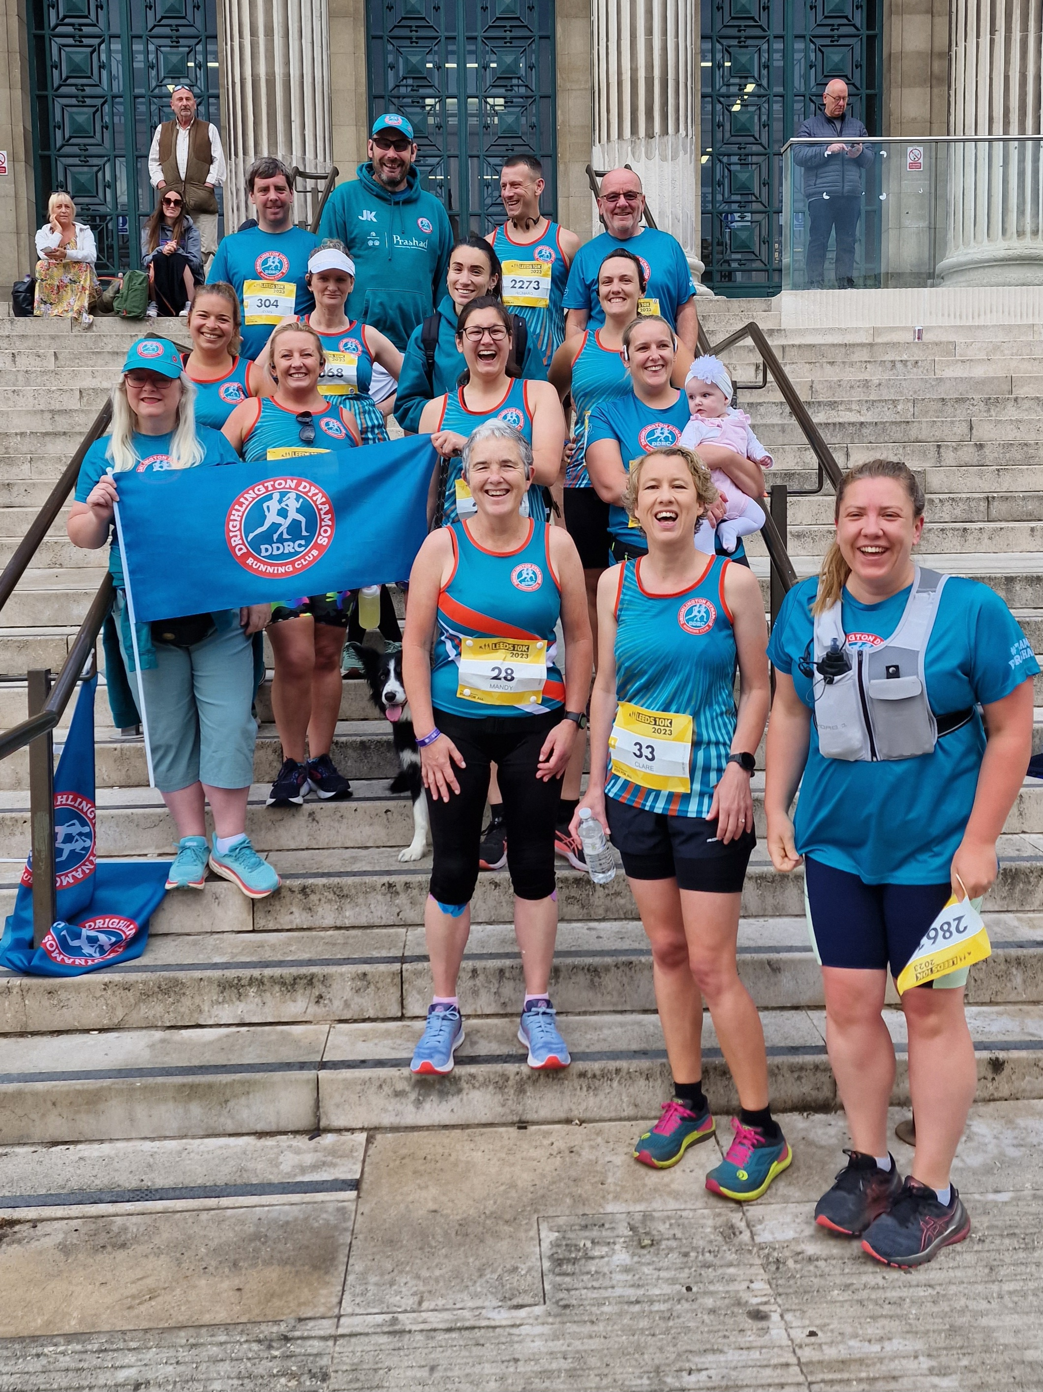
17th June was the another big day out for several Dynamo members. This time the Leeds 10k was no match for the jade army. Dozens of Dynamos took part in both running and supporting this event. For several members this was their longest race to date for others seconds and in some cases minutes shaved of their personal bests. Well done everyone but especially to the fabulous supporters on the day!

Drighlington Dynamos Walkie Talkies

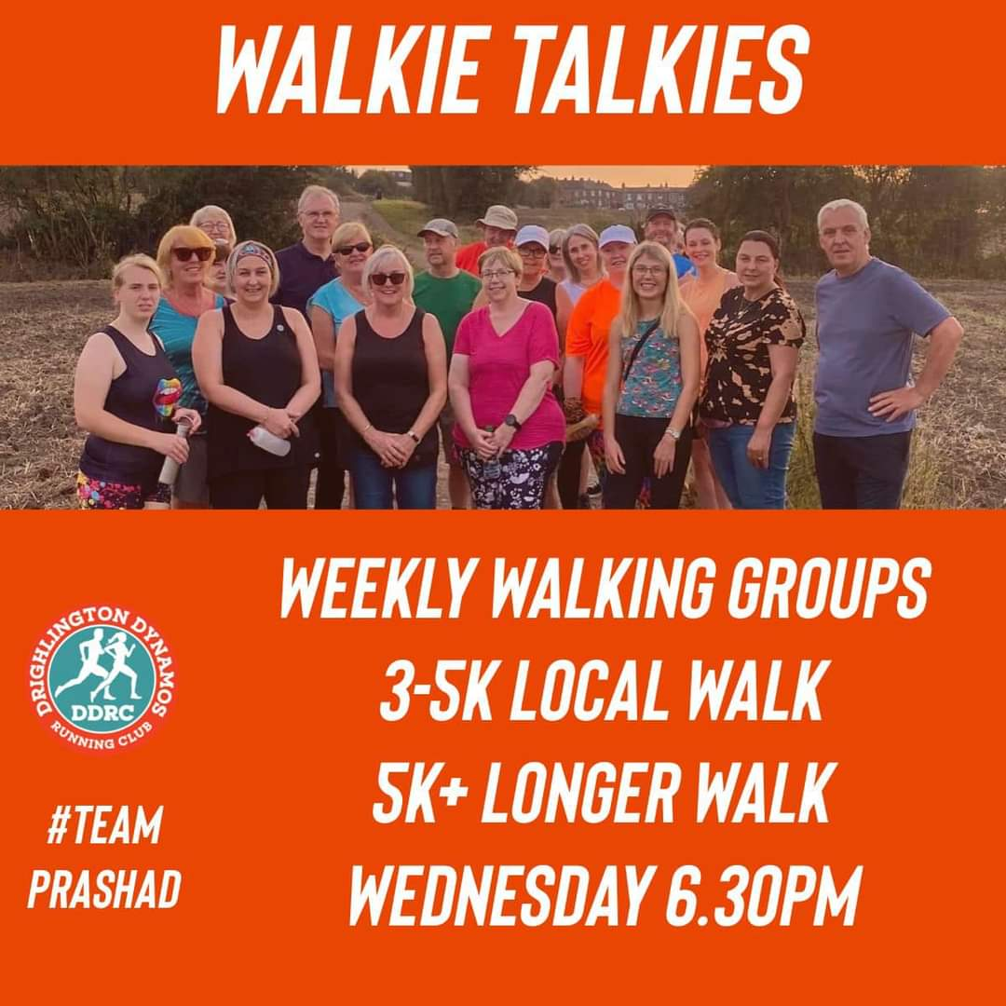
The Drighlington Dynamos Walkie Talkies continues to go from strength to strength with more and more members enjoying the inclusive, well being walks. So much so that we’ve had to recruit more walk leaders and introduce a second Drighlington Dynamos Walkie Talkies group. We now have two groups to choose from on Wednesday night both leave Drighlington Community Sports Club at 6:30pm. How to register and join in for free can be found on the link below.
https://groups.runtogether.co.uk/DrighlingtonDynamos/Runs

DDRC Members of the Month
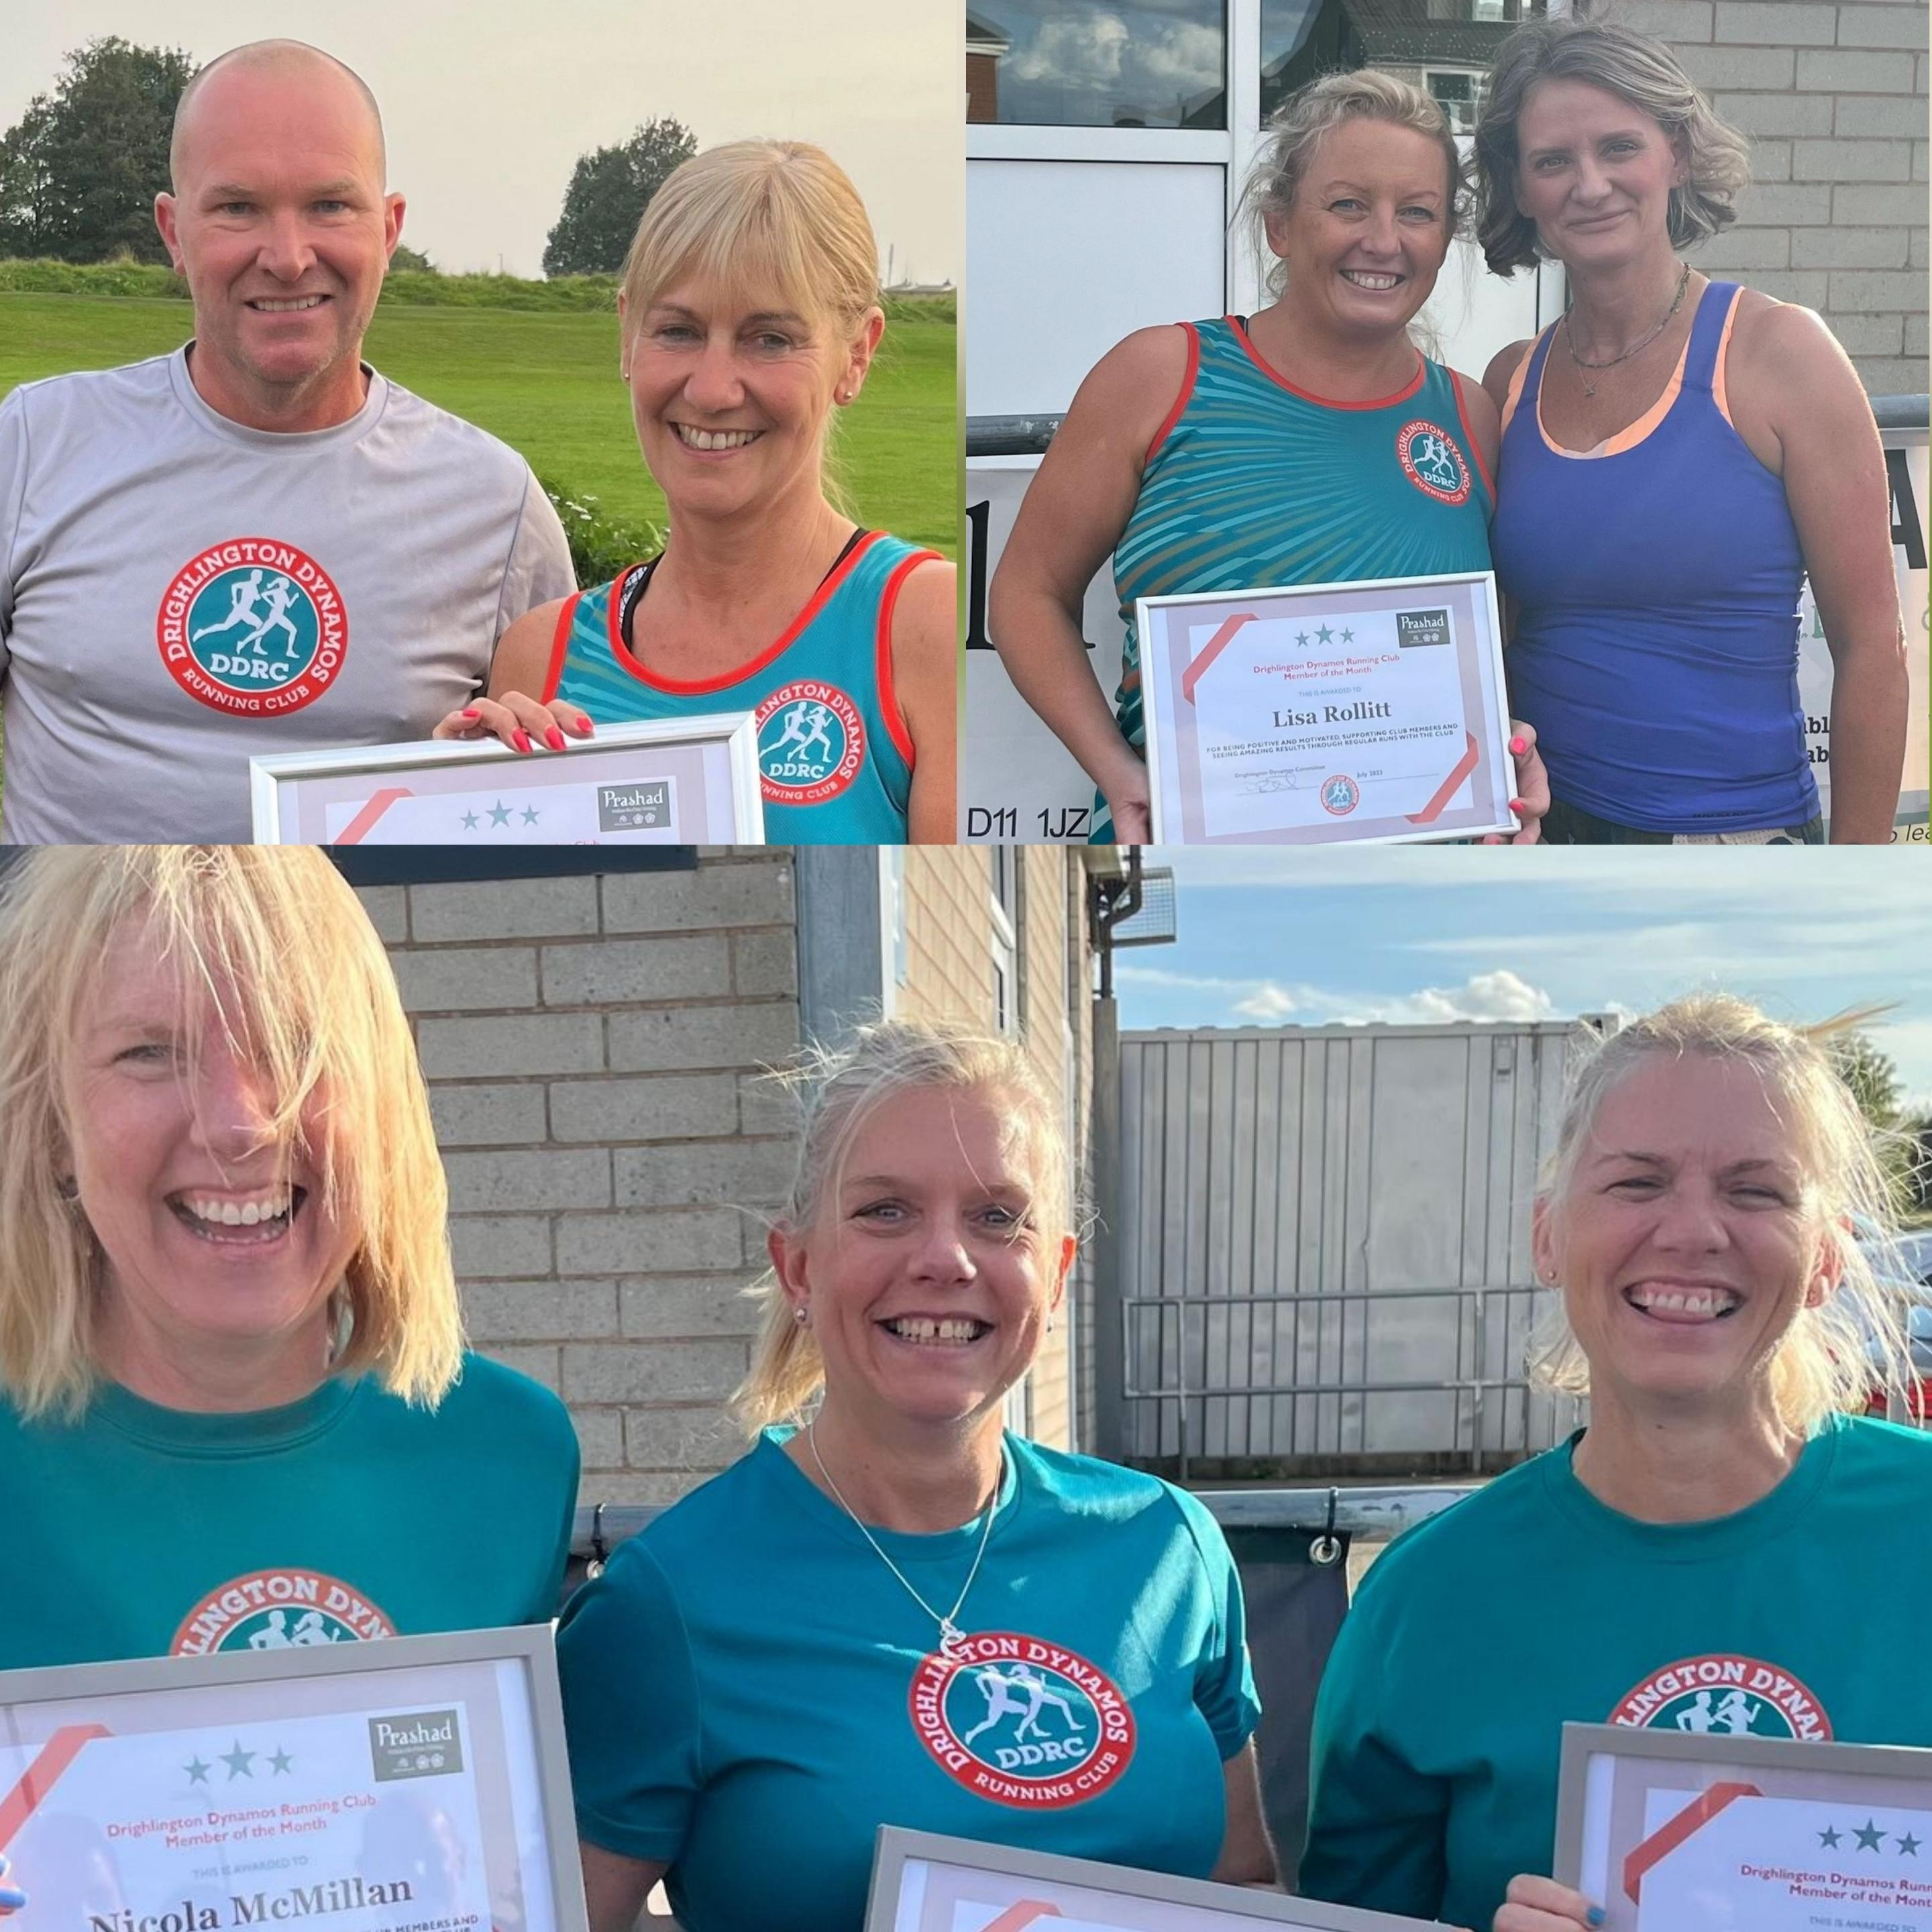
Congratulations to our most recent recipients of the Drighlington Dynamos member of the month. Firstly we saw Nicola McMillan, Vanessa Myers and Charlotte Mincher collectively known as “The Three Sisters” receive the awards for June. Secondly we congratulated Lisa Rollitt for picking up July’s award. Lastly but by no means least we saw Sue Mulholland collect the member of the month for August. Well done ladies very well deserved and keep up the amazing work.

DDWT Member of the Month
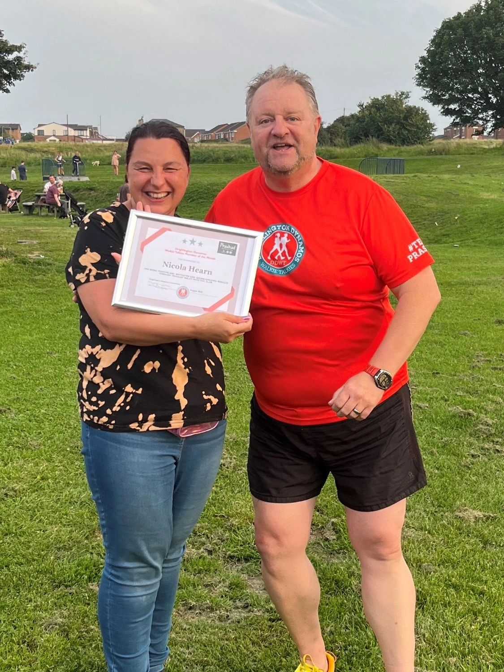
As our wonderful club continues to grow and push forward we want and expect all members old and new regardless of ability to enjoy the benefits of this inclusive club. We have therefore decided that our Drighlington Dynamos Walkie Talkies group need to celebrate and recognise their members in the same way our running fraternity do. So without further ado let’s get onto our inaugural Drighlington Dynamos Walkie Talkies Member of the Month. A huge congratulations to Nicola Hearn her walking, confidence and ability continue to grow weekly with DDWT. The smile says it all. Very well done Nicola keep up the brilliant work.

Run for Jo 2023

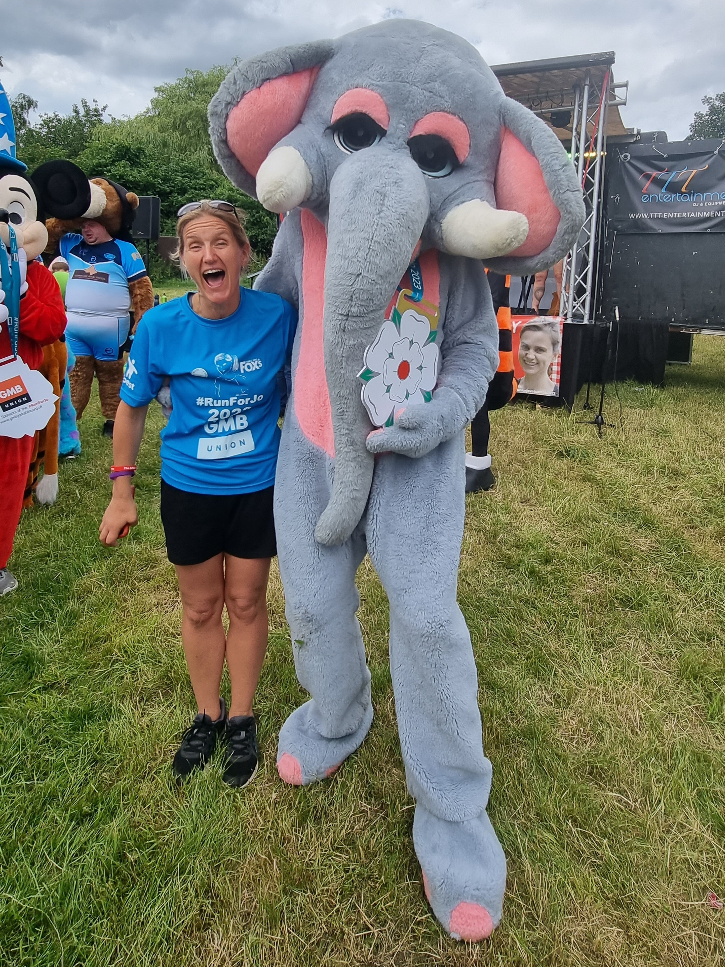
On Sunday 25th June the Dynamos help celebrate the life and legacy of a great West Yorkshire lady Jo Cox. Hundreds of people gathered across the day at Oakwell Hall to participate and support 3 races around its idyllic grounds. After meeting and speaking to Jo’s sister on the day. She personally wanted to thank each and every Dynamos for their tremendous support on the day. Without so many of our fabulous volunteers events like this simply couldn’t take place. Congratulations everyone and give yourselves a big pat on the back. Thank you once again for make our club stand out for all the right reasons.
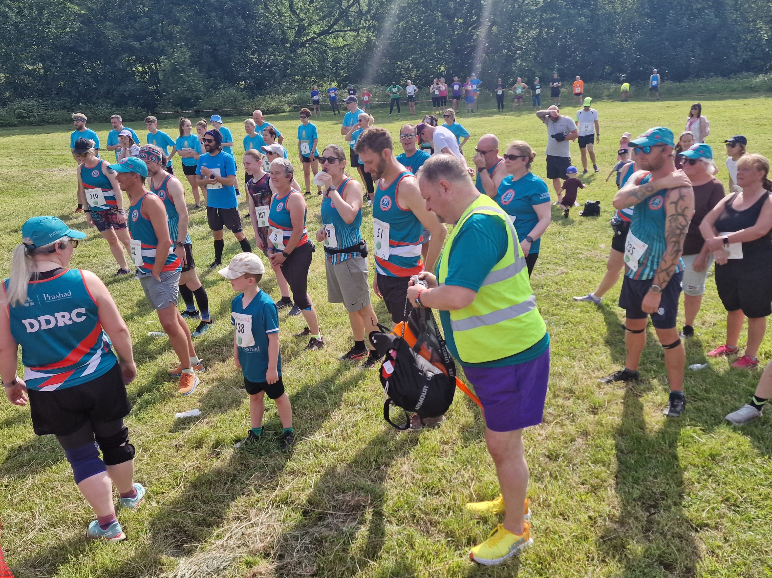

New run leaders alert.
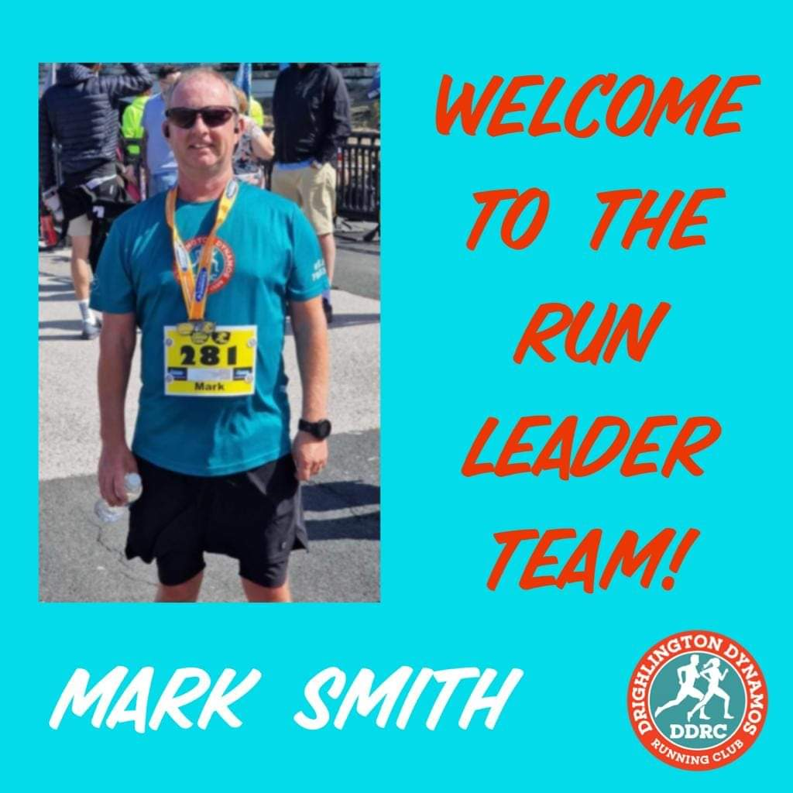
With the continued growth of the club we are pleased to announce yet another new runner leader in the form of Mark Smith. Mark has run with the club on a regular basis since its infancy. I’m confident that Mark will make a fabulous addition to the team and I’m eagerly waiting for his first club lead. Please join me in welcoming Mark and thank him for his commitment to the club. Welcome aboard Mark.

#####Coming up soon!#####

York Festival of Running
The Yorkshire Marathon returns on 15 October 2023 to celebrate the 10th anniversary of the event enjoyed by thousands of runners every year. This scenic route takes runners along charming country lanes and past picturesque historic sites. Taking place at the same time of the Yorkshire Marathon, the Yorkshire 10 Mile is a shorter but no less stunningly scenic route through York.

Halloween 2023
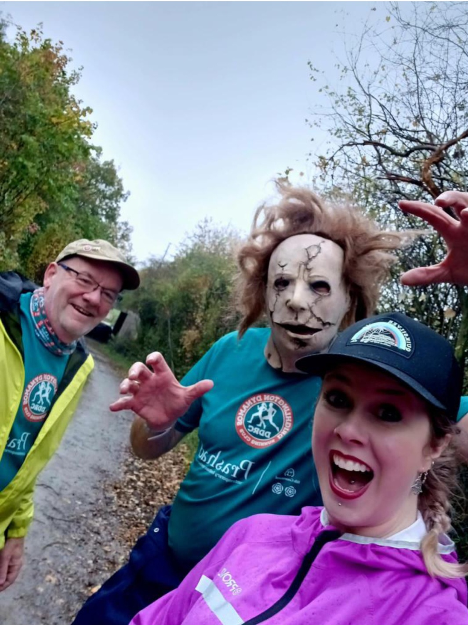
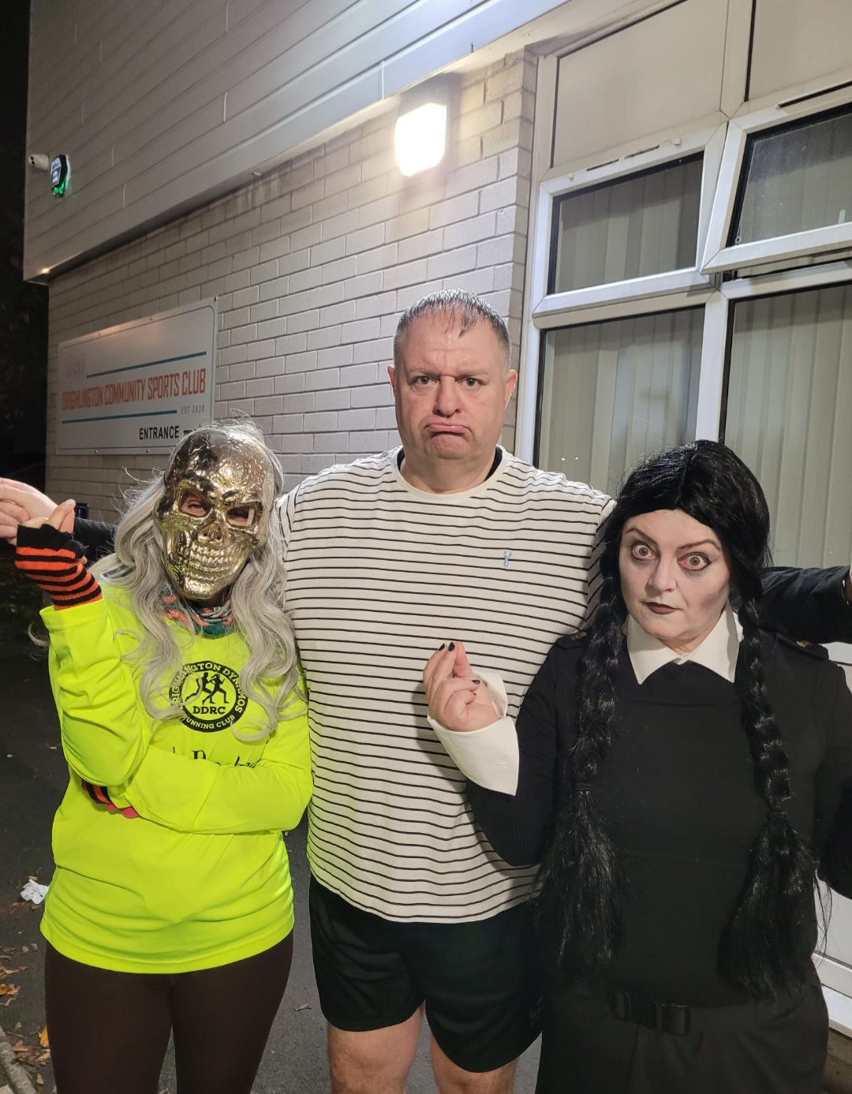
Prepare to scare. Drighlington Dynamos Running Club and Drighlington Dynamos Walkie Talkies will be celebrating Halloween on Wednesday 1st November’s club runs and walks. As always fancy dress is optional but fun. Be creative as you wish but try to remember to be bright and be seen even when celebrating Halloween!

Next Edition
Next time find out more about Drighlington Dynamos Christmas Party 2023. Also the exciting news about Drighlington Dynamos Santa Dash planning. We can’t talk about Christmas yet surely!!!

Drighlington Dynamos Website
As always updates and news can be found at our very own website which is www.drighlingtondynamos.co.uk There are new news stories and photos added regularly. You’ll find access the back editions of our newsletter, see the run leader bios, members of the month and so much more!

Editors Comments
I hope you’ve enjoyed reading this latest bumper edition of the Dynamos Run. There’s plenty more coming in the next edition. Remember Dynamos Run, Walk and socialise too. Enjoy squeezing out the last drops of summer. See you out on your next run or walk.

