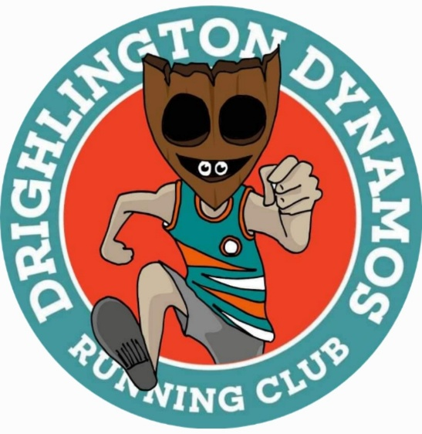
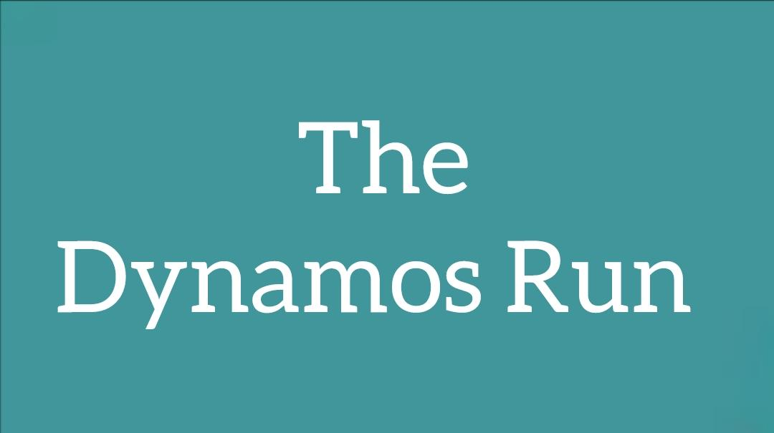
Jan 2023
Welcome Dynamos to 2023. We trust that you have had a fabulous festive period and here’s to a prosperous 2023. I think that many of us have found this festive holiday period to be the first “proper one” since Covid restrictions were lifted. I also think that as a result this has lead to more people socialising and several of us have caught seasonal bugs. I for one have definitely over indulged this year end too, again with our new found freedom. So if you, like me, are ready to blow away those cobwebs and shed a few of those extra pounds then remember this slogan “A new year, a new you!” Without further ado let’s have a look back at some of our achievements in 2022 and see what 2023 has in store.
DDRC 2022 A Brief Overview
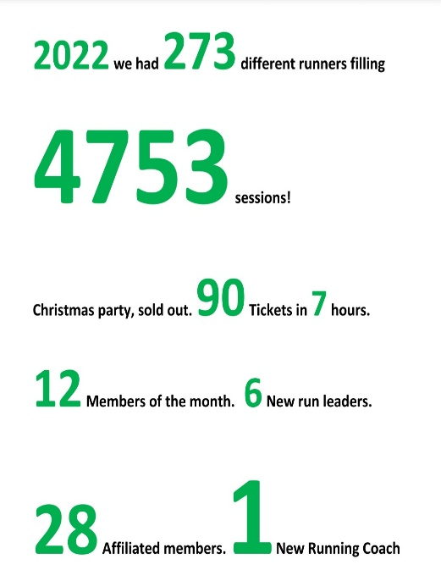
Let’s start with a look back at an amazing year of achievements from everyone at the club. We’ve seen everything from new members graduating from C25K to members running their 1st marathons. The club has welcomed several newly qualified runleaders who have stepped up from running within the club. We’ve seen our first qualified running coach’s progression at the club. DDRC has now welcomed over 600 members into the club. Here are some astonishing facts and figures.
Member of the Year
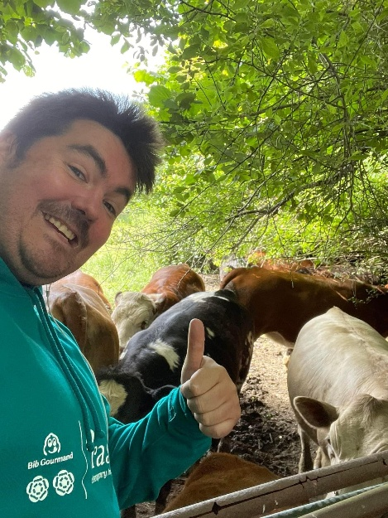
Nick Cross handed the Member of the Year Award to Phil Wilkins in December. Nick was our member of the year for 2021, our first member of the year due to his commitment and support for the club during our first year. Phil was awarded the member of the year for 2022 for his commitment and enthusiasm during the year, stepping up to a run leader role, organising weekly park runs and the Dynamos Park Run takeover at Oakwell Hall. Congratulations Phil.

Drighlington Walkie Talkies

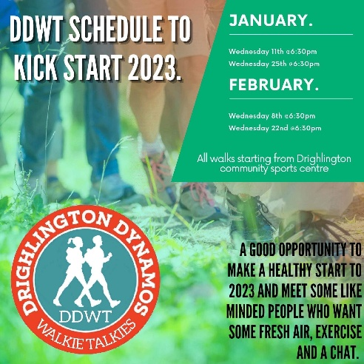
2022 saw the relaunch of the Dynamos walking group with its own identity ‘The Walkie Talkies’ for members, family and friends who want to exercise together and meet like minded people, for those who may be returning from injury or those who just fancy a walk instead of a run.
The Walkie Talkies has gone from strength to strength and 2023 saw a successful start to the year with 25 people taking part in the club walk.
A massive thank you to Mandy Boole, Karen Holroyd, Louise Kavanagh, Nick Rollitt and Caroline Sugden for volunteering their time as walking leaders

Bramley Parkrun 300th Event
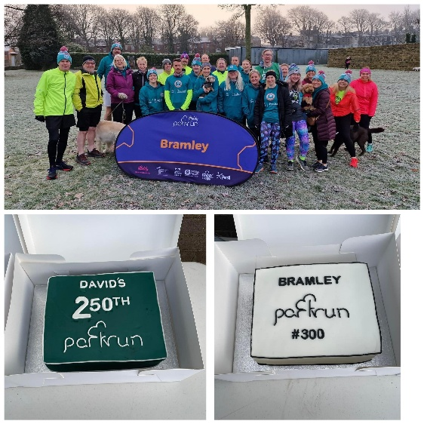
On Saturday 21st January, on a very chilly, misty morning, David Sullivan completed his 250th Parkrun at Bramley Park. His fantastic milestone Parkrun coincided with Bramley’s own amazing milestone of their 300th run!! Congratulations to both!! Parkrun is a fabulous way so start your weekend. Anyone thinking about it for the first time just need to register for free at
https://www.parkrun.org.uk/register/
Details about barcodes and how to take part can be found on the link above. It also is run solely by volunteers and Parkrun always welcome new runners and indeed volunteers.

#dynamosontour
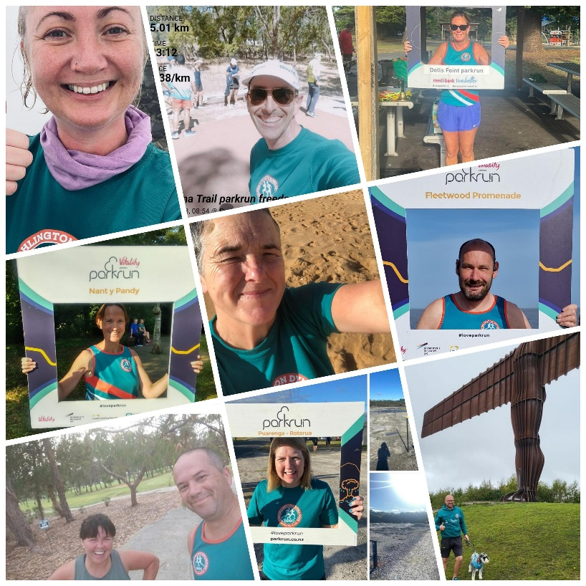
Dynamos are taking their runs and walks far and wide, here are a few members posting photos from holidays abroad and in the UK, at the top of mountains and on sunny beaches.
Don’t forget to take your club colours and send us your photos. Let’s see how far we can take these colours. Run or walk #dynamosontour

Leeds Sports Awards
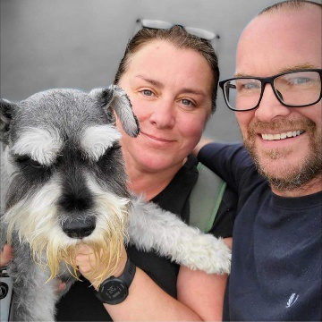
Our very own Louise and Danny Barnes have been successfully nominated for an award at this year’s Leeds Sports Awards. They with 3 other finalists in the category of Inspirational Community Champion (sponsored by University of Leeds) I am sure you’ll all agree that the work and effort they have put in founding and running Drighlington Dynamos is monumental. I am extremely excited for the evening and regardless of the result they are already winners to over 600 members of the Drighlington Dynamos.

London Marathon
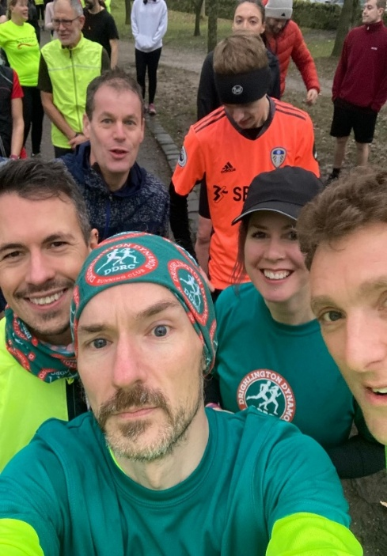
As an affiliated club, we are able to offer one free place to an EA affiliated member each year for the London Marathon.
On 5th December, the draw took place with six brave members hoping to win the place for 2023.
Nathan Ward (our very own Mr Merchandise) was our lucky winner for 2023. Nathan will be taking part in three Marathons during the year: London, Leeds and Yorkshire Marathons. All the best Nathan for all three, we look forward to seeing your results and we will be cheering you on!!
DDRC Events Calendar 2023
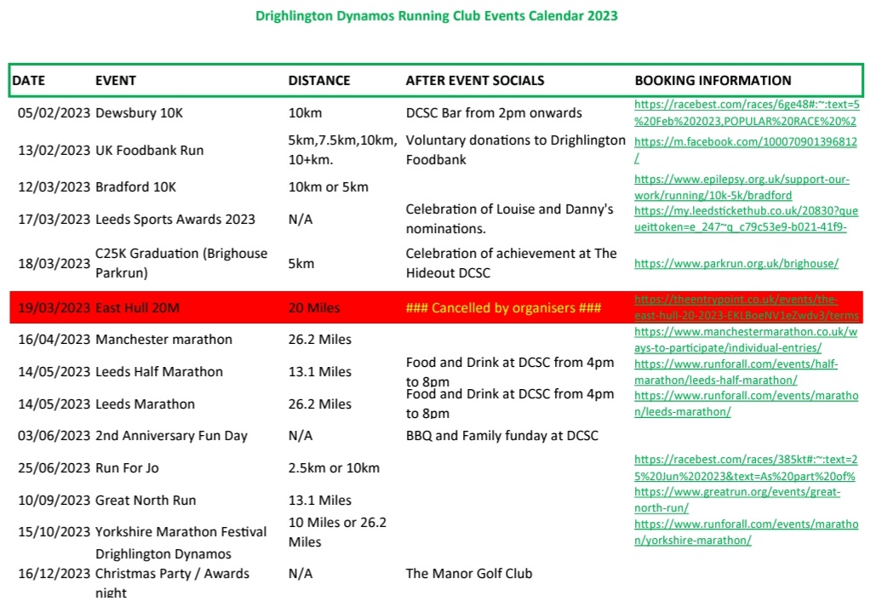
The above events are just a sample of what’s to come this year. Keep an eye out for up coming events during the year.

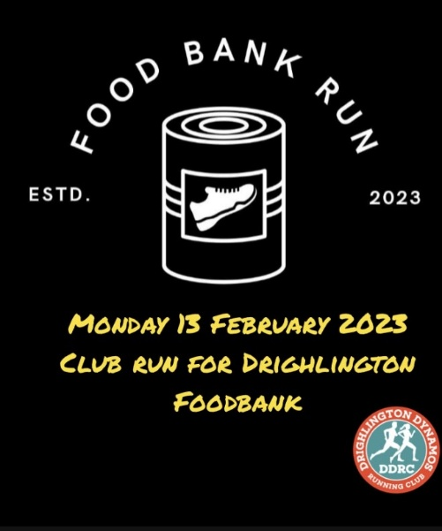
National Food Bank Run
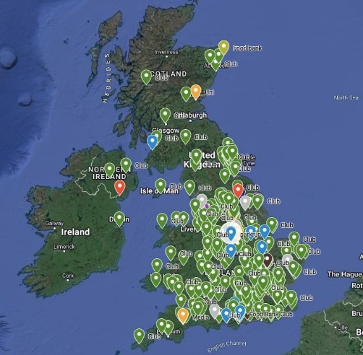
On Monday 13th February, the Dynamos will be supporting the National Food Bank Run where running clubs across the UK will be running and collecting for local food banks throughout February. We already support Drighlington Foodbank and we are so grateful to all members who regularly contribute. Trevor Martin who runs the Food Bank at Drighlington Methodist Church filled his car when he came to meet the Dynamos. Our member Kate Weldon now volunteers at the Food Bank and has continued to collect monthly at our club runs. The Dynamos have been added to the map as participants in the National Food Bank Run, let’s contribute to support this event. Further information will be posted the week before.

Dewsbury 10k
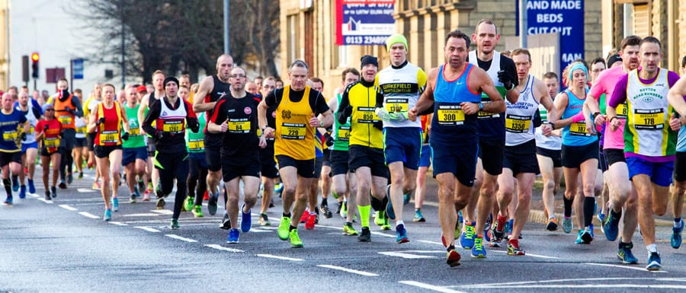
Dewsbury 10k on 5th February is usually the first race on the Dynamos calendar and this year is no exception. Close to 50 Dynamos are due to line the streets of Dewsbury and with the usual army of supporters it’s certainly becoming a very popular event for DDRC. It will be a great day for all with a celebratory drink or two afterwards in the Drighlington Community Sports Club bar from 2pm onwards.

Dynamos 2nd Anniversary Barbecue
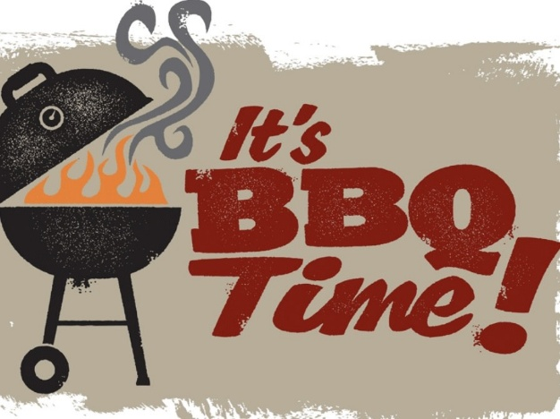
On Saturday 3rd June we will be celebrating the Dynamos 2nd Anniversary with a family fun day from 2-5pm at the Drighlington Community Sports Club.

Watch this space and reserve the date in your diaries!!!

Rob Burrows Leeds Marathon and Half Marathon
Many of our Dynamos have signed up to run in the Leeds Marathon and Half Marathon on 14th May 2023 whilst others have volunteered as Marshall’s or will be cheering on our members from the side-lines on the day.
Marathon training plans have started and the run leaders are supporting members with longer training runs as part of their own marathon training.
If anyone would like to be involved in organising a supporters group on the day for members, families and friends who can cheer the dynamos on at points along the routes, please message Louise Barnes or email ddrunningclub@gmail.com

Run for Jo 2023
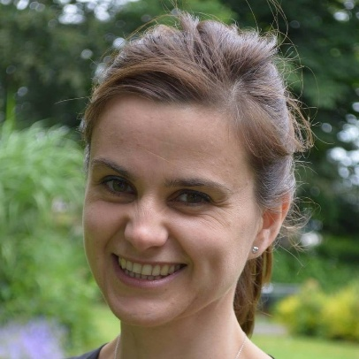
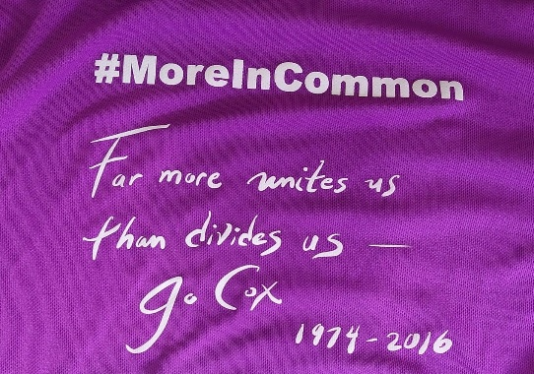
Sunday 25 June 2023 - Save the date.
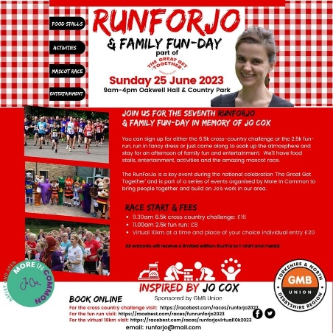
The 7th Run for Jo & family fun day in memory of Jo Cox will take place at Oakwell Hall. A number of members have already signed up to run and last year members also supported as volunteers. This is a great opportunity to get your family and friends involved in this community event right on our doorstep and to enjoy this get together in memory of Jo.
You can book via racebest.com to take part in the 6.5km or 2.5km events.
We look forward to seeing you all there!

####Now for the boring bits!####
RunTogether App
The Committee and its Run Leaders would just like to remind all members old and new to remember to cancel any booked places that they will not be attending. This allows availability for others on fuller runs and prevents everyone waiting around unnecessarily particularly in bad weather. Please also remember keep the medical information, next of kin and in case of emergencies contact details up to date on the RunTogether app. This is for your safety and wellbeing. In line with GDPR regulations your information is only available for run leaders and committee to see and access in case of emergency.

Code of Conduct
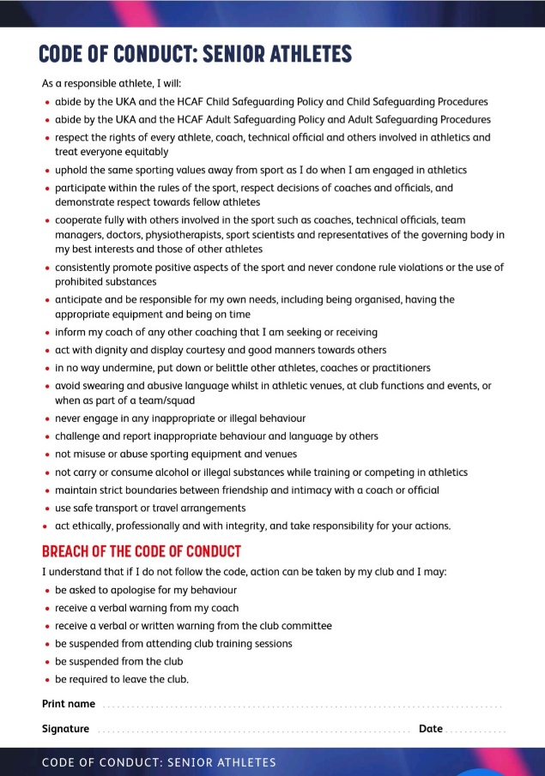
As the start of the year is upon us the Committee would like to remind all members new and old that we have a code of conduct for all members. This can be found on the DDRC Group Facebook page at the top in the files section. We also have a code of conduct for volunteers (Runleaders and Committee etc) again this can be found at the top of the DDRC Group Facebook page in the files section. We urge all members to make themselves familiar with its contents and if anyone doesn’t agree to abide by the code then please email the club directly at ddrunningclub@gmail.com and you’ll be removed from all the clubs social media platforms and asked not to attend any future club runs or events. This is massively important to adhere to the clubs and the committees ethos. It is also vitally important to ensure that we keep our EA and UKA affiliation.
Social Media Policy
When joining the club all members are asked to adhere to the clubs social media policy. This policy is there to ensure all members are treated equally, fairly and that posts are kept relevant and appropriate for a running club. Just as a reminder it is not permitted to ask for or promote sponsorship events on the club page. Obviously we actively encourage members to fund raise for their chosen good causes but keep their promotion of these events to their own social media profiles. It’s also vitally important that we don’t offer unused race bibs to other members of the club via our social media platforms. This is completely against EA rules and could lead to us losing our affiliation. Similarly do not share sportsshoes.com discount codes on our social media sites either. Again this could lead to these privileges for sportsshoes.com to be revoked. The codes are for members only. Thank you for your understanding.
Editors Comments
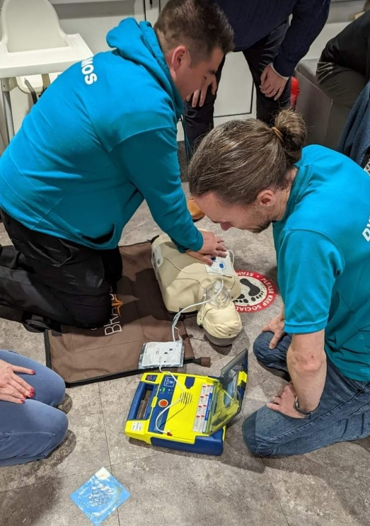
If, after reading all those policies and rules, you feel like you need resuscitation like this poor chap. Just remember that we are here for you. We want to maintain our inclusive ethos and welcome all members new and old. Everyone is entitled to miles of smiles running and indeed walking with the Drighlington Dynamos. Lookout for an exciting announcement regarding fund raising for MND as well as a new club website that’s due to launch this year as well as loads more Dynamos news.

