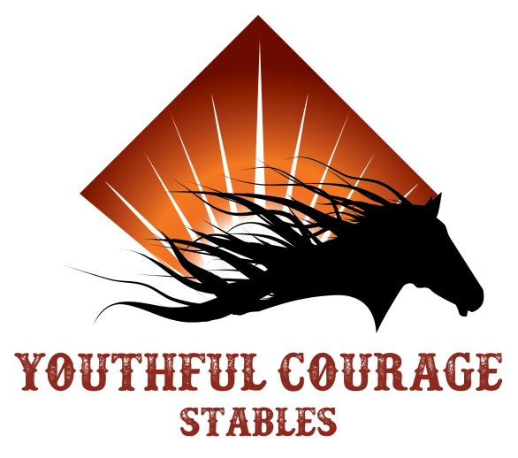

***Youthful Courage Stables 2023 Outlook for the Year***

April 7,8,9,10 Break for Easter weekend

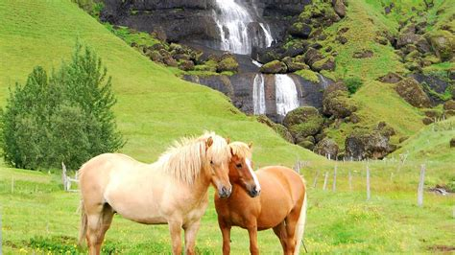April 15th Family Fun Day Easter Egg Hunt at 12pm

bring filled eggs (no chocolate please)

June 6,7 (10) Camps for Able Riders Students

8:30-10:30, 10:45-12:45

June 13th-16th Summer Camp Renaissance themed

Ages 6-11yrs, 8am-1pm $300 per camper

Call Rocky 530-301-4146 to Sign Up

***There will be scheduled Trail Riding Outings TBD during the Summer***

June 17th No Lessons

July 11-14th Summer Camp Wild West days Themed

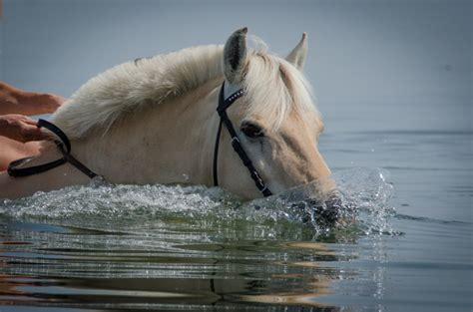 Ages 12-15, 8am-1pm $300 per camper

Call Rocky 530-301-4146 to Sign Up

July 18,19 (22) Camps for Able Riders

8:30-10:30am, 10:45-12:45

July 15th No Lessons

August 15th-Sept. 4th Stable will be on Break

September 5 Lessons Resume

Nov. 21-25 Thanksgiving Break

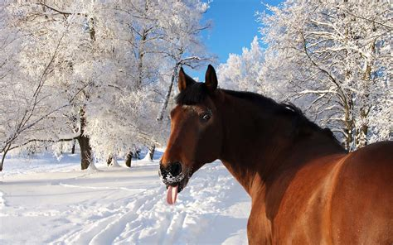December 2 Christmas Parade Marysville

December 16th Stables Christmas Party

Dec. 18 - January 13th Stables on winter Break

January 16th Lessons Resume