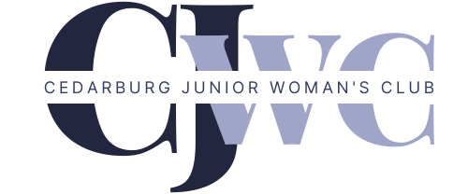

**Cedarburg Junior Woman’s Club**

**Community Assistance Grants**

**Program**

Amount Requested: $250 - $500

Note: Award announcements and any granted funds will   
be made in May 2025

Application Deadline:

March 14, 2025

Return Application To:

CAG Chair

Cedarburg Junior Woman’s Club

PO Box 205

Cedarburg, WI 53012-0205

or

[cag@cedarburgjuniors.org](mailto:cag@cedarburgjuniors.org)

For questions regarding application or eligibility, please contact

Lisa Johnson at [cag@cedarburgjuniors.org](mailto:cag@cedarburgjuniors.org)

**Cedarburg Junior Woman’s Club**

**Community Assistance Grants Program**

Since its inception in 1953, the Cedarburg Junior Woman’s Club (CJWC) has been one of the catalysts for positive change in our community. Cedarburg Junior Woman’s Club members, through their volunteer and fund-raising efforts, have created and/or supported over 150 organizations. CJWC continually monitors community needs and focuses its efforts on supporting local organizations and programs striving to meet community needs.

The Community Assistance Grants (CAG) program is designed to provide money to area non-profit organizations to support projects or activities that will make an impact on women, children and families. CJWC invites non-profit organizations to submit applications for project development, training, and educational needs throughout the year. Grants are awarded to applicants that meet the CJWC guidelines. The guidelines exist to help the CJWC respond to community needs of non-profit organizations.

Each recipient organization will assist CJWC in publicizing the applicant’s receipt of such award with a description of the program details. A written report accounting for the use of the granted funds is required of each recipient organization no later than 90 days following the receipt of the award.

**COMMUNITY ASSISTANCE GRANTS APPLICATION**

**Organization and Request Information**

Today’s Date

1. Name of Organization   
     
   Address   
     
   City/State/Zip   
     
   Contact Person Name & Title   
     
   Phone Number Email Address   
     
   Name of Program   
     
   Amount Requested Date Funds are Needed   
    *\*Requests can be made for $250-$500 and are not available for distribution until May 2025*
2. Please check which of the following best describes how your program/project aligns with the CJWC goals:

* Responds to a critical human or community need
* Explores new opportunities for addressing existing or emerging issues of concern to CJWC and the community
* Addresses specific training or educational need of program participants (non-employees)
* Other: ____________________________________________________________

1. To be considered, one copy of the following components must be submitted:
   1. This application as a cover page
   2. A narrative (maximum two pages, minimum 12 pt font, typed) describing the proposed program/project for which funds are being requested. This narrative should include:
      1. **NEED**: Describe the need for the program/project, including whether the services or activities are provided elsewhere.
      2. **OBJECTIVES**: Clearly state measurable objectives. If appropriate, include the total number of people to be served.
   3. Proof of Non-profit status. Copy of 501(c)(3).