Gallery 32 Membership Form
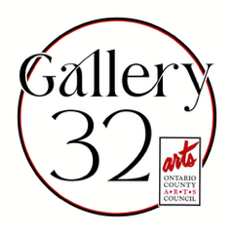
Application for Makers’ Mart Membership**
Makers’ Mart Application
Name
Address
Phone
Email
Website

Item 1 Description*:

Item 2 Description*:

Item 3 Description*:

Item 4 Description*:

Item 5 Description*:

*(Example: Item1 Description: Smith_John Painting 01.jpg). Please reduce images to 1.5 MB each or smaller before sending. Thank you.
Title | Size | Medium | Gallery Price* | Insurance Value**
* Please note: Selling price can be 20% higher than Insurance value.
**(Can be same as selling price)
Signature Date
Email this form and 5 jpeg images of your artwork with labeled description to: Admin@ocacgallery32.org and 14424gallery32@gmail.com

** Maker’s Mart Membership will be JURIED and will be first come, first serve, due to limited space. Artwork may be rotated out after 3-months, allowing for other OCAC members to sell their wares:
- Makers’ Mart Members are encouraged to volunteer for the art functions (openings, etc). Makers’ Mart Membership is based on availability of the space. Cost for exhibiting for 3 months is $30.00 and is due when artwork is dropped off (post being juried).
- The space is limited so Makers’ Mart members will rotate out every 3 months to allow for other members to show their work. All makers’ mart members must be OCAC members and can sign up here OCAC membership. ($35)

- Makers’ Mart membership allows work to be showcased and sold in the Makers’ Mart (within the gallery). Pay out of all works sold is 80% to the artist. PLEASE NOTE: Items cannot sell for more than$100 in the Makers’ Mart.

