Gallery 32 Membership Form
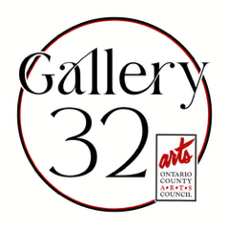
Exhibiting Membership to Rent Entire Gallery 32 space***
Exhibiting Membership Application for 2 and 3D artists wishing to rent the entire space:
Name
Address
Phone
Email
Website

INTERNAL OCAC Term Paid Yes No
Item 1 Description*:

Item 2 Description*:

Item 3 Description*:

Item 4 Description*:

Item 5 Description*:

*(Example: Item 1 Description: Smith_John Painting 01.jpg) Please reduce images to 1.5 MB each or smaller before sending. Thank you.
Title | Size | Medium | Gallery Sale Price | Insurance Value can be 20% less than Sale Price

Signature Date
Email this form and 5 jpeg images of your artwork with labeled description to: 14424gallery32@gmail.com
*** Exhibiting Membership Details to Rent Entire Gallery 32 space:

- All Exhibiting Members who rent space to show their work are selected by a juried process.
- Exhibiting Members are encouraged (but not required) to commit two ½ days per month, keeping the space clean, and doing light duties.
- All Exhibiting Members who are selected to show their work will be juried via submitting 5 digital jpegs along with this application. (The application is posted here.) Turnaround is approximately 1 week from submission.
- Selected Exhibiting Members who wish to rent the Entire Gallery space will pay $1000 for 1 month. This is in addition to the yearly OCAC membership ($35). Commitment will be for 1 month and $1000 will be due the week prior to the first month start. Pay out of all works sold is 80% to the artist.

