**DEFENSIVE DRIVING**

**PREVENTING BACKING COLLISIONS**

## BACKGROUND AND PURPOSE:

National statistics indicate that backing collisions account for about one-quarter of all collisions. Of course, the growing number of rear-vision camera systems figures to decrease the incidence of these collisions in the near future. But backing will always carry its own set of risks. Here is a list of safety tips aimed at preventing backing collisions.

## PREVENTING BACKING COLLISIONS

* **Get to know a vehicle’s blind spots.** Remember that mirrors can never give the whole picture when backing.
* **Think in advance**. Don’t put yourself in unnecessary backing situations.
* **Park defensively.** Choose easy-exit parking spaces that don’t crowd neighboring vehicles. Park in the center of your parking space.
* **If needed, take extra measures when parking in an alley.** Again, this involves thinking ahead. If an alley doesn’t permit driving all the way through or room to turn around, you should back into the alley parking space (assuming this complies with local ordinances). That way, when you leave you can drive forward to pull into the street.
* **Perform a walk-around.** Walking around a vehicle gives you a firsthand view of the backing area and will alert you to any limitations or hazards. Check for children, soft or muddy areas, potholes, tire hazards and other dangers.
* **Know the clearances.** When performing a walk-around, check for obstructions, low-hanging trees and wires, and any other potential clearance-related problems.
* **Remember that every backing situation is new and different.** You may back out of the same spot day after day, but don’t allow yourself to get complacent and relaxed. Be watchful each time for changes and new obstacles.
* **Use a spotter.** Don’t be afraid to ask for someone’s help when backing if needed. Use hand signals you’ve both agreed upon. Don’t have the spotter walking backwards while giving instructions.
* **After finishing the walk-around, don’t delay.** Return to the vehicle and start backing within a few seconds. This will allow very little time for people or obstacles to change behind the vehicle. Backing without a spotter should only take place after you have as much information about the area as possible. A backup alarm can help warn away pedestrians and drivers of other vehicles who may try to enter the area you’re backing into.

## ADDITIONAL BACKING TIPS

* Ensure your mirrors are clean and adjusted to give you the widest possible rear view.
* Tap the horn twice just prior to backing to notify others in the area that your vehicle is backing.
* Roll down the driver’s window so you can hear any warnings, such as a honking horn. Stop immediately if you hear such a warning.
* Keep the backing distance to a minimum.
* Back at a creep/idle speed and cover the brake.
* Back to the driver’s side of the vehicle. This approach will give you a clearer picture of where the vehicle is going. Continually scan the mirrors, look over your left shoulder, and check the swing out of the right front fender as you back.
* If you’re unsure of the clearance around or above the vehicle, secure the vehicle, then exit and look around to ensure the backing path is clear. Check behind, to both sides and above the vehicle.
* If you’re using a spotter, make sure he or she is standing in an area that can be easily seen in the driver’s side mirror. Stop immediately if the spotter cannot be seen. Again, use hand signals you’ve agreed upon, but also make sure the driver’s side window is rolled down so you can hear any verbal instructions or warnings.

## BACKING PROCEDURES AND TECHNIQUES

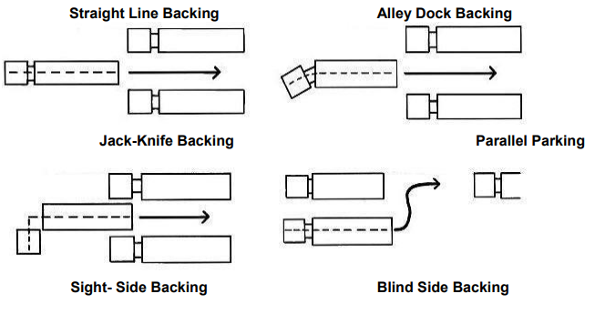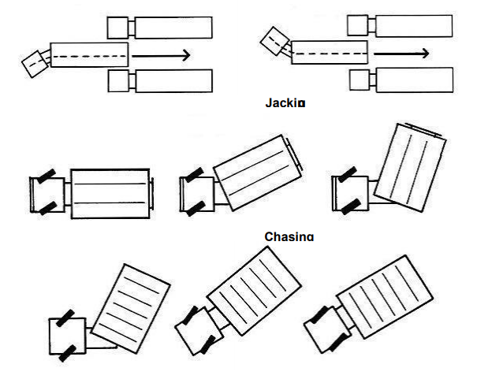­­­­

**CHASING**

**JACKING**

|  |
| --- |
| Discuss recent incidents (if any): |
|  |
|  |
|  |

|  |
| --- |
| Seek employee feedback: |
|  |
|  |
|  |

|  |
| --- |
| Meeting Attended By: |
|  |
|  |
|  |

|  |  |  |
| --- | --- | --- |
| Date: |  | Supervisor’s Signature: |