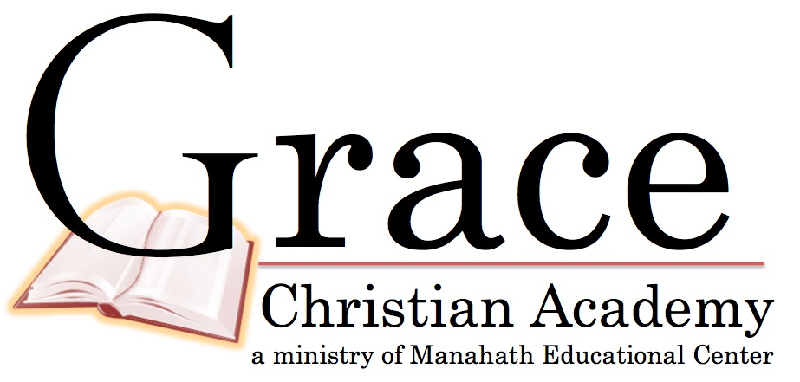

Names of Students:

___________________________________ _____________________________________

___________________________________ _____________________________________

1. I have read the 2015 Parent/Student Handbook. I understand and agree to abide by the policies, rules and procedures contained therein.
2. I understand the Biblical philosophy and mission of Grace Christian Academy. I agree to have my child(ren) taught in accordance with the doctrinal beliefs of the school as expressed in the GCA Statement of Faith.
3. I agree to pay the required tuition by the date(s) specified in my payment agreement.
4. I understand that the following process is to be followed in the collection of late tuition and fees:
   * In the event that tuition and/or fees are not paid by the tenth day of the month, the school will send a payment reminder to all applicable families. This will be done no later than the tenth of each month. A late fee of 10% of the monthly tuition will be assessed to all accounts past due on the tenth of each month.
5. I understand that the registration fee is nonrefundable. I understand that if my child is withdrawn or dismissed for any reason, unpaid registration fees are due at the time of withdrawal (or dismissal), and I agree to pay them at that time.

1. I further expressly agree that Grace Christian Academy reserves the right to dismiss (expel) any student at any time for academic or disciplinary reasons, for lack of parental compliance to the rules, policies, and regulations, or for nonpayment of tuition or fees. I also expressly agree that Grace Christian Academy shall have the right to dismiss any student at any time if the school, in its sole discretion, determines that the dismissal of the student is in the best interest of the student or the school.
2. I understand if my child leaves Grace Christian Academy, no records will be released until past due tuition is paid.
3. If I become dissatisfied with the school in any respect, I will seek to resolve the matter with the person involved in a kind and considerate manner. I will not spread criticism or hold a negative attitude in my heart.
4. If I am offended by another parent or student, I will go to that person directly and not discuss the matter with anyone else. I will allow others latitude of conduct and, therefore, will only confront regarding substantive issues.
5. In the event I should have any disagreement with the school concerning any matter that is not resolved through the means described above, I agree to seek resolution of any such disagreement through arbitration (in accordance with the rules of the American Arbitration Association) and not through judicial proceedings.
6. I recognize that my tuition payments do not cover the expenses of teaching my child. As the Lord enables, I will support the school by gifts in addition to my tuition payments and fees.
7. I will attend meetings for parents regularly.

Parents' Signatures: (both parents sign if possible) Accepted for Grace Christian Academy by

___________________________________ _ ___________________________________

____________________________________

Date: _______________________________ Date: _______________________________

Revised 3/2011

4927 E. Lee Hwy Max Meadows, VA 24360  276-637-3727  http://www.gracechristianva.com

Parent Covenant