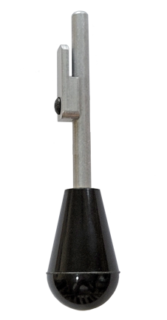
The 650 Primer Ejector Tool™ is custom designed to empty unused primers from the XL 650 Primer System. It attaches temporarily to the Primer Indexing Arm and makes it quick and easy to manually advance the Rotary Primer Disk … thus emptying the Primer Magazine and ejecting the primers into the Primer Chute.

Note: Refer to the Instruction Manual for your press for the location of the parts mentioned herein.

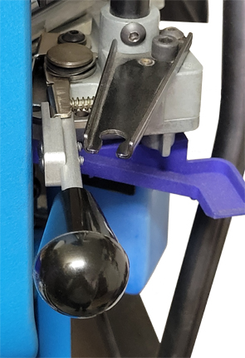
Emptying 650 Primer System
- Disengage Failsafe Rod (#13629) from Failsafe Bracket (#18726) and either reposition so it is out of the way or detach from Powder Measure and set aside.
TIP: If you raise the ram slightly (just 1 inch), you can easily disengage the Failsafe Rod from the Failsafe Bracket without needing to upset the adjustment of the Wing Nut (#13799).
- Be sure to leave press ram fully down for Steps 3 through 7 of this procedure.
- Insert the 650 Primer Ejector Tool™ into the end of the Primer Indexing Arm (#13662) as shown in photo at right.
- Gently move the 650 Primer Ejector Tool™ to the right to Index the Rotary Primer Disk (#13499 – Small Primer or #13431 – Large Primer). The ejected primer will be captured by the Primer Chute (#16210).
CAUTION: Forcing the Primer Indexing Arm to move beyond its normal range of motion may bend the Primer Indexing Arm and/or break the 650 Primer Ejector Tool™.
- Release pressure on the 650 Primer Ejector Tool™ and allow the Indexing Arm Spring (#13965) to return the Primer Indexing Arm to its normal position.
- Repeat Steps 4 and 5 until all primers have been ejected from the Primer System.
NOTE: Make sure that you have indexed the Primer Disk enough times to ensure that the Primer Magazine is empty. There are 16 holes for primers in the Rotary Primer Disk and it takes 10 strokes to remove the last primer from the Primer Magazine and eject it into the Primer Chute.
NOTE: Keep an eye on the Primer Chute and empty frequently so that primers don’t overflow onto the floor.
TIP: You may wish to invest in an alternative to the Dillon Primer Chute that has more capacity and/or makes it easier to retrieve the primers. The UniqueTek 650 Live Primer Chute (Item No.: T1306) is just one example.
(Procedure Continued on Next Page.)

- When all primers have been ejected from the Primer System, remove the 650 Primer Ejector Tool™ from the Primer Indexing Arm.
CAUTION: Raising the press ram with the 650 Primer Ejector Tool™ attached may damage the Primer Cam (#13670), Primer Indexing Arm or 650 Primer Ejector Tool™.
- Install Failsafe Rod and check that it is adjusted as described in the Dillon XL 650 Instruction Manual.
- Pistol Section – Toolhead Set Up, Part F
- Rifle Section – Toolhead Set Up, Part H

The 650 Primer Ejector Tool™ can also be used at the start of a reloading session to advance the Rotary Primer Disk to where the first primer will arrive at Station 2 at the same time as the first case. This requires just 6 strokes.
If you forget and start cycling the press, you can pause when the first case reaches Station 2, advance the Rotary Primer Disk 6 strokes and then seat the primer.*
* Don’t forget that before using the 650 Primer Ejector Tool™ you must first disengage the Failsafe Rod from the Failsafe Bracket to get it out of the way.

Starting 650 Primer System
- Fill Primer Magazine (T22032 - Small Primer or T22033 - Large Primer) with primers.
- Disengage Failsafe Rod (#13629) from Failsafe Bracket (#18726) and either reposition so it is out of the way or detach from Powder Measure and set aside.
- Be sure to leave press ram fully down for Steps 3 through 7 of this procedure.
- Insert the 650 Primer Ejector Tool™ into the end of the Primer Indexing Arm (#13662).
- Gently move the 650 Primer Ejector Tool™ to the right to Index the Rotary Primer Disk (#13499 – Small Primer or #13431 – Large Primer). It takes 6 Strokes.
CAUTION: Forcing the Primer Indexing Arm to move beyond its normal range of motion may bend the Primer Indexing Arm and/or break the 650 Primer Ejector Tool™.
- Release pressure on the 650 Primer Ejector Tool™ and allow the Indexing Arm Spring (#13965) to return the Primer Indexing Arm to its normal position.
- Repeat Steps 5 and 6 for six strokes.
- Remove the 650 Primer Ejector Tool™ from the Primer Indexing Arm.
CAUTION: Raising the press ram with the 650 Primer Ejector Tool™ attached may damage the Primer Cam (#13670), Primer Indexing Arm or 650 Primer Ejector Tool™.
- Install Failsafe Rod and check that it is adjusted as described in the Dillon XL 650 Instruction Manual.
- Pistol Section – Toolhead Set Up, Part F
- Rifle Section – Toolhead Set Up, Part H

CAUTION: DO NOT ATEMPT TO USE the 650 Primer Ejector Tool™ to free a jammed Rotary Primer Disk. Applying that much force may bend the Primer Indexing Arm and/or break the 650 Primer Ejector Tool™. To free a jammed Rotary Primer Disk, it is recommended to remove the Primer System from the press.

Disclaimer: UniqueTek, Inc. is not liable for damages or personal injury that may be incurred as a result of using this product in an improper way or in a reloading press that has been improperly maintained or operated. It is your responsibility to ensure that your reloading equipment is properly assembled, is maintained in proper working condition, and is used according to the manufacturer’s instructions and safe reloading practices.

