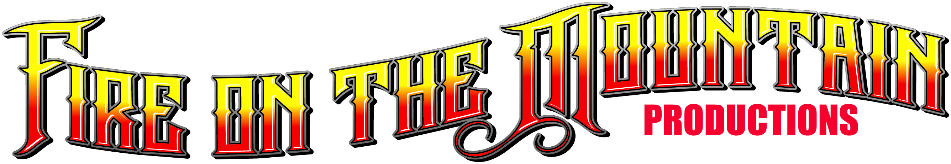
presents
“Blast from the Past 5”
Nostalgia Boat, Car & Hot Rod Show
October 9th, 2021 - Lake Ming, Bakersfield

NAME_______________________________________ Phone___________________________________

Address_______________________________ City_________________ State_____ Zip Code__________

E-Mail__________________________________________________ Club _________________________

Year ________ Make & Model________________________________________________________

RV Parking $75 per night Vendor Info call 310-625-1352

Pre-Registration Fee: $40.00 per entry for Show. $60.00 per entry for Show and Speed Passes.
Ambulance and Safety Boats will be on site for those who sign up to make Speed Passes
Pre-registered Entries will receive a T-Shirt and Plaque. The Event will include Boats, Cars, Hot Rods, RC Boats, Awards, Music, Vendors and more.
Additional T-Shirts will be available for purchase at $20.00
After the show, join us for our
3rd Annual Drag Boat Reunion and
Hall of Fame Induction

Pre-Registration must be Received by October 4th, 2021
Make checks payable to: Fire on the Mountain Productions
Mail to: Blaine White 2075 Valley Road, Reno Nevada, 89512
Phone: 310-625-1352 e-mail: blaine@FOTMevents.net

I, the undersigned, have adequate insurance based on my state requirements and accept full responsibility for the welfare of my vehicle and persons with my vehicle while attending the Blast From The Past Show, and hold harmless the host, host committee, Fire on the Mountain Productions, The City of Bakersfield and MING Lake Parks and Recreation for any claim for personal injury or damages to my vehicle asserted by participants or attendees. All boats that wish to make Speed Passes must have safety equipment.

Signed_________________________________________________Date__________

Set up on Friday, October 8th from 9:00am to 6:00pm
Saturday, October 9th from 7:00am to 9:30am

