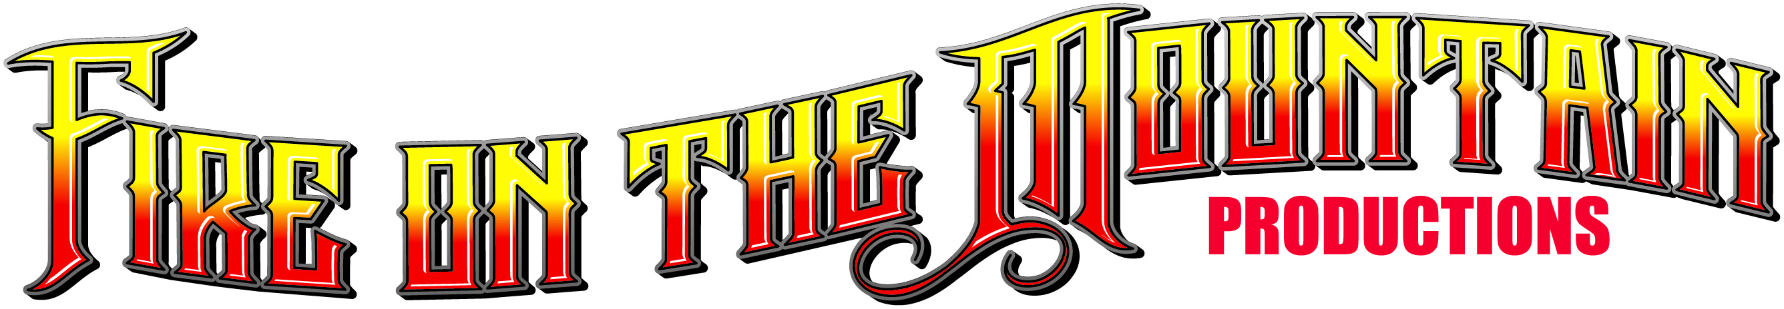
presents
“Blast from the Past 5”
Nostalgia Boat, Car & Hot Rod Show
October 9th, 2021 - Lake Ming, Bakersfield

Business Name_______________________________________________

Address_______________________________ City_________________ State_____ Zip Code__________

Phone______________________________ Cell____________________________

E-Mail____________________________________________________

Type of business_________________________________________________________

Prices:
10x10 space $100.00
10x20 space $150.00
10x30 space $200.00
Spaces are assigned by event staff prior to the show but we do take requests.
Payment:
Make checks payable to: Fire on the Mountain Productions
2075 Valley Road
Reno, NV. 89512
Contact: Blaine White 310-625-1352 blaine@FOTMevents.net

Set-up: October 8th from 12:00pm to 6:00pm & October 9th from 7:00am to 9:00am

Vendors must provide their own tables, canopies and power source, if needed.
Food vendors must have current Bakersfield Health Permit

I understand that I am responsible for my display equipment, products and transportation of said items while at the Blast from the Past show and hold harmless the host, host committee, Fire on the Mountain Productions, County of Kern, it’s Officers, Employees, Agents, Boards and Commissions including but not limited to any claim for personal injury or damages to my display equipment or property asserted by participants or attendees.

_______________________________________ _____________________
Signature Date

