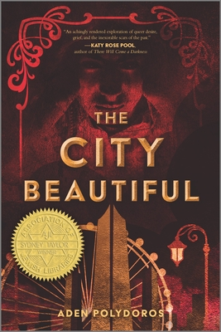
The City Beautiful
Published in October 2021 by Inkyard Press/HarperCollins.
Chicago, 1893. For Alter Rosen, this is the land of opportunity. Despite the unbearable summer heat, his threadbare clothes, and his constantly empty stomach, Alter still dreams of the day he’ll have enough money to bring his mother and sisters to America, freeing them from the oppression they face in his native Romania.
But when Alter’s best friend, Yakov, becomes the latest victim in a long line of murdered Jewish boys, his dream begins to slip away. While the rest of the city is busy celebrating the World’s Fair, Alter is now living a nightmare: possessed by Yakov’s dybbuk, he is plunged into a world of corruption and deceit, and thrown back into the arms of a dangerous boy from his past. A boy who means more to Alter than anyone knows.
Now, with only days to spare until the dybbuk takes over Alter’s body completely, the two boys must race to track down the killer—before the killer claims them next.

Translations
Spain: La ciudad bella. Published by Monogatari Media Editorial (November 2022)

Awards and Nominations
- Winner of the 2022 Sydney Taylor Book Award for Young Adult Fiction.
- Finalist in the 2022 World Fantasy Award, Novel Category
- Finalist in the 2021 National Jewish Book Award, Young Adult Category
- Finalist in the 2022 Lambda Literary Awards, LGBTQ Young Adult Category
- 2021 Bram Stoker Award Preliminary Ballot
- Finalist in the 2021 Cybils Award category for Young Adult Speculative Fiction.

Lists and Accolades
- YALSA 2022 Top Ten Best Fiction Pick
- Declared a Best YA Book of 2021 by New York Public Library, BookPage, Buzzfeed, and Tor.com.
- A BookPage 2021 Reader's Choice.
- IndieNext Kids' List pick for Nov/Dec 2021 and an Amazon Editor's Pick for Best YA Book of October 2021.
- New York Public Library Winter 2022 Pick.
- Locus Magazine's 2021 Recommended Reading List pick.

Praise and Trade Reviews
☆ “Readers looking for finely wrought historical fiction with fully realized characters and a thrilling pursuit of justice are sure to be satisfied by Alter’s story.”—Publishers Weekly, Starred Review
☆ “A wild ride of a queer gothic fantasy that’s a must-have for YA fantasy collections.”—School Library Journal, Starred Review
☆ “A gorgeous, disturbing, visceral and mystical experience… steeped in vibrant historical detail… His [Polydoros’s] unflinching and well-rounded depiction of Jewish American and immigrant history makes The City Beautiful a superb addition to the ranks of YA historical fiction.”—BookPage, Starred Review
☆ “The City Beautiful is a triumph, showcasing queer love, illuminating historical events, and guiding readers to an enthralling ending that will leave them satiated yet desirous to return to the world in which they have become immersed.”—Booklist, Starred Review
“Readers will become immersed in Alter’s world, rooting for his survival, hoping for his reunion with his family, and wishing for him to find the love that he deserves.”—Kirkus Reviews
“Aden Polydoros’s gothic thriller is a tale of love and vengeance set in the Jewish neighborhoods of 1893 Chicago, where the glitz and glamor of the World’s Columbian Exhibition, just around the corner, might as well belong to another world.”—Jewish Book Council
"The City Beautiful is an immersive and chilling mystery thriller—with an entrancing main character, complex depictions of queerness and community and transportive prose, Polydoros delivers an uncanny and sinister story that will keep readers guessing to the very end."—The Nerd Daily
"The City Beautiful has darkness at its heart, as its characters struggle to survive amidst antisemitism, horrific labor standards, and prejudice... its details (are) rich with specificity and research, and its joys tinged with sorrow... but that makes it all the more moving."—NPR

Articles
Fall Brings YA Historicals About Haunted Boys And The Rapscallions Who Love Them, NPR
Bringing The City Beautiful to Life, a guest post by Aden Polydoros, Teen Librarian Tool Box (School Library Journal)

Author Interviews
Q&A With Aden Polydoros, The City Beautiful, DiverseBooks.org
Aden Polydoros Wants More Jewish Characters in Genre Fiction, Hey Alma
Interview with Author Aden Polydoros, Geeks Out
Q&A: Aden Polydoros, Author of ‘The City Beautiful’, The Nerd Daily
Jewish Heritage in Horror: An Interview with Aden Polydoros, Horror.org
Dybbuk in Chicago: A Conversation with Aden Polydoros, Jewish Book Council
Aden Polydoros On His New Queer YA Historical Fantasy, The City Beautiful, United by Pop
Author Chat with Aden Polydoros, YA Book Central
Your Author Series: Aden Polydoros, Los Angeles Public Library

Author Blurbs
"The City Beautiful is the haunting, queer Jewish historical thriller of my darkest dreams." —Dahlia Adler, creator of LGBTQ Reads and editor of That Way Madness Lies
"An achingly rendered exploration of queer desire, grief, and the inexorable scars of the past." —Katy Rose Pool, author of There Will Come A Darkness
"Like a darkly compelling dream; I dare readers to try to put down this queer triumph of a book where myth, mystery, and death lurk around every corner of the Windy City."—Sarah Glenn Marsh, author of the Reign of the Fallen series
"With stark, poignant prose and an endearing main character, The City Beautiful is an entrancing and chilling tale that deftly analyzes complex themes of identity and assimilation. One-part historical fantasy, one-part gothic thriller, this genre-blending story has something for everyone."—Kalyn Josephson, author of the Storm Crow duology
"Sinister and alluring, The City Beautiful will utterly transport you. With a keen eye for historical details, Polydoros deftly weaves together a gruesome murder mystery, a beautiful romance, and a rich depiction of Jewish life in the 19th century. I absolutely adored Alter, a boy on a quest for closure, love, and belonging in a hostile world."—Allison Saft, author of Down Comes the Night
"Set during the 1893 Chicago World Fair, The City Beautiful is a gripping, fast-paced book that expertly marries thriller and murder mystery. Polydoros is not afraid to tear aside the façade of beauty and civility to confront the darkest aspects of human nature, no holds barred. The resulting book is something truly special."—Sophie Gonzales, author of Only Mostly Devastated

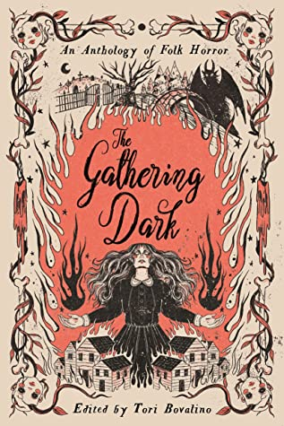
The Gathering Dark: An Anthology of Folk Horror
Published in September 2022 by Page Street Books.

A cemetery full of the restless dead. A town so wicked it has already burned twice, with the breath of the third fire looming. A rural, isolated bridge with a terrifying monster waiting for the completion of its summoning ritual. A lake that allows the drowned to return, though they have been changed by the claws of death. These are the shadowed, liminal spaces where the curses and monsters lurk, refusing to be forgotten.

Hauntings, and a variety of horrifying secrets, lurk in the places we once called home. Written by New York Times bestselling, and other critically acclaimed, authors these stories shed a harsh light on the scariest tales we grew up with.

Lists and Accolades
Indie Bestseller, Young Adult category (#8, 9/14; #10, 9/21; #8, 9/28; #14, 10/05)

Praise and Trade Reviews
☆ “Tapping into timeless fears such as ghosts and monsters, and interweaving overarching themes of friendship and love, this unique and delightfully creepy anthology delivers scares while inviting contemplation.”—Publishers Weekly, Starred Review
“Ominous, moody, and fiercely original, this anthology provides a delightful introduction to horror and an irresistible diversion for existing genre fans […] Perfectly creepy.”—Kirkus Reviews
"[A] thrilling ride [...] Hand this book to fans of 'good for her' horror movies like The Witch and listeners of horror anthology podcasts such as Old Gods of Appalachia and The Magnus Archives."—School Library Journal
“[A] haunting assortment of tales [...] that dishes out chills and simultaneously explores the pressures and heightened emotions of adolescence."—Booklist
"For teens who grew up reading Alvin Schwartz's iconic Scary Stories to Tell in the Dark, The Gathering Dark will be the perfect shivery autumnal read."—BookPage
“Aden Polydoros’s “It Stays With You” provides a cleverly painful take on the familiar Bloody Mary legend.”—The Wall Street Journal
“‘It Stays With You’ by Aden Polydoros does not hang around, getting straight into deadly territory. I adored this fresh take on the Bloody Mary myth, with a pinch of Pennywise mixed in for good measure. Polydoros deftly explores facing trauma and defeating your monsters, while emphatically emphasising how recovery is a journey with highs and pitfalls.”—The Nerd Daily

Articles
39 of the Most Anticipated YA Books for the Rest of the Year, Goodreads
New Dark and Twisty YA Reads for Fall, Goodreads
New Young Adult Science Fiction, Fantasy, and Horror for September & October 2022, Tor.com
13 Spooky New Horror Books Coming This Fall, Geek Girl Authority
September's New Book Releases 2022 Are Spooky and Fulfilling, Distractify
New and Forthcoming 2022-2023 YA Anthologies to TBR, Book Riot
Sweet Reads: September Book Releases To Welcome Fall, The Honey Pop
Get Your Hands On These Anticipated July To December 2022 Book Releases, The Nerd Daily

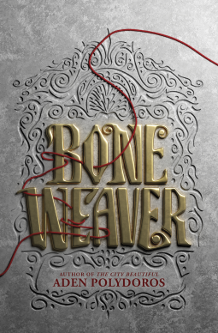
Bone Weaver
Published in September 2022 by Inkyard Press, an imprint of HarperCollins.
The Kosa empire roils in tension, on the verge of being torn apart by a proletarian revolution between magic-endowed elites and the superstitious lower class, but seventeen-year-old Toma lives blissfully disconnected from the conflict in the empire with her adoptive family of benevolent undead.
When she meets Vanya, a charming commoner branded as a witch by his own neighbors, and the dethroned Tsar Mikhail himself, the unlikely trio bonds over trying to restore Mikhail’s magic and protect the empire from the revolutionary leader, Koschei, whose forces have stolen the castle. Vanya has his magic, and Mikhail has his title, but if Toma can’t dig deep and find her power in time, all of their lives will be at Koschei’s mercy.

Praise and Trade Reviews
☆ “Superb... Polydoros is a master of world building and conjuring suspense in a page-turning plot. His characters are highly empathetic and memorable, as is this emotionally charged story.”—Booklist, Starred Review
“A dark and thrilling tale.”—Kirkus Reviews
"Polydoros (The City Beautiful) constructs a rich, Slavic-folklore-influenced world in this spirited adventure with emotional heft... Polydoros capably delivers an enchanting fantasy adventure, brimming with civil war allegiances, encounters with monsters, innovative magic systems, and fantastical new technology." —Publishers Weekly
“With detailed and startling imagery, Polydoros crafts a magical world that readers will revel in exploring, and he avoids heavy exposition with narrator Toma, whose keen insight and sheltered existence make her a useful audience cipher through which to learn about the world…. Fans of Justina Ireland’s Dread Nation (BCCB 05/18) and the Shadow & Bone series will love this dark fantasy with a touch of horror.”—Bulletin of Center for Children’s Books
"In Bone Weaver, author Aden Polydoros draws inspiration from Russian history, Slavic folklore, and Jewish culture to craft a detailed setting that feels fully alive, even as it's constantly shadowed by death... Bone Weaver is a bloody and unflinching fantasy that balances its darkness with an unwavering cascade of love."—BookPage
“[…] Polydoros made the world feel vast and boundless while also keeping the story contained. To Toma, Mikhail, and Vanya, everything that takes place is life-or-death, yet Polydoros gives readers tantalizing slices of the outside world that will one day kick the door down to the Kosa Empire. I almost wish we’d get a sequel set a century later, just to see where things land.”—Tor.com

Articles
39 of the Most Anticipated YA Books for the Rest of the Year, Goodreads
A Story of Imperialism and Identity: Bone Weaver by Aden Polydoros, Tor.com
5 New YA Reads to Check out This Fall, NPR

Interviews
‘Pasts That Are as Diverse as the Present’: A Conversation between Sacha Lamb and Aden Polydoros, Jewish Book Council

Author Blurbs
"A heart-pounding adventure. Magic and monsters lurk in every corner as a headstrong trio search for their place in Aden Polydoros's haunting world." ––Chloe Gong, #1 New York Times bestselling author of These Violent Delights

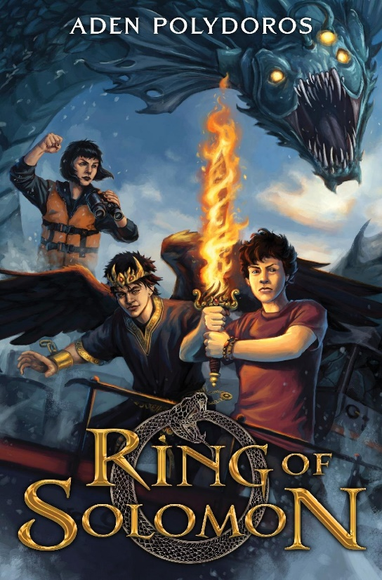
Ring of Solomon
Forthcoming February 2023 by Inkyard Press, an imprint of HarperCollins.
The little beachside town of San Pancras is not known for anything exciting, but when Zach Darlington buys a mysterious ring at the local flea market, his quiet little hometown is turned topsy-turvy by monsters straight from Jewish folklore and a nefarious secret society focused on upholding an apocalyptic prophecy.
Zach discovers that the ring grants him strange powers, and he’s intrigued; maybe he can use the ring’s strengths to halt the slew of anti-Semitic and homophobic bullying he’s experiencing at school. But soon the ring brings unexpected visitors—Ashmedai, King of Demons, in the guise of a preteen boy named Ash, and the local chapter of the Knights of the Apocalypse, a secret society intent on completing a creepy prophecy that will bring three monsters to Earth to start the events of the end of times.
Now responsible for the ring and its consequences, will Zach and his friends, with the help of Ash, be able to stop the Apocalypse and save the world?

Author Blurbs
“Jam-packed with action and humor, Ring of Solomon is a rip-roaring good read. Buoyed by the fast pace and excitement of this Jewish mythology-inspired adventure, I plowed right through until there was no more left. I already miss Zach and the endearing cast of characters. Please, I need more!"—Graci Kim, author of The Last Fallen Star
"This exploration of a boy's self is full of fun, humor, and Jewish mythology that I never knew could be so cool."—Rex Ogle, author of Free Lunch and The Supernatural Society
“Will keep you on the edge of your seat and grinning until the last page!”—Greg Howard, author of The Whispers and The Visitors

