

EST. 2021

It Is Festival Time

BASTROP PRIDE 3rd ANNUAL PRIDE FESTIVAL WEEKEND

Bastrop Pride will be hosting the 3rd Annual Music, Art and PrideFestival. This event is back and better, as the result of this expansion, this will be the first year Bastrop Pride and our sponsors have made it possible for this event to become a Block Party street festival. The Music, Art and Pride festival will be two days of entertainment, shopping, food and drinks. Pride in the Park is proud to be a family friendly, inclusive and all-ages event.

Bastrop Pride is an organization that has been active within the community year-round, with monthly digital workshops, festival participation, and volunteering.

Support and Sponsorship of Bastrop Pride is a great way to participate and showcase your community support for Bastrop Pride, and your local LGBTQIA+ community. Become a sponsor and partner with Bastrop Pride. Your help and support will ensure the continued growth of, not only this ground but, all the good community outreach Bastrop Pride participates and is involved in. Bastrop Pride is the prime local resource for the LGBTQIA+ community, this community's allies and all marginalized communities that need a voice.

Any and all support is greatly appreciated. Please let us know how we can assist you making your donation, which is **tax-deductible**, or assist you in becoming a sponsor. Without great community supporters such as you, none of what Bastrop Pride is able to do would be possible.

Thank-you!



EST. 2021

THE 3rd ANNUAL BASTROP “PRIDE IN THE PARK” FESTIVAL

Fisherman’s Park

Sunday, June 4th, 2024: 3PM - 8PM

**You are invited to be a 2024 Bastrop Pride Festival Sponsor!**

LOCATION: Fisherman’s Park

DATES/TIMES: Sunday, June 2nd, 2024: 3PM - 8PM

ATTENDANCE: Estimated to be 500+

AUDIENCE: Family-friendly event to include all ages from the Central Texas region and beyond. Last year we had attendees from as far as California, Dallas, and even Greece!

ACTIVITIES: This pride in the park is a day of musical delight featuring local bands and ensembles, unique shopping at arts & crafts booths, youth programming and activities and plenty of festival food and beverages.

MARKETING OPPORTUNITIES:

• Print and website coverage (Partnership sponsor level)

• Sponsorship banner placements opportunity

• Recognition leading up and throughout the event.

• Booth/exhibit space

PROMOTION IDEAS:

• Product sampling and sales

• Database development (register to win)

• Contests/Promotions/Premium Incentives/Coupons/Bounce-Backs/Cross-Promotions/Sponsor Partnerships



EST. 2021

THE 2nd ANNUAL BASTROP PRIDE “STREET FAIRE”

Historic Downtown Block Party

Saturday, June 1st 2024: 7PM - 11PM

**You are invited to be a 2024 Bastrop Pride Festival Sponsor!**

LOCATION: Bastrop’s Historic Downtown - Chestnut to Spring St.

DATES/TIMES: Saturday, June 1st 2024: 7PM - 11PM

ATTENDANCE: Estimated to be 300+

AUDIENCE: 21+ event to include from the Central Texas region and beyond.

ACTIVITIES: The evening market is an exotic break from the mundane. Bringing in the weird and wacky that is inside us all, enjoy the evening with a drink of choice and browse the wares of evocative vendors selling trinkets and crafts that tickle the fancy. Set to a backdrop of drum circles and performances, this night is packed with renaissance feelings.

MARKETING OPPORTUNITIES:

• Print and website coverage (Partnership sponsor level)

• Sponsorship banner placements opportunity

• Recognition leading up and throughout the event.

• Booth/exhibit space

PROMOTION IDEAS:

• Product sampling and sales

• Database development (register to win)

• Contests/Promotions/Premium Incentives/Coupons/Bounce-Backs/Cross-Promotions/Sponsor Partnerships



EST. 2021

SPONSORSHIP FORM

Name:_______________________________________________________________________

Company Name:_______________________________________________________________

Brief introduction about your company for promotional announcements and web directory listing:

____________________________________________________________________________________

____________________________________________________________________________________

____________________________________________________________________________________

Business Address:_____________________________________________________________

____________________________________________________________________________

Business Phone:________________________ Email:_____________________________

Contact Name:_________________________ Contact Phone:______________________

Sponsorship Level:_____________________ Donation Amount:$___________________

☐ Check here, if you plan to have a booth at either or both Bastrop Pride events.

Please fill out a Vendor Application Form to ensure we reserve a space for you.

*Festival banners are to be provided by sponsor (see Sponsorship Levels section for details and sizing).* To ensure your company name is on our promotional materials, please return application, sponsorship fees, and digital logos to pridebastrop@gmail.com no later than **May 1st, 2024**.

DONATION STEPS AND INFORMATION

1. Visit https [donate.bastroppride.org](http://donate.bastroppride.org)
2. Click on “Donate” and choose the desired amount and frequency..
3. Email [info@bastroppride.org](mailto:info@bastroppride.org) to confirm donation, receive determination letter and W9 tax form, and to set up benefits (including shipping address if needed).

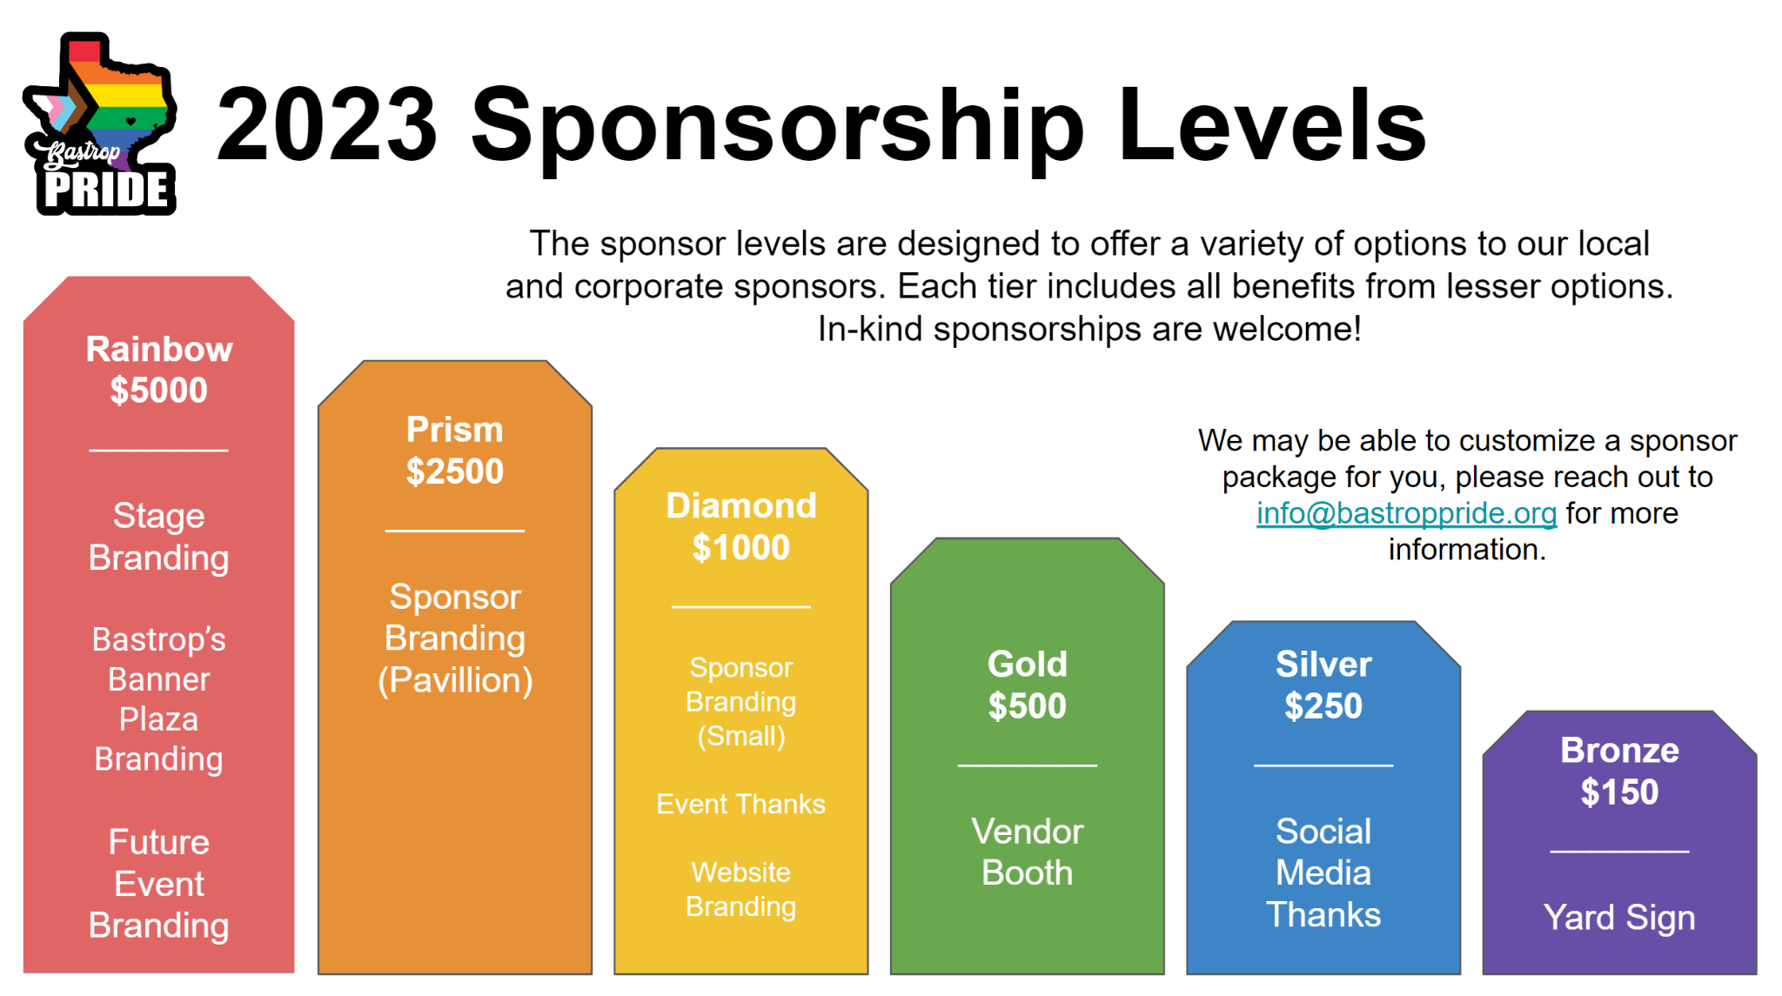



**VENDOR INFORMATION**

| **COMPANY / FIRM NAME** as shown on Federal Tax Return | | | **VENDOR ID.** if applicable |
| --- | --- | --- | --- |
|  | | |  |
| **ALTERNATE NAME** if applicable / (doing business as) | | | **TAX ID NUMBER** FEIN OR SSN |
|  | | |  |
| **POINT OF CONTACT NAME** | | **TITLE** | |
|  | |  | |
| **VENDOR ADDRESS** | | | |
|  | | | |
| **PAYMENT ADDRESS** if different from address above | | | |
|  | | | |
| **PHONE** | **FAX** | **VENDOR EMAIL** | |
|  |  |  | |
|  | **VENDOR WEBSITE** | | |
|  |  | | |

| **ORGANIZATION TYPE** (select one) | | | | | |
| --- | --- | --- | --- | --- | --- |
|  | Corporation |  | Individual / Sole Proprietor |  | Joint Venture |
|  | LLC |  | Partnership / Limited Partnership |  | Non Profit |

**\*\*No payment necessary for Non-Profits\*\***

| **Vending Payment for Paypal** | **Mail Vending Payment** | **DATE SENT** |
| --- | --- | --- |
| [donate.bastroppride.org](http://donate.bastroppride.org) | 906 Main St. #146, Bastrop, TX 78602 |  |

| Which events vending? | **Street Fair (6/3) - $50 vend fee** | **Pride in the Park (6/4) - $50 Vend Fee** | **Both - $75 vend fee** |
| --- | --- | --- | --- |
|  |  |  |



EST. 2021

**Vendor Agreement**

The undersigned Festival vendor (“Vendor”) agrees to be bound by each and every term set forth herein and the terms and representations set forth in the Vendor Application, which is incorporated herein by reference as though fully set forth. If the Vendor violates any term of this agreement, Bastrop Pride and/or the authorized agents of Bastrop Pride may within their sole discretion and at any time (1) terminate this agreement, (2) require Vendor, immediately upon notice of violation of this agreement, to cease operations and vacate the premises, and (3) forfeit any and all fees paid to Bastrop Pride for the right and privilege of participating in the festival area of Bastrop Pride. This agreement represents the entire agreement between Bastrop Pride and the Vendor and may not be amended without the mutual consent of both parties set forth in writing and signed by authorized representatives of Bastrop Pride and the Vendor.

1. Bastrop Pride will provide an appropriate 10’ x 10’ space within the festival area for Vendor to set up. Vendors are responsible for providing their own tables, tents or other equipment.

2. Electricity may not be available at the vendor's booth. Gas-powered generators are restricted to Food Truck Vendors.

3. Vendors agree to obey all rules and instructions as directed by the Bastrop Pride authorized agents during the festival. Any failure to strictly adhere to such rules or instructions may result in the immediate termination of this agreement and immediate removal from the festival area.

4. Vendor understands and agrees that Bastrop Pride is intended to be, and at all times shall be, a community-friendly event. Therefore, Vendors in the open festival area shall not openly display any materials that are obscene, sexually explicit, pornographic or indecent. Nor shall Vendors display materials that are viewed as statements of hate, violence or derogatory in nature towards any person or group of people.

5. Out of fairness and consideration of all Festival participants, Vendor acknowledges and agrees to only utilize such space contained within the confines of its booth, and not to extend beyond 5 feet directly in front of its booth, for any sales, distribution, or other solicitation by the Vendor. Vendor acknowledges and agrees that they are strictly prohibited from “canvassing” or otherwise roaming the Festival Grounds in any effort to promote its booth’s purpose. Bastrop Pride will make every reasonable effort, as allowed by law, to prohibit any unauthorized “canvassing.”

6. Bastrop Pride reserves the right to place Vendors in a booth location at the complete discretion of Bastrop Pride. Bastrop Pride shall have sole and complete authority to place the participant in any location contained in the festival area, irrespective of the participant’s request.

7. All Vendors must have appropriate permits to sell.

8. Vendors acknowledges and understands its liability, and agrees to compensate Bastrop Pride, for any damages(s) caused by, including but not limited to, its representatives, agents, employees, volunteers, members, vehicles, equipment, materials, objects to the environs and infrastructure of the local buildings, businesses or city property which causes Bastrop Pride to pay for the repair, replacement, or other remuneration to the City of Bastrop, building or business for such damage to their environs or infrastructure.

9. Vendor acknowledges and understands that they are responsible for sales and use tax and shall in no way hold Bastrop Pride or its representatives responsible for any type of permits other than for the festival itself. Vendor is responsible for the acts, and all costs associated with, any and all its employees and volunteers. No Vendor shall hold itself out as an Agent of Bastrop Pride.

10. Bastrop Pride makes no representation or guarantees towards actual festival attendance. Bastrop Pride makes no representation, nor does it guarantee any volume of “foot-traffic” of Festival Guests in any area of the festival area. Bastrop Pride cannot speculate, nor control, the popularity of one area of the festival over the other.

11. Vendor understands that Bastrop Pride has no control over weather, acts of God, acts of terrorism, illness, injury, governmental intervention, or any other cause that may prevent and alter and or interrupt, the festival weekend, and participants shall hold Bastrop Pride harmless for any losses that could arise because of such event.

12. Vendors upon vacating their booth space(s) will ensure that such space shall be free of any and all trash or refuse with such being placed in the appropriate containers.

____________________________________________

Vendor Signature & Name