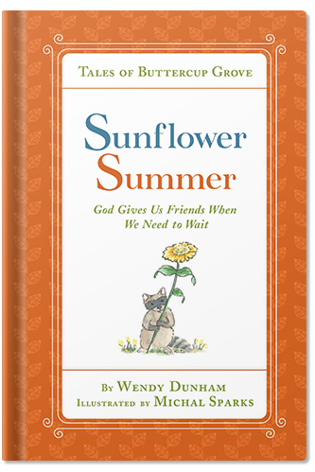
Sunflower Summer ~ Literary Journal Questions
Name: ____________________________________
Date: _________________
- What is the title of this book: _____________________________________________________

- Tell 3 main events of the story:

- ___________________________________________________

- __________________________________________________

- ___________________________________________________

- Was there conflict in the story? If yes, what was it, and how was it resolved? _____________________________________________
_____________________________________________________
_____________________________________________________

- What was your favorite part of the story? ___________________

_____________________________________________________

_____________________________________________________

- Would you recommend this book to a friend? Why or why not? ______________________________________________________

______________________________________________________
talesofbuttercupgrove.com #talesofbuttercupgrove #wendydunham #michalsparks

