**Sunflower Summer Word Search**

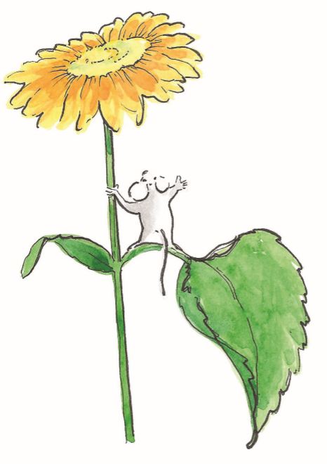

Find the words in the word box:

picnic patience plant

sunflower friends seeds

cid:D9467367-B561-48B7-84AC-445EC9427FD3

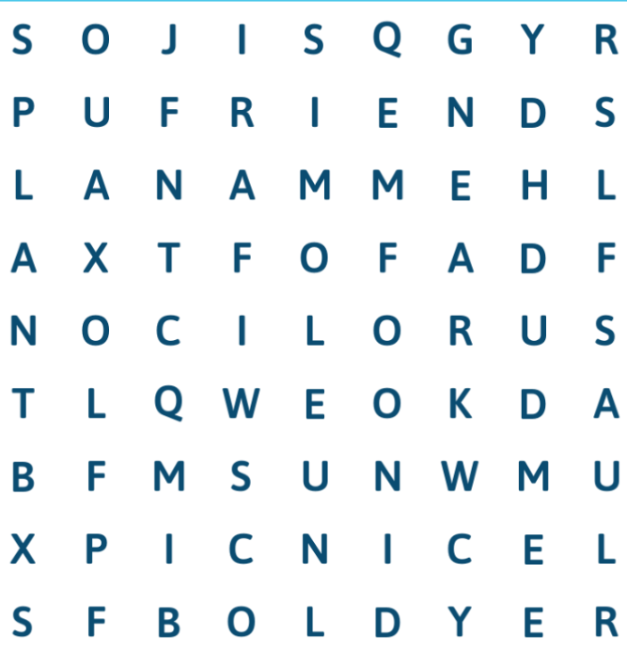

talesofbuttercupgrove.com #talesofbuttercupgrove #wendydunham #michalsparks