A Windy Spring Day 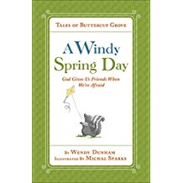
Scrambled Story Strips
These story strips are all mixed up. Cut them out and then put them in the right order. Try your best to cut on the lines!
Skunk and Raccoon built a kite.
Raccoon went to Skunk’s house.
Everyone took turns building the kite.
The wind blew and Skunk was afraid.
Raccoon showed Skunk the surprise.
Skunk called Raccoon on the phone.
Skunk and Raccoon called their other friends.

Talesofbuttercupgrove.com

