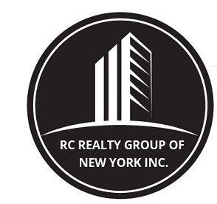

260 West 91st street, Suite #1A,
NEW YORK, NEW YORK 10024
T: (646) 780-1856
F: (646) 813-1497
EMAIL: rcrealtynyc@gmail.com
WEBSITE: WWW.RCREALTY.NYC

Residential Information & Amenities Form

Property Address
Building Name
Building Type (circle) | Rental Co-op Condominium Cond-Op  Pre-War Post War
Apartment #
Apartment Size
Room Breakdown | ___Rooms ___Bedrooms ___Bathrooms
Room Dimensions | _______Bedroom _______Bedroom _______Bedroom  _______Bathroom _______Bathroom _______Living Room  _______Dining Room _______Kitchen
Maid’s Room | Yes No
Monthly Rent
Term (months)
Start Date
End Date
Pets | Yes No
Contact Person
Contact Phone
Show Policy (days/hours)
Exposure(s)
Views
Overall Condition
Kitchen Condition
Kitchen Amenities
Bath Condition
Bath Amenities
Apartment Amenities | Wood Floors Wet Bar Murphy Bed Penthouse  Ground Floor New Windows Corner Live/Work  Wall-to-Wall Carpeting Noise Abatement Windows
Washer/Dryer in Apartment | Yes No
Dishwasher in Apartment | Yes No
Laundry Room in Building | Yes No
Outdoor Space | Terrace Wrap Terrace Balcony Garden  Private Roof Terrace
Fireplace | Wood Burning Decorative Gas None
ISSUES: ______________________________________________________________________________
___________________
Name: _____________________________ Title of Individual filling out Questionnaire: ______________

