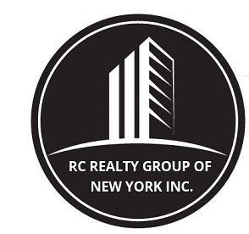

260 West 91st street, SUITE #1A,
NEW YORK, NEW YORK 10024
T: (646) 780-1856
F: (646) 813-1497
EMAIL: rcrealtynyc@gmail.com
WEBSITE: RCREALTY.NYC

OPTIONS FOR RENTAL FEE

_____ of the first annual rent for a rental of one (1) year or more.

_____ of the total rent for a rental of more than six (6) months and up to one (1) year.

_____ month’s rent for a rental of more than two (2) months and up to six (6) months.

_____ Half (½) month’s rent for a rental of up to two (2) months.

