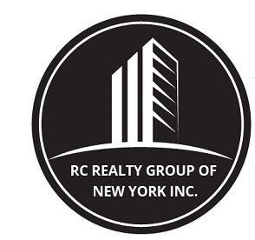

260 West 91st street, SUITE #1A,
NEW YORK, NEW YORK 10024
T: (646) 780-1856
F: (646) 813-1497
EMAIL: rcrealtynyc@gmail.com

WEBSITE: WWW.RCREALTY.NYC

Welcome to Our Open House

We strive to provide you with elegant properties that will suit your needs while providing unparalleled service.

Date: Address of Property: ____________________________ Apartment # ____

Name: | Name: | Name:
Telephone #: | Telephone #: | Telephone #:
E-Mail: | E-Mail: | E-Mail:
How did you hear about this Open House?  Ad_____ Name of Newspaper _____  Broker__________________________________________  Mailing__________  Friend__________  Other __________ | How did you hear about this Open House?  Ad_____ Name of Newspaper __________  Broker__________________________________________  Mailing__________  Friend__________  Other __________ | How did you hear about this Open House?  Ad_ Name of Newspaper __________  Broker_________________________________________  Mailing_________  Friend_________  Other __________
Name: | Name: | Name:
Telephone #: | Telephone #: | Telephone #:
E-Mail: | E-Mail: | E-Mail:
How did you hear about this Open House?  Ad_____ Name of Newspaper __________  Broker__________________________________________  Mailing__________  Friend_________ Other ______________ | How did you hear about this Open House?  Ad_____ Name of Newspaper __________  Broker__________________________________________  Mailing__________  Friend__________ Other_____________ | How did you hear about this Open House?  Ad_____ Name of Newspaper __________  Broker_________________________________________  Mailing__________  Friend__________ Other ____________

